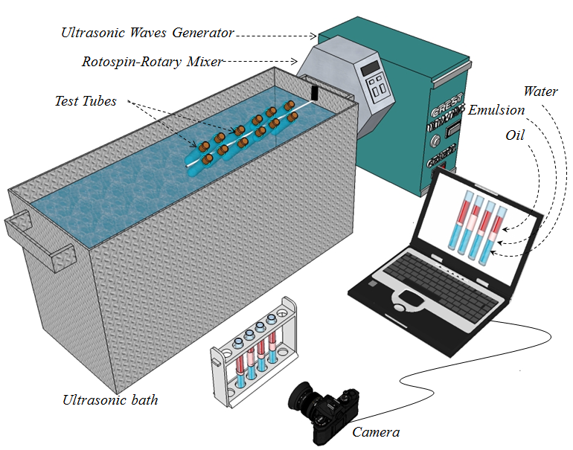
Fig. 1. Experimental setup for emulsion tests.

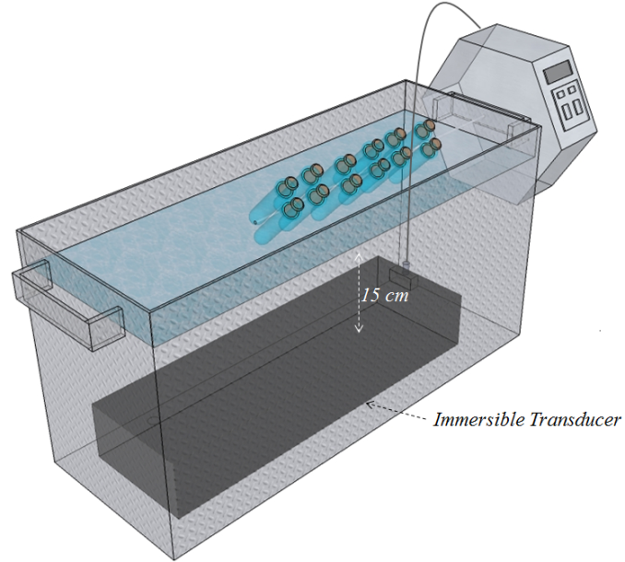
Fig. 2. Ultrasonic bath and immersible transducer.

Optimal Salinity
Fig. 3. Solubilization parameters vs. salinity, % NaCl and 3% surfactant concentration under no ultrasonic stimulation (NUS)
Optimal Salinity
Fig. 4. Solubilization parameters vs. salinity, %NaCl and 3% surfactant concentration after 15 mins ultrasonic stimulation
Optimal Salinity
Fig. 5. Solubilization parameters vs. salinity, %NaCl and 3% surfactant concentration after 60 mins ultrasonic stimulation

Fig. 6. Relative phase volume vs. salinity, % NaCl and 3% surfactant concentration using no ultrasonic waves (NUS)

Fig. 7. Relative phase volume vs. salinity, % NaCl and 3% surfactant concentration after 15 mins radiation of ultrasonic waves

Fig. 8. Relative phase volume vs. salinity, % NaCl and 3% surfactant concentration after 60 mins radiation of ultrasonic waves
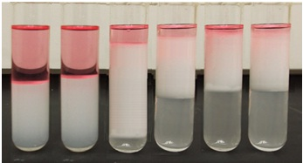
0.5 %
1
%
1.5
%
2
%
2.5 %
3 %
Fig. 9. Phase behavior of oil and 3% AOS solution (salinity changes from 0.5 to 3 % from left to right).

Fig. 10. Comparison of microemulsion volumes for the mechanical agitation technique; without using ultrasonic waves (black), after 15 mins. radiation of ultrasonic waves (red), and after 60 mins. radiation of ultrasonic waves (blue)

Fig. 11. Comparison of the volume of oil solubilized in microemulsion for the mechanical agitation technique; without using ultrasonic waves (black), after 15 mins. radiation of ultrasonic waves (red), and after 60 mins. radiation of ultrasonic waves (blue)

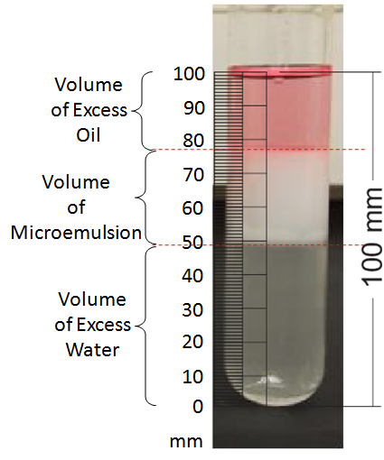
Fig. 12. Volume measurement of microemulsion, excess oil and water

Fig. 13. Water temperature changes under influence of ultrasonic waves (40 kHz and 500 W) in ultrasonic bath

Fig. 14. Comparison of microemulsion volumes for the mechanical agitation technique; 3 % AOS concentration and without using ultrasonic waves (black), 3 % AOS concentration and after 15 mins. radiation of ultrasonic waves (red), 1 % AOS concentration and after 15 mins. radiation of ultrasonic waves (green)

Optimal Salinity
Optimal Salinity
32˚C
63˚C

Fig. 15. The effect of temperature on interfacial tension for 15 and 60 mins ultrasonic stimulation using 3 % AOS concentration

