Geochemical evidence for a Cretaceous oil sand (Bima oil sand) in the Chad Basin, Nigeria
Timothy Bata^{1 & 2 *}, John Parnell¹, Nuhu K. Samaila², Mohammed B. Abubakar^{2 & 3} and Abubakar S. Maigari²
¹Department of Geology and Petroleum Geology, University of Aberdeen, Aberdeen, AB24 3U, U.K.
²Department of Applied Geology, Abubakar Tafawa Balewa University, Bauchi, Nigeria
³National Centre for Petroleum Research and Development, A.T.B.U., Bauchi, Nigeria
*Corresponding Author (e-mail: timothybata@abdn.ac.uk, +447425934972)

Abstract
Palaeogeographic studies have shown that Earth was covered with more water during the Cretaceous than it is today, as the global sea level was significantly higher. The Cretaceous witnessed one of the greatest marine transgressions in Earth’s history, represented by widespread deposition of sands directly on underlying basement. These sand bodies hold much of the world’s heavy oil. Here, we present for the first time, geochemical evidence of a Cretaceous oil sand (Bima oil sand) in the Chad Basin, Nigeria. Bima oil sand is similar to other Cretaceous oil sands, predominantly occurring at shallow depths on basin flanks and generally lacking a seal cover, making the oil susceptible to biodegradation. The bulk properties and distribution of molecular features in oils from the Bima oil sand suggest that they are biodegraded. Sterane maturity parameters and the trisnorhopane thermal indicator for the oils suggest thermal maturities consistent with oils generated as conventional light oils, which later degraded into heavy oils. These oils also show no evidence of 25-norhopane, strongly suggesting that biodegradation occurred at shallow depths, consistent with the shallow depth of occurrence of the Bima Formation at the study locality. Low diasterane/sterane ratios and C₂₉H/C₃₀H ratios greater than 1 suggest a carbonate source rock for the studied oil. The Sterane distribution further suggests that the oils were sourced from marine carbonate rocks. The C₃₂ homohopane isomerization ratios for the Bima oil sand are 0.59–0.60, implying that the source rock has surpassed the main oil generation phase, consistent with burial depths of the Fika and Gongila Formations, which are both possible petroleum source rocks in the basin.

Keywords: Bima oil sand; Cretaceous oil sands; Cretaceous marine transgression; Chad Basin; Bima Formation; Biodegradation.

Highlights:
- We present evidence of a Cretaceous oil sand in the Chad Basin.
- Cretaceous Bima oil sand is similar to other Cretaceous oil sands.
- Results suggest that biodegradation in the Bima oil sand occurred at shallow depths.

1. Introduction
Transgressive strata (like the Bima Formation presented in this study) are deposited during the landward movement of a coastline. This suggests a significant rise in relative sea level. Many paleogeographic studies (e.g., Jenkyns et al., 2004; DeConto et al., 2008; Hay, 2008; Kominz et al., 2008; Blakey, 2011) have shown that the Cretaceous Earth was covered with more water than it is today, as the global sea level was significantly higher than today. Two important events that led to the rise in global sea level during the Cretaceous were the increase in the rate of seafloor spreading due to the disintegration of the former continents, and the extreme global warmth witnessed at that time, which led to the increase in seawater volume as a result of melting of the polar ice caps (Coe et al., 2002; Huber et al., 2002; Friedrich et al., 2012). The Cretaceous marine transgression events are represented by the widespread deposition of shoreline and marine strata directly overlying the basement rocks or much older sedimentary strata. These globally distributed Cretaceous sand bodies are important today because they hold much of the world’s heavy oil.
Oil sands (also called bituminous sands or tar sands) are sands saturated with severely biodegraded oil (heavy oil or bitumen). Usually, the term “oil sand” refers to those oil saturated reservoir sands with oils that are too viscous to flow into a wellbore, and as such, are uneconomical to produce without technological intervention (Hein et al., 2013). Bitumen/heavy oil resources of the world are projected at about 5.6 trillion bbl, with most of it occurring in Canada, Venezuela, and the United States (Hein, 2006). The majority of these oil sands are Cretaceous in age, with the largest oil sand deposit in the world occurring within the Mannville Formation (Lower Cretaceous) in the Western Canada Sedimentary Basin.

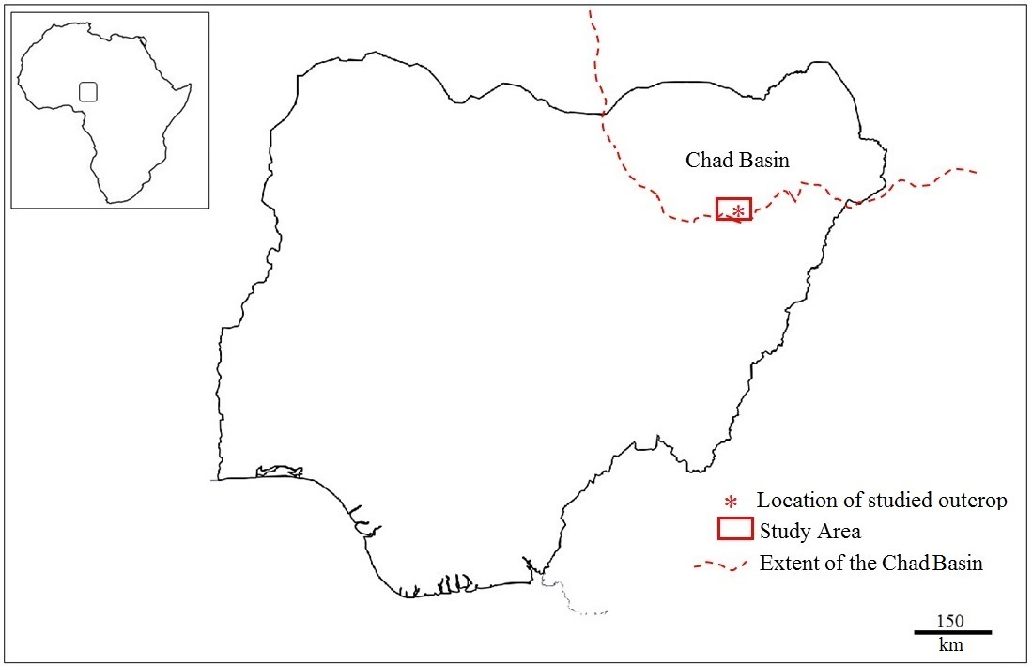
Figure 1. Outline map of Nigeria showing the study area. Note that the Chad Basin extends beyond Nigeria.

The Chad Basin in Nigeria is the southwestern part of the Chad Basin, which spreads to parts of the Republic of Niger, Chad Republic, Cameroon, and the Central African Republic (Fig. 1). Genetically, the Chad Basin in Nigeria is related to the West and Central African Rift Systems (WCARS), whose origin is generally associated with the Cretaceous fragmentation of Gondwana and the opening of the South Atlantic Ocean and the Indian Ocean (Fairhead, 1986). Hydrocarbon exploration in the Chad Basin in Nigeria has been ongoing since the late seventies, based on the occurrence of oil and gas in the Chad Republic, the Republic of Niger, and Cameroon. In the Chad Republic, production from the Doba discovery (with a projected one billion bbl of oil reserves) resulted in the development of a pipeline that is about 1070 km long, running through Cameroon to the Atlantic Coast. In the Republic of Niger, hydrocarbons have also been discovered in the East Niger Graben, which is structurally linked to the Benue, Chad, Sudan, and Libyan rift complexes (Genik, 1993; Mohamed et al., 1999; Habib and Xie, 2012). The Nigerian National Petroleum Corporation (NNPC), through its exploration services unit, the National Petroleum Investment Management Services (NAPIMS), has drilled 23 wells in the Nigerian segment of the Chad Basin with no commercial oil discovery.

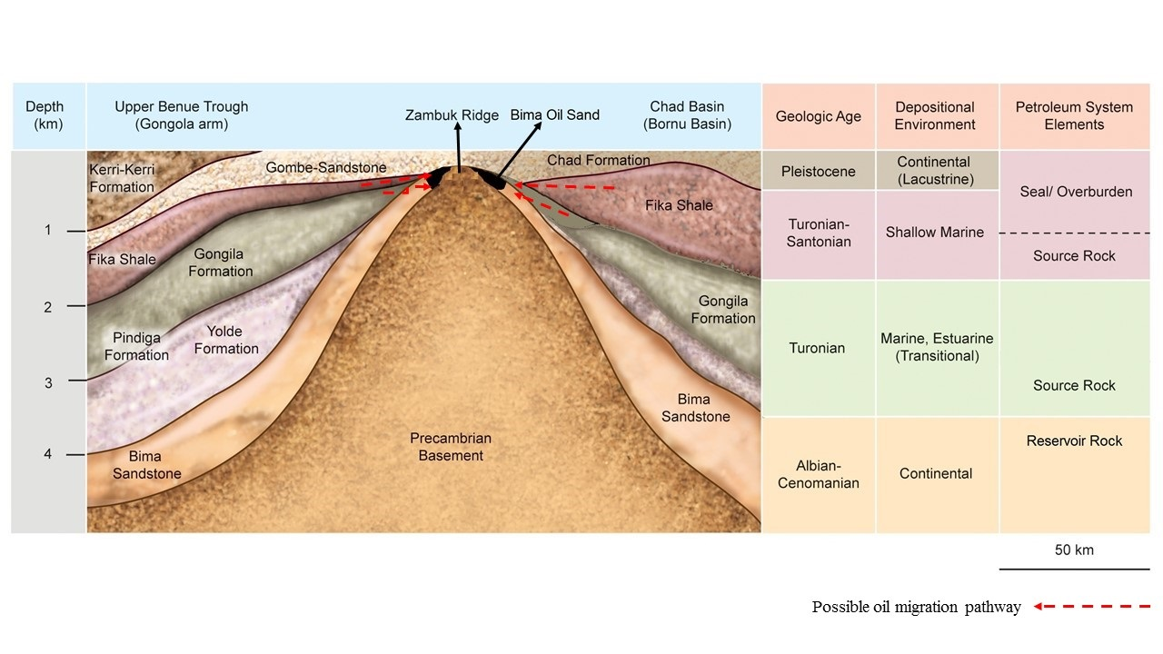 Figure 2. Schematic geological cross-section of the study area showing possible elements of a petroleum system in the Chad Basin, Nigeria. Note that the Bima oil sand occurs on the flank of the Chad Basin in Nigeria and the Zambuk Ridge that separates the Nigerian sector of the Chad Basin from the Gongola Arm of the Upper Benue Trough. Also note that juxtaposition of the Bima Formation against younger formations with oil generating capabilities (e.g., Gongila and Fika Formations) would allow lateral oil migration in the study area.

The Chad Basin in Nigeria is estimated to have about 6000 m of sediments with lower Cretaceous strata outcropping in the southern part of the basin. The Cretaceous successions occurring in the southern Chad Basin are clearly correlated with comparable strata in the Gongola arm of the Upper Benue Trough, which is separated from the Chad Basin by the Zambuk Ridge (Fig. 2). There is evidence of oil-generating, organic-rich sediments in both the Nigerian sector of the Chad Basin and the Upper Benue Trough (e.g., Olugbemiro et al., 1997; Akande et al., 1998; Obaje et al., 2004; Alalade and Tyson, 2010, 2013; Habib and Xie, 2012; Adegoke et al., 2014a; Boboye and Nzegwu, 2014). However, there is little or no published geochemical data on oil occurring in the reservoir rocks of either the Nigerian sector of the Chad Basin or the Upper Benue Trough. In this paper, we present for the first time field and geochemical descriptions of oils occurring in the Cretaceous Bima Formation of the Chad Basin, Nigeria. Apart from showing that the Cretaceous Bima oil sand is similar to other globally distributed Cretaceous oil sands, this study is also vital for understanding the petroleum system occurring in the Chad Basin in Nigeria.

2. Geological Setting
The Chad Basin in Nigeria represents nearly one-tenth of the entire area of the Chad Basin, which extends to parts of the Republic of Niger, Chad Republic, Cameroon, and the Central African Republic. It is believed to be genetically related to the Benue Trough, a NE–SW-trending abandoned rift basin (Olade, 1975; Adegoke et al., 2014b). The merging of the South Atlantic and Tethys seas through the Benue Trough and the Chad Basin in the late Cretaceous has been suggested to have controlled the deposition of sediments in the Chad Basin during the Cretaceous (Burke et al., 1970; Akande et al., 2012). The stratigraphic succession of the Nigerian sector of the Chad Basin is dominated by thick sedimentary successions that range in age from Albian to Pliocene (Petters, 1981; Whiteman, 1982; Okosun, 1995; Adegoke et al., 2014b) (Fig. 2).
Sedimentation commenced in the Chad Basin, Nigeria, during the Cretaceous global marine transgression with the deposition of the Bima Formation, which is a transgressive sequence comprising of poorly sorted, sparsely fossiliferous, medium- to coarse-grained sandstone, unconformably underlain by the Precambrian basement (Okosun, 1995). This basal succession is overlain by the marine Turonian Gongila Formation, composed of thin to reasonably thick bedded, grey to dark grey calcareous shales, silts, sandstones, and limestone. The Fika Formation (Turonian–Santonian) conformably overlies the Gongila Formation and is composed of blue-black, ammonite-rich shale, which is sometimes gypsiferous, with intercalations of thin limestone beds (Fig. 2). The Chad Formation, the youngest stratigraphic unit in the Chad Basin in Nigeria, unconformably rests on the Fika Formation. It consists of continental lacustrine and fluviatile facies, made up of Quaternary sedimentary (Pleistocene) sequences of fine- to coarse-grained sand and clay.

3. Methodology
Samples taken from an outcrop of the Bima Formation were solvent-extracted using 93:7 (v/v) dichloromethane and methanol. The extracted oils were then separated into saturate, aromatics, and polar fractions using thin layer chromatography. The saturate fraction was then examined by gas chromatography-mass spectrometry (GC-MS). The GC-MS analysis was carried out with an Agilent 6890N GC fitted with a J & W DB-5 phase 50-m-long column that is linked to a 5975 MSD and a quadruple mass spectrometer working in selected-ion monitoring (SIM) mode with ionization energy of 70 eV. Samples were manually injected with a split/splitless injector working in splitless mode (purge 40 ml min^{–1} for 2 min). The temperature range of the GC oven varied between 80 and 295 °C. The GC oven was held at the initial temperature of 80 °C for two minutes, increasing by 10 °C min^{–1} for 8 min, then by 3 °C min^{–1}, and finally at the highest temperature of 295 °C for 10 minutes. Compounds were identified by matching retention times to well-characterized materials that served as reference samples. The bulk and molecular composition of the oil extracted from the Bima oil sand were obtained in order to understand the source, thermal maturity, and extent of biodegradation in the extracted oils. Samples of other Cretaceous oil sands including the Huitrin Formation (Neuquén Basin Argentina), Captain Sand (Western Moray Firth Basin UK), Mannville Group (Western Canada Sedimentary Basin), Afowo Formation (Dahomey Basin Nigeria) and Mesaverde Formation (Utah USA) were also analysed and compared with the Bima oil sand.

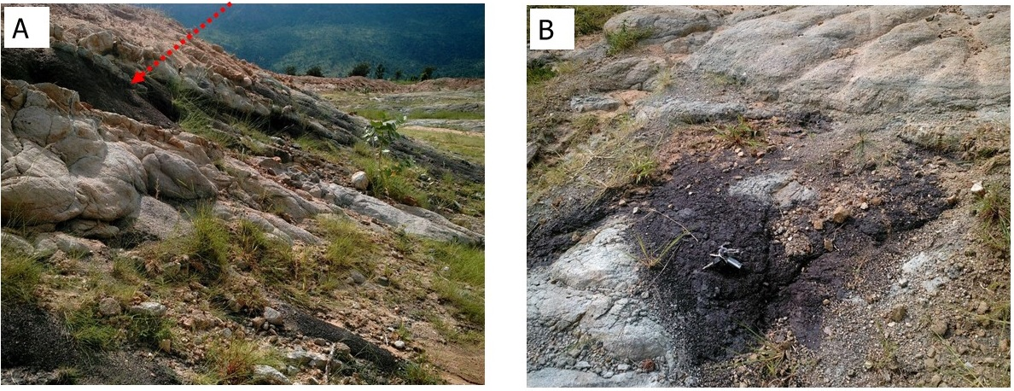
Figure 3. Field photographs showing (A) the Bima oil sand (red arrow) on the flank of hills scattered around the Zambuk Ridge and (B) the site of a passive oil seep close to Yaranduwa village, south of the study area.

4. Results
The sampling site of the Cretaceous Bima oil sand analyzed in this study is situated close to the village of Gamadadi in the Bayo area of Borno State in Nigeria. This locality is on the southern margin of the Chad Basin, Nigeria, near the Zambuk Ridge, which is the boundary between the Chad Basin in Nigeria and the Upper Benue Trough (Figs. 1 and 2). Here, The Bima Formation pinches out on the flanks of the Bima hills scattered around the Zambuk Ridge (Fig. 3A). The Bima Formation, which runs for over 240 km in the Chad Basin, Nigeria, extends into the Upper Benue Trough. The Bima Formation is divided into three lithologic units; the Lower Bima (B₁), Middle Bima (B₂) and Upper Bima (B₃) (e.g., Avbovbo et al., 1986; Yandoka et al., 2015). After an extensive field and sedimentological study of the Bima Formation in the southern Chad Basin in Nigeria and the Upper Benue Trough, Tukur et al. (2015) reclassified the Bima Formation into two members (Lower Bima and Upper Bima) against the known three members. The Lower Bima Sandstone member, which is the host rock of the heavy oil presented in this study, consists of pebble to coarse-grained, feldspathic sandstones with alternating clay and shale. The Upper Bima Sandstone member consists predominantly of tabular cross-bedded sandstone with parallel laminated sandstone and greenish mudstone.
South of the study area, there is evidence of hydrocarbon seepage close to Yaranduwa in the Gongola arm of the Upper Benue Trough (Fig. 3B). Oil seeps are good indicators of oil occurrence in the subsurface, and could reflect the migration of hydrocarbons.
The studied Bima oil sand shows evidence of biodegradation, as summarized in the ternary diagram presented in Figure 4. Total ion current (TIC) fragmentograms for two representative samples of the Bima oil sand (BOS 1 and BOS 2) are shown in Figure 4. The Cretaceous Bima oil sand is similar to other globally distributed Cretaceous oil sands that mostly occur unconformably on the Precambrian basement or much older sedimentary successions. TIC fragmentograms for oils extracted from some examples of the Cretaceous oil sands are also presented in Figure 4. These show unresolved complex mixture (UCM) humps that are typical of biodegraded oils (e.g., Gouch et al., 1992; Frysinger et al., 2003; Ventura et al., 2008; Parnell et al., 2015). Locations and oil bulk properties of these examples are given in Table 1.

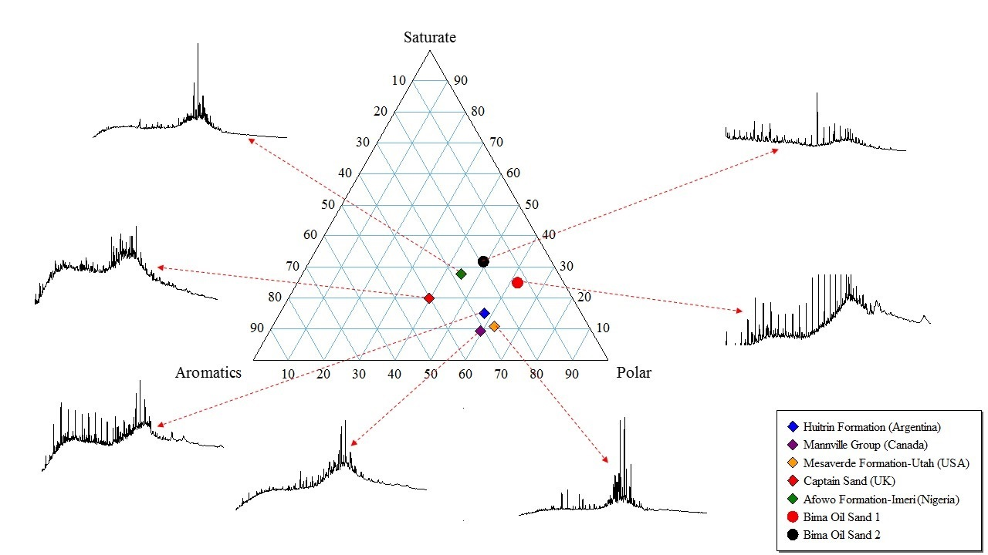
Figure 4. Ternary plot showing the bulk properties of oils extracted from the studied Cretaceous Bima oil sand and other representative Cretaceous oil sands. Oils extracted from the studied Cretaceous oil sands are enriched in the polar fraction, which is consistent with oils that have been biodegraded. Inserted total ion current (TIC) fragmentograms show unresolved complex mixture (UCM) “humps” also consistent with oils that have undergone biodegradation.

Sterane distributions for two representative samples of the Bima oil sand (BOS 1 and 2) are presented in Figure 5. Oils extracted from the Bima oil sand are low in diasteranes relative to regular steranes. This suggests that the oils were sourced from carbonate rocks which tend to have low diasterane/sterane ratios (Peters et al., 1993, 2005). The ternary plot of the relative amounts of C₂₇, C₂₈, and C₂₉ steranes in oils extracted from the Bima oil sand (Fig. 5) further suggests that the oils were sourced from marine carbonate rocks. The sterane maturity parameters, ααα C₂₇20S/(20S+20R), ααα C₂₈20S/(20S+20R), and ααα C₂₉20S/(20S+20R), are 0.89, 0.49, and 0.47, respectively, for BOS1, and 0.43, 0.52, and 0.46, respectively, for BOS2. These data are consistent with oils derived from source rocks that have thermal maturities equivalent to early and peak oil generation. The trisnorhopane thermal indicators (Ts:Tm ratio) for the studied samples are 0.90 (BOS1) and 0.93 (BOS2). This again suggests that the studied oils have thermal maturity levels consistent with oils generated within the oil window (e.g., Bata et al., 2015).
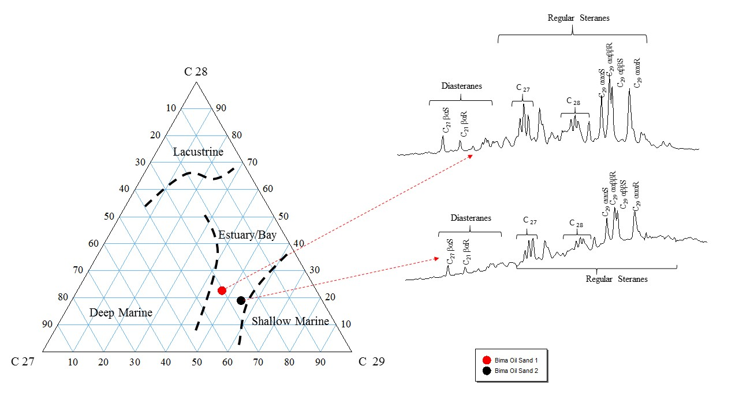
Figure 5. Ternary plot showing the relative amounts of C₂₇, C₂₈, and C₂₉ regular steranes in the studied Bima oils sand. Note that the inferred depositional environment for the source rock of the studied oils occurring in the Bima oil sand is marine (estuary/bay). Inserted m/z 217 fragmentograms of the two representative samples of the Bima oil sand show low diasterane/regular sterane ratios, suggesting a carbonate source rock for the oils occurring in the Bima oil sand.

The hopane characteristics of the studied oils are presented in the m/z 191 fragmentograms shown in Figure 6. The C₂₉H/C₃₀H ratios for the studied oils are 1.28 (BOS1) and 1.25 (BOS2). This further suggests that oils occurring in the Bima oil sand are sourced from a carbonate rock that was deposited in a normal saline environment (Peters et al., 2005). The C₃₂ homohopane isomerization ratios for the studied oils are 0.59 (BOS1) and 0.60 (BOS 2). This implies that the source rock for the oils occurring in the Bima oil sand has reached or exceeded the major oil-generating stage (Peters et al., 2005). There are no 25-norhopanes in oils extracted from the Bima oil sand. The presence of 25-norhopane in oils commonly indicates that biodegradation occurred at depth (Peters et al., 2005; Bennet et al., 2006). The 25-norhopanes are identified on the m/z 177 fragmentogram, and their appearance is observed at a lower retention time compared with the homohopanes on the m/z 191 chromatogram (López, 2014). No displacement in retention time is observed between the homohopanes on the m/z 191 fragmentograms and the matching norhopanes on the m/z 177 fragmentograms in the Bima oil sands (Fig. 6). To further demonstrate that oils occurring in other Cretaceous oil sands generally lack 25-norhopanes, the m/z 191 and m/z 177 fragmentograms of oils extracted from the Afowo Formation in Dahomey Basin (Nigeria) and the Mesaverde Formation in Utah (USA) are presented in Figure 7. Like the Cretaceous Bima oil sand, both the Afowo oil sand and the Mesaverde oil sand show no evidence of displacement in retention time between the homohopanes on the m/z 191 fragmentograms and the matching norhopanes on the m/z 177 fragmentograms. This implies that these other Cretaceous oil sands similarly have no 25-norhopane.

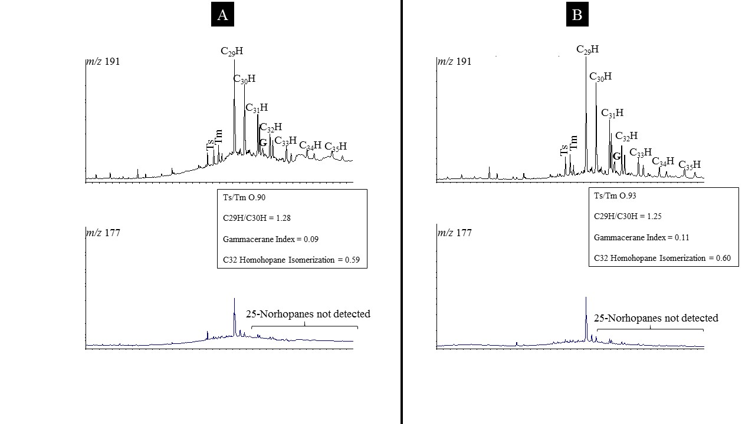
Figure 6. Fragmentograms (m/z 191 and m/z 177) for the studied oils: (A) Bima oil sand 1 and (B) Bima oil sand 2. Both samples show no displacement in retention time between the homohopanes on the m/z 191 fragmentogram and corresponding norhopanes on the m/z 177 fragmentogram. This suggests that there are no 25-norhopanes in the studied oils, implying that biodegradation occurred at shallow depth.

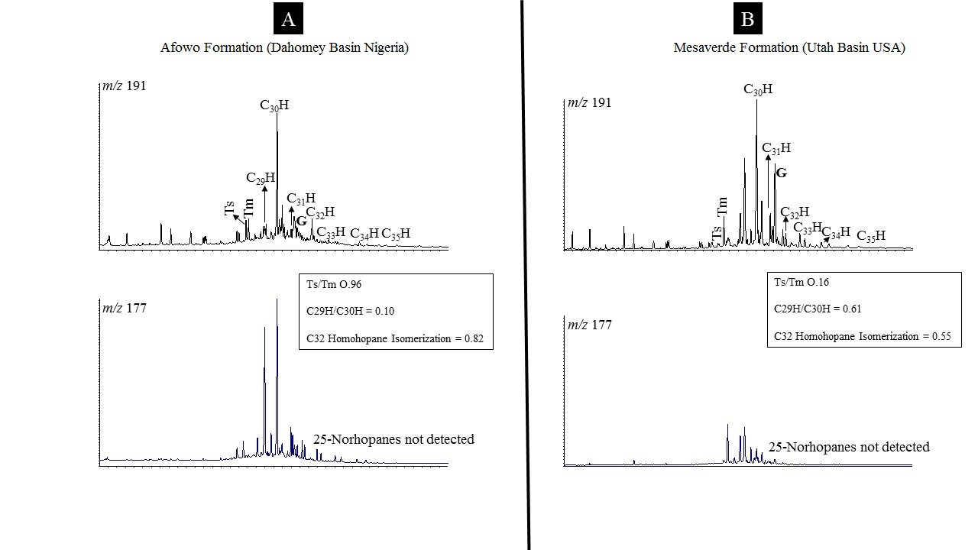
Figure 7. Fragmentograms (m/z 191 and m/z 177) of other Cretaceous oil sands: (A) Afowo Formation, Dahomey Basin (Nigeria) and (B) Mesaverde Formation, Utah Basin (USA). Both samples also show no evidence of 25-norhopane occurrence. This is similar to the Bima oil sand and no occurrence of 25-norhopanes in the Cretaceous oil sands, implying that biodegradation occurred at shallow rather than greater depths in the Cretaceous oil sand.

5. Discussion
Because global sea level was significantly high during the Cretaceous, expanded oxygen-minimum layers were developed in the Cretaceous seas (Arthur et al., 1979). Various widespread anoxic events that controlled deposition of organic-rich sediments (petroleum source rocks) occurred during the Cretaceous (e.g., Jenkyns, 1980, 2010; Bralower et al., 1994; Erba, 2004). The Cretaceous period also witnessed the landward movement of coastlines, which resulted in the deposition of transgressive sands unconformably on the Precambrian basement or much older sedimentary successions. Close interaction of these Cretaceous transgressive sands (e.g., the Bima Formation discussed in this study) with Cretaceous organic-rich sediments makes them suitable for hydrocarbon prospecting. The possibility of hydrocarbons migrating into such transgressive sand is high because the transgressive sands commonly occur above an unconformity. The underlying plane of unconformity serves as a migration pathway for long distance petroleum migration. There is field evidence showing cases of hydrocarbon migration over several hundreds of kilometers. For example, oil in the Athabasca oil sand is believed to have been derived from shale source rocks several hundred kilometers away from the reservoir sand (Head et al., 2003; Larter et al., 2006).
The occurrence of passive oil seepage in the study area (Fig. 3B) is of great significance to hydrocarbon exploration in both the Chad Basin in Nigeria and the Gongola arm of the Upper Benue Trough. This passive oil seepage suggests the existence of a petroleum system in both basins. The discovery of many of the world’s great oil fields, such as the eastern foothills of the Sierra de Perijá, the Lake Maracaibo Basin (Venezuela), the Dezful Embayment (SW Iran), and the Bagua Basin (north-central Peru) were a direct consequence of seepage drilling (Escobar et al., 2011; Salati et al., 2013; Gentzis, 2013). Samaila et al. (2008) have previously documented the occurrence of microstructures within the Bima Formation. These microstructures act as routes for oil migration in the study area, as seen in Figure 3B.
Bulk properties and the distribution patterns of molecular features in oils extracted from the two representative samples of the Bima oil sand suggest that these oils are biodegraded (Figs. 4, 5, and 6). The low diasterane/sterane ratio and the C₂₉H/C₃₀H ratio of greater than one for both oils strongly suggest that the source rock for the oil is a carbonate marine rock. Field evidence (e.g., Obaje et al., 2004, Obaje, 2009; Alalade and Tyson 2010; Adegoke et al., 2014b) has shown that the Fika Formation and the Gongila Formation, occurring in the Chad Basin in Nigeria, contain organically rich and thermally mature carbonate rocks. It is therefore possible that the oils occurring within the Bima Formation were sourced from the carbonate rocks in either the Gongila Formation or the Fika Formation, or both. Juxtaposition of the Bima Formation against younger source rock facies (Gongila and Fika Formations) would allow for lateral oil migration in the study area (Fig. 2).
There were no 25-norhopanes detected in the studied oils (Fig. 6). This strongly suggests that biodegradation in the Cretaceous Bima oil sands occurred at shallow depths rather than at greater depths, which is consistent with most Cretaceous oil sands also occurring at shallow depths and generally lacking seal covers (Bata et al., 2015). Petroleum biodegradation requires conditions that support microbial life, and is controlled by a range of factors including reservoir temperature, nutrient availability (nitrogen, potassium, and phosphorus), oil composition, the oil–water contact area, water salinity, and oil volume in the reservoir (Wenger et al., 2002; Larter et al., 2006). Since most Cretaceous oil sands occur at shallow depths, are usually cool, and lack proper seal covers (e.g., Figs. 2 and 3A), they are susceptible to biodegradation, as organisms capable of degrading hydrocarbons find the water they need alongside the electron donors and acceptors, as well as the carbon source (oil) necessary to provide energy and generate biomass. Where these Cretaceous reservoirs occur at depths greater than 2000 m and are properly sealed, it is possible to find non-biodegraded oils in them as long as they are connected to active source rocks and have good structures that result in oil traps (e.g., Wilhelms et al., 2001). The occurrence of reservoired oil within the Chad Basin in Nigeria is not restricted to the present study area, as there is documented evidence showing that the sand unit within the Gongila Formation encountered in the Tuma-1 well drilled by the NNPC has total organic carbon (TOC) values ranging between 0.88 and 1.89 (Alalade and Tyson, 2013). Such TOC values for sandstones could suggest the presence of oil in the pores of the sandstone (e.g., Bata and Parnell, 2014). It may therefore be possible to find more deeply buried non-biodegraded oils within the Chad Basin Nigeria, provided there are favorable structures that can form good petroleum traps.

6. Summary and Conclusions
This study reports the occurrence of a Cretaceous oil sand in the Chad Basin in Nigeria and also provides key information on the occurrence of a petroleum system in the Chad Basin in Nigeria. Specifically, this study demonstrates the following:
- The occurrence of the Cretaceous Bima oil sand in the Chad Basin in Nigeria is similar to other globally distributed Cretaceous oil sands.
- Like other globally distributed Cretaceous oil sands, the occurrence of the Bima Formation at shallow depths on the basin flank and without a seal cover makes it susceptible to biodegradation.
- The biomarker data presented in this study suggest that the studied oils were sourced from marine carbonate rocks. This suggests that the Fika Formation and/or the Gongila Formation are possible source rocks for the studied oils.
- As is the case in most Cretaceous oil sands, the studied oils show no evidence of 25-norhopane occurrence. This strongly implies that biodegradation in the studied oils occurred at shallow depths.
- Occurrence of passive oil seepage close to the study area confirms the existence of a petroleum system in the Chad Basin in Nigeria. It may therefore be possible to find non-biodegraded oils in parts of the basins where the Bima Formation or other reservoir rocks are more deeply buried, properly sealed, and have favorable structures that form good oil traps.

Acknowledgements
Timothy Bata is thankful to the Petroleum Technology Development Fund of Nigeria (PTDF) for sponsoring his PhD research at the University of Aberdeen, and the management of Abubakar Tafawa Balewa University, Bauchi, Nigeria, for permitting him to proceed on study leave. We are grateful to Colin Taylor for his help during laboratory work and S. Bowden for advice on the interpretation of the gas chromatographic data.

References
Adegoke, A.K., Abdullah, W.H., Hakimi, M.H., Yandoka, B.M.S., Mustapha, K.A., Aturamu, A.O., 2014a. Trace element geochemistry of kerogen in Upper Cretaceous sediments, Chad (Bornu) Basin, northeastern Nigeria: Origin and paleo-redox conditions. J. Afr. Earth Sci. 100, 675–683.
Adegoke, A.K., Abdullah, W.H., Hakimi, M.H., Sarki Yandoka, B.M., 2014b. Geochemical characterisation of Fika Formation in the Chad (Bornu) Basin, northeastern Nigeria: Implications for depositional environment and tectonic setting. Appl. Geochem. 43, 1–12.
Akande, S.O., Egenhoff, S.O., Obaje, N.G., Ojo, O.J., Adekeye, O.A., Erdtmann, B.D., 2012. Hydrocarbon potential of Cretaceous sediments in the Lower and Middle Benue Trough, Nigeria: Insights from new source rock facies evaluation. J. Afr. Earth Sci. 64, 34–47.
Akande, S.O., Ojo, O.J., Erdtmann, B.D., Hetenyi, M., 1998. Paleoenvironments, source rock potential and thermal maturity of the Upper Benue rift basins, Nigeria: implications for hydrocarbon exploration. Org. Geochem. 29, 531–542.
Alalade, B., Tyson, R.V., 2013. Influence of igneous intrusions on thermal maturity of Late Cretaceous shales in the Tuma well, Chad Basin, NE Nigeria. J. Afr. Earth Sci. 77, 59–66.
Alalade, B., Tyson, R.V., 2010. Hydrocarbon potential of Late Cretaceous Gongila and Fika Formations, Bornu (Chad) Basin, NE Nigeria. J. Pet. Geol. 33, 339–354.
Arthur, M.A., Schlanger, S.O., 1979. Cretaceous "Oceanic anoxic events" as causal factors in development of reef-reservoired giant oil fields. Am. Assoc. Pet. Geol. Bull. 63, 870–885.
Avbovbo, A.A., Ayoola, E.O., Osahon, G.A., 1986. Depositional and structural styles in Chad Basin of Northeastern Nigeria. Am. Assoc. Pet. Geol. Bull. 70, 1787–1798.
Bata, T., Parnell, J., Bowden, S., Boyce, A., 2015. Origin of Heavy Oil in Cretaceous Petroleum Reservoirs. In Press: Bull. Can. Pet. Geol.
Bata, T., Parnell, J., 2014. A Neoproterozoic petroleum system in the Dalradian supergroup, Scottish Caledonides. J. Geol. Soc. 171, 145–148.
Bennett, B., Fustic, M., Farrimond, P., Huang, H., Larter, S.R., 2006. 25-Norhopanes: Formation during biodegradation of petroleum in the subsurface. Org. Geochem. 37, 787–797.
Blakey, R.C., 2011. Global paleogeography. http://jan.ucc.nau.edu/~rcb7/globaltext2.html
Boboye, O.A., Nzegwu, U.A., 2014. Evaluation of bio-molecular signatures and hydrocarbon potential of upper Cretaceous Shale, NE Nigeria. J. Afr. Earth Sci., http://dx.doi.org/10.1016/j.jafrearsci.2014.04.014
Bralower, T.J., Arthur, M.A., Leckie, R.M., Sliter, W.V., Allard, D.J., Schlanger, S.O., 1994. Timing and paleoceanography of oceanic dysoxia/anoxia in the late Barremian to early Aptian (Early Cretaceous). Palaios 9, 335–369.
Burke, K., Dessauvagie, T. F. J., Whitman, A. J., 1970. Geological history of the Benue valley and adjacent areas, in: Dessauvagie, T.F.J., Whiteman, A.J. (Eds.), African Geology: Cretaceous Rocks of Nigeria and Adjacent Areas. University of Ibadan Press, Nigeria, pp. 187–205.
Coe, M.T., Costa, M.H., Botta, A.L., Birkett, C., 2002. Long-term simulations of discharge and floods in the Amazon Basin. J. Geophys. Res. 107 (D20), 8044. doi:10.1029/2001JD000740
DeConto, R.M., Pollard, D., Wilson, P.A., Pälike, H., Lear, C.H., Pagani, M., 2008. Thresholds for Cenozoic bipolar glaciation. Nature 455, 652–656.
Erba, E., 2004. Calcareous nannofossils and Mesozoic oceanic anoxic events. Marine Micropaleontology 52, 85–106.
Escobar, M., Márquez, G., Inciarte, S., Rojas, J., Esteves, I., Malandrino, G., 2011. The organic geochemistry of oil seeps from the Sierra de Perijá eastern foothills, Lake Maracaibo Basin, Venezuela. Org. Geochem. 42, 727–738.
Fairhead, J.D., 1986. Geophysical controls on sedimentation within the African Rift systems, in: Frostick, L.E. (Ed.), Sedimentation in the African Rifts. Geological Society of London, Special Publication, 25, 19–27.
Friedrich, O., Norris, R.D., Erbacher, J., 2012. Evolution of middle to Late Cretaceous oceans-A 55 m.y. record of Earth’s temperature and carbon cycle. Geology 40 (2), 107–110.
Frysinger, G.S., Gaines, R.B., Xu, L., Reddy, C.M., 2003. Resolving the unresolved complex mixture in petroleum-contained sediments. Environ. Sci. Technol. 37, 1653–1662.
Genik, G.J., 1993. Petroleum Geology of Cretaceous – Tertiary rift basins in Niger, Chad and central African republics. A.A.P.G. Bull. 77, 1405–1434.
Gentzis, T., 2013. Geochemical characterization of an oil seep from the Bagua Basin, north-central Peru. Int. J. of Coal Geol. 108, 18–26.
Gouch, M.A., Rhead, M.M., Rowland, S.J., 1992. Biodegradation studies of unresolved complex mixtures of hydrocarbons: model UCM hydrocarbons and the aliphatic UCM. Org. Geochem. 18, 17–22.
Habib, M., Xie, C., 2012. Nigeria’s inland basins: Investment opportunities and environment. Journal of Petroleum and Gas Exploration Research 2, 202–211.
Hay, W.W., 2008. Evolving ideas about the Cretaceous climate and ocean Circulation. Cretaceous Res. 29 725–753.
Head, I.M., Jones, D.M., Larter, S.R. 2003. Biological activity in the deep subsurface and the origin of heavy oil. Nature 426, 344–352.
Hein, F.J., 2006, Heavy oil and oil (tar) sands in North America: An overview and summary of contributions. Nat. Resour. Res., 15(2) 67–84, doi:10.1007/s11053-0069016-3.
Hein, F.J., Leckie, D., Larter, S., Suter, J.R., 2013, Heavy oil and bitumen petroleum systems in Alberta and beyond: The future is nonconventional and the future is now, in: Hein, F.J., Leckie, D., Larter, S., and Suter, J.R. (Eds.), Heavy Oil and Oil-sand Petroleum Systems in Alberta and Beyond: AAPG Studies in Geology 64, 1–21.
Huber, B.T., Norris, R.D., MacLeod, K.G., 2002. Deep-sea paleotemperature record of extreme warmth during the Cretaceous. Geology 38, 123–126.
Jenkyns, H.C., 1980. Cretaceous anoxic events: from continents to oceans. Journal of the Geological Society, 137, 171–188.
Jenkyns, H.C., 2010. Geochemistry of oceanic anoxic events. Geochem. Geophys. Geosyst. 11, 1–30.
Jenkyns, H.C., Forster, A., Schouten, S., Damsté, J.S.S., 2004. High temperatures in the late Cretaceous Arctic Ocean. Nature 432, 888–892.
Kominz, M.A., Browning, J.V., Miller, K.G., Sugarman, P.J., Mizintseva, S., Scotese, C.R., 2008. Late Cretaceous to Miocene sea‐level estimates from the New Jersey and Delaware coastal plain coreholes: An error analysis. Basin Res. 20, 211–226.
Larter, S., Huang, H., Adams, J., Bennett, B., Jokanola, O., Oldenburg, T.B.P., Jones, D.M., Head, I.M., Riediger, C., Fowler, M. 2006. The controls on the composition of biodegraded oils in the deep subsurface: Part II – Geological controls on subsurface biodegradation fluxes and constraints on reservoir-fluid property prediction. Am. Assoc. Pet. Geol. Bull. 90, 921–938.
López, L., 2014. Study of the biodegradation levels of oils from the Orinoco Oil Belt (Junin area) using different biodegradation scales. Org. Geochem. 66, 60–69.
Mohamed, A.Y., Pearson, M.J., Ashcroft, W.A., Illiffe, J.E., Whiteman, A.J., 1999. Modeling petroleum generation in the southern Muglad rift basin, Sudan. Am. Assoc. Pet. Geol. Bull. 83:1943–1964.
Obaje, N.G., 2009. Geology and mineral resources of Nigeria (Vol. 120). Springer Science & Business Media.
Obaje, N.G., Wehner, H., Hamza, H., Scheeder, G., 2004. New geochemical data from the Nigerian sector of the Chad basin: implications on hydrocarbon prospectivity. J. Afr. Earth Sci. 38, 477–487.
Okosun, E.A., 1995. Review of the geology of Nigerian sector of the Chad Basin. J. Min. Geol. 31, 113–122.
Olade, M.A., 1975. Evolution of Nigeria’s Benue Trough (Aulacogen): A tectonic model. Geol. Mag. 112, 575–583.
Olugbemiro, R.O., Ligouis, B., Abaa, S.I., 1997. The Cretaceous series in the Chad basin, NE Nigeria: Source rock potential and thermal maturity. J. Pet. Geol. 20, 51–68.
Parnell, J., Bellis, D., Feldmann, J., Bata, T., 2015. Selenium and tellurium enrichment in palaeo-oil reservoirs. J. Geochem. Explor. 148, 169–173.
Peters, K.E., Walters, C.C., Moldowan, J.M., 2005. The Biomarker Guide: Biomarkers and Isotopes in Petroleum Exploration and Earth history (Vol. 2). Cambridge University Press.
Peters, K.E., Moldowan, J.M., 1993. The Biomarker Guide: Interpreting Molecular Fossils in Petroleum and Ancient Sediments. Prentice Hall, Englewood Cliffs, NJ.
Petters, S. W., 1981. Stratigraphy of Chad and Iullemmeden basins (West Africa). Eclogae Geologi Helvetiae 74, 139–159.
Salati, S., van Ruitenbeek, F.J., Carranza, E.J.M., van der Meer, F.D., Tangestani, M.H., 2013. Conceptual modeling of onshore hydrocarbon seep occurrence in the Dezful Embayment, SW Iran. Mar. Pet. Geol. 43, 102–120.
Samaila, N.K., Dike, E.F.C., Obaje, N.G., 2008. Microstructures in the Cretaceous Bima Sandstone, Upper Benue Trough, NE Nigeria: Implication for hydrocarbon migration. J. Afr. Earth Sci. 50, 6–15.
Tukur, A., Samaila, N.K., Grimes, S. T., Kariya, I.I., Chaanda, M.S., 2015. Two Member Subdivision of the Bima Sandstone, Upper Benue Trough, Nigeria: Based on Sedimentological Data. Journal of African Earth Sciences, 104, 140–158.

Ventura, G.T., Kenig, F., Reddy, C.M., Frysinger, G.S., Nelson, R.K., Van Mooy, B., Gaines, R.B., 2008. Analysis of unresolved complex mixtures of hydrocarbons extracted from Late Archean sediments by comprehensive two-dimensional gas chromatography (GC × GC). Org. Geochem. 39, 846–867.
Wenger, L.M., Davis, C.L., Isaksen, G.H., 2002. Multiple controls on petroleum biodegradation and impact in oil quality. SPE Reservoir Evaluation and Engineering 5, 375–383.
Whiteman, A.J., 1982. Nigeria: Its Petroleum Geology, Resources and Potential, 1 and 2. Graham and Trotman, London.
Wilhelms, A., Larter, S.R., Head, I., Farrimond, P., Di-Primio, R., Zwach, C., 2001. Biodegradation of oil in uplifted basins prevented by deep-burial sterilization. Nature, 411(6841), 1034–1037.
Yandoka, B.M.S., Abdullah, W.H., Abubakar, M.B., Hakimi, M.H., Adegoke, A.K., 2015. Geochemical characterisation of Early Cretaceous lacustrine sediments of Bima Formation, Yola Sub-basin, Northern Benue Trough, NE Nigeria: Organic matter input, preservation, paleoenvironment and palaeoclimatic conditions. Marine and Petroleum Geology, 61, 82–94.

Table 1. Bulk properties, location, and geological age of Cretaceous oil sand samples.
S/No  Sample Code | Country | Locality | Name & Age of Cretaceous Strata | Saturate  % | Aromatics % | Resin % | Asphaltene %
1 | Argentina | Neuquén Basin | Huitrin Formation  (Aptian) | 15.3 | 27.1 | 31 | 26.6
2 | United Kingdom (UK) | Western Moray Firth Basin | Captain Sand  (Aptian) | 20 | 40.4 | 20.8 | 18.8
3 | Canada | Western Canadian Sedimentary Basin | Mannville Group  (Albian) | 9.4 | 31.3 | 26.6 | 32.7
4 | Nigeria | Dahomey Basin  (Imeri) | Afowo Formation  (Turonian) | 28 | 27.3 | 18.5 | 26.2
5 | United States of America (USA) | Near Vernal, Utah | Mesaverde Formation  (Albian) | 11.1 | 26.4 | 28.6 | 33.9
6 | Nigeria | Chad Basin | Bima Formation  (Aptian) | 25 | 13 | 31 | 28
7 | Nigeria | Chad Basin | Bima Formation  (Aptian) | 32 | 19 | 25 | 24

Figure 1
Figure 2

Figure 3

Figure 4

Figure 5

Figure 6

Figure 7

