A framework for reliability assessment of ship hull damage under ship bow impact
Abayomi Obisesanª, Srinivas Sriramulaª, John Harriganª
ª Lloyd’s Register Foundation (LRF) Centre for Safety and Reliability Engineering, School of Engineering, University of Aberdeen, Aberdeen AB24 3UE, United Kingdom
Corresponding author: Dr. Srinivas Sriramula, Email: s.sriramula@abdn.ac.uk, Tel: +44(0)1224272778

word count: 10,556
A framework for reliability assessment of ship hull damage under ship bow impact
Abayomi Obisesan, Srinivas Sriramula, John Harrigan
Lloyd’s Register Foundation (LRF) Centre for Safety and Reliability Engineering, School of Engineering, University of Aberdeen, Aberdeen AB24 3UE, United Kingdom
ABSTRACT
Ship collision analysis outcomes are generally used in computational models to derive damage distributions. However, damage is usually assessed after the collision energy has been fully absorbed by structural members rather than at the onset of outer hull fracture. Furthermore, the deformation behaviour of ship structural members under load depends on uncertainty modelling through material, geometric, and structural considerations, captured in an appropriate reliability framework. To consider these significant missed opportunities in understanding the probability of ship structures meeting their performance targets during collisions, a novel stochastic framework is proposed in this paper. For efficient reliability computations, a plate resistance model is developed for hull damage assessment at the onset of failure. Stochastic modelling capabilities of Python scripting are interfaced with Abaqus® to compute the stochastic response. The reliability computations show that the probability of hull fracture increases as the hull deformation progresses, with maximum values occurring at the onset of outer hull fracture. The framework outcomes are useful in determining optimal ship structural design capabilities.
Keywords: ship collision; hull damage; numerical simulation; structural reliability; analytical model

NOMENCLATURE
${ σ}_{0}$ Flow stress
$F_{N}$ Collision frequency
$N_{A}$ Number of ship collisions
$P_{c}$ Causation probability
$R_{b}$ Bow parameter
$S_{x}$ Sensitivity index of variable $x$
$b_{c}$ Cruciform flange width
$b_{w}$ Web girder half-width
$δ_{f}$ Failure displacement
$ε_{c}$ Critical strain
$σ_{u}$ Ultimate stress
$σ_{y}$ Yield stress
COV Coefficient of Variation
FEM Finite element method
FORM First Order Reliability Method
MCS Monte Carlo Simulation
PDF Probability Density Function
SAM Simplified Analytical Model
$L$ Parabloid bow length
$R$ Parabloid bow horizontal radius
$a$ Plate half-length
$b$ Plate half-width
$c$ Sum of Cruciform flange widths
$r$ Spherical bow radius
$t$ Thickness
$α$ Paraboloid bow curvature in the x-direction
$β$ Paraboloid bow curvature in the y-direction
$δ$ Displacement
$θ$ Plate angular displacement
$λ$ Effective length factor

1: INTRODUCTION
The increase in energy and commodity demand worldwide has led to a rise in the number and size of ships plying in new and existing shipping routes. This rise has in turn led to an increase in the probability of sea accidents which poses a threat to personnel, marine biodiversity, structural assets and reputation of companies. Efforts are being made to step up proactive measures for preventing the occurrence of ship collision, but unfortunately, ship collisions still happen. Such occurrences reiterate the importance of accurately assessing the structural performance of ships during collisions (Youssef et al. 2015).
The analysis of ship collision can be done by performing three tasks: evaluation of the energy dissipated during a collision; evaluation of the energy absorbed by the structural members of involved ships and their deformation mechanism; and, estimation of the likelihood of damage to the involved ships given the occurrence of a collision (Zhang 1999). The first two tasks are achievable from the study of external dynamics and internal mechanics, respectively. The external dynamics is concerned with the global rigid body motion analysis of the struck and striking ships as well as the resulting energy dissipated during a collision. The principles of conservation of momentum and energy are the tools used to analyse the collision, by evaluating the impulse of force causing changes to the momentum of the ships involved. The internal mechanics is concerned with the local deformation of the structural members and their response during a collision. The energy absorbed by each member is calculated by applying the virtual work theorem on their kinematically admissible deformation mechanisms (Lu and Yu 2003).
The inclusion of the probability of damage allows for the quantification of the likelihood that damage would occur during a collision event, through the consideration of uncertainties in the loads applied and in the capacity of ship structures (Béghin 2013). The result of this calculation is useful for assessing the structural performance of ships during collisions and for establishing an acceptable level of ship structural integrity. The probability of damage would consider the total probability of separate events that could result in damage. Damage could come from events such as grounding, stranding, ship contact with offshore structures and ship-to-ship contact. By applying the law of total probability, the probability of damage can be derived as:
$P\left(damage\right)= \left[P\left(\left.damage\right|collision\right).P\left(collision\right)\right]+\left[P\left(\left.damage\right|grounding\right).P\left(grounding\right)\right]+\left[P\left(\left.damage\right|contact\right).P\left(contact\right)\right]+\left[P\left(\left.damage\right|stranding\right).P\left(stranding\right)\right].$ (1)
The focus of this paper is the first term of Eq. 1. The evaluation of $P\left(\left.damage\right|collision\right)$ quantifies damage during a collision. The probability is a function of collision scenario parameters and the particulars of the struck ship and the striking ship. There are models available in the literature that have considered the random behaviour of collision scenario parameters and the particulars of the struck ship and the striking ship (Lutzen 2001; Brown 2002; Youssef et al. 2013; Youssef et al. 2014a). The collision damage analysis reported by Lutzen (Lutzen 2001) gave an expression for $P\left(\left.damage\right|collision\right)$, and used the probability distribution of its components as input to a collision computation model. These components are classified in three categories: probability of the type, length, loading and bow shape of the colliding ship; probability of the collision scenario parameters, such as collision angle, striking location, velocity of the struck ship and colliding ship; and, probability of damage given that the collision scenario parameter conditions are met. Uncertainties in collision scenarios and the particulars of colliding ships were quantified from the statistical data of historical ship losses, such as the IHS Fairplay world casualty statistics series (IHS Fairplay 2012). The resulting probabilistic collision scenarios serve as an input to collision computation models to obtain distributions for damage length, damage height, penetration and deformation energy.
In some studies, it was stated that the probability of a collision $\left(P\left(collision\right)\right)$ between two ships is an exponential function of the frequency of ship-ship collision. The frequency of ship-ship collision $\left(F_{N}\right)$ is calculated by (Goerlandt and Kujala 2014):
$F_{N}= P_{c}N_{A},$ (2)
where $P_{c}$ is the causation probability and $N_{A}$ is the number of ship collisions if no aversive action is taken. The probability $P_{c}$ is estimated by considering the logic of the chain of actions, inactions and external contributions resulting in a collision. The interaction of lower level events leading up to the top event is usually captured using tools like fault tree analyses and Bayesian belief networks (Lutzen 2001). Examples of lower level events are human factors, environmental conditions, instrumentation and mechanical status of the ships, traffic type and management of the shipping route. The value of $N_{A}$ is estimated by simulating marine traffic based on the trajectory of ships plying a particular route. The goal of the simulation was to identify cases where ships from two different routes come in contact (Goerlandt and Kujala 2014). Therefore, $N_{A}$ is a function of the shipping route, speed, size, type of ships and the time frame when the study was performed.
The resulting damage distributions from the existing collision computation models are evaluated after certain criteria are met. An example of such criteria is when the kinetic energy loss (estimated from the external dynamics) equals the total energy absorbed by the struck ship structural members (estimated from internal mechanics). However, these analyses derive distributions by considering the maximum penetration of the colliding bow. This type of approach overlooks a very important aspect, the point at which a pre-defined failure first initiates. The study by Ståhlberg et al. (2013) compared the deformation energy of a ROPAX vessel at the onset of inner and outer hull breach with those of different collision scenarios to estimate the probability of hull breach for the vessel during a collision. Youssef et al. (2014b) developed risk-based exceedance curves by considering the deformation energy, damaged volume and the penetration of a striking bow into a ship hull until the rupture onset of the outer and inner side shell plates. Therefore, the investigation of the onset of failure in collision consequence analysis will increase the existing knowledge in probabilistic ship collision analysis as it provides valuable information such as: the probability of ship structures meeting their performance target during collisions; most probable design point of ship structural properties for optimum risk-based design; and, significance of variables according to their level of influence on ship deformations during collisions. Such information will also be helpful to the decision maker for reviewing the structural characteristics. However, a large number of uncertainties at various levels complicate the performance assessment.
The analyses of ships during collisions involve deformation mechanisms of different structural members. The behaviour of these members is dependent on the load type, material and geometric properties. Uncertainties of load types have so far been considered through the probabilistic quantification of collision scenario random variables. However, uncertainties of material and geometric properties are overlooked and have been represented by their deterministic values (Samuelides 2015). The novelty of this paper is in developing a framework to assess the ability of ship structural members fulfilling significant design criteria, focusing specifically at the onset of outer hull rupture, by considering the likely source of uncertainties in their material and geometric properties.
The framework is developed by combining response surface methodologies, numerical simulations, simplified analytical computations and Advanced Structural Reliability Methods (ASRM) to assess the possibility of achieving the desired performance functions by ship structures. The deformation mechanism of the reference hull structure is simulated with non-linear finite element software, Abaqus®. Simplified analytical models (SAM) of structural members are combined to assess the resistance of a reference hull structure subjected to a bulbous bow impact. Four different simplified analytical models are developed and compared with the numerical simulation result. The analytical models are developed with respect to the idealisation of the bulbous bow geometries; spherical, circular and elliptical parabolic bows. For the purpose of reliability assessment, a single SAM expression to assess the resistance of shell plates from a spherical bow impact is developed in the present study.
Uncertainties associated with the material and geometric properties of structural members are statistically quantified and then represented by their resulting probabilistic characteristics. Abaqus® is interfaced with the Python programming language for the purpose of sampling a hull structure impact model with several probabilistic design sets of the material and geometry variables. The outcomes of these simulations are several critical displacement data at outer hull rupture that can either be indexed directly or fitted with a suitable probability density function for sampling and gradient based reliability assessment, respectively, to evaluate the reliability index and the probability of hull fracture during a collision. Sensitivity analysis is also carried out using Sobol’s first-order indices to determine the importance of the input variables on damage variation.

1.2: Overview of the Proposed Framework
A framework is developed for the reliability assessment of ship structures during collisions. The performance target of the framework is to maximise the operational reliability of ships by predicting their structural reliability with the consideration of associated uncertainties in material and geometric properties that may influence the behaviour of ship structural members during collisions.
As shown in Figure 1, inputs to the assessment procedure come from two independent analyses. First is the analysis of the reference hull structure using numerical simulation and SAM methods. The outcome of the analysis provides a basis for deciding the failure criteria of the framework, that is, the critical displacement value at which the outer hull starts to rupture. Secondly, probabilistic analysis is carried out to quantify the uncertainties present in the geometric and material properties of the hull structural material. The outcome of the analysis is the creation of input space design sets that will be used to sample the numerical simulation and SAM expressions.
The advanced structural reliability module comprises of two sections; the Response Surface Methodology (RSM) and Structural Reliability Assessment (SRA). RSM involves the creation of SAM objective functions, automation of the numerical simulation input files and probabilistic sampling to evaluate the critical displacement value at the onset of outer hull fracture for each design set. SRA involves the creation of limit state functions by comparing the results of RSM with the assigned hull failure criteria. The limit state functions are evaluated using Monte Carlo Simulations (MCS) and gradient based methods such as FORM/SORM techniques to quantify whether or not fracture initiates in the hull structure.
The investigation of ship structural performance at the onset of rupture in the outer hull provides a new way of modelling ship structure material and geometric variables to quantify the possibility of damage during collisions and to determine optimal ship structural design capabilities. To demonstrate the functionality of the framework, it is applied to study the resistance of a ship hull to a bulbous bow impact in the following sections. Assumptions are made in the study to illustrate the effect of material and geometric random variables on the reliability of ships during collisions; the bulbous bow is assumed to be normal to the ship hull, the struck ship is static during the analysis and the location of impact is constant in all collision cases.

2: SIMPLIFIED ANALYTICAL FORMULAE FOR IMPACT RESISTANCE
The hull structure of ships usually comprise of the shell plating which could be single or double for mono-hull and double-hull structures, respectively. They also have a system of web girders to support the hull plating, and are classified as transverse frames and longitudinal stringers, as shown in Figure 2. The intersection of the frames and stringers is of importance in SAM analysis as the behaviour of members in this region significantly contributes to the impact resistance of the hull structure. The type of intersection commonly found in the plane of ship impact is the cruciform. Hence, the basic members of a ship hull structure are the hull plating, cruciform and web girder.
The material response of hull structural members during loading is dominated by plastic deformation. Therefore, plasticity theories are used to idealise the behaviour of these materials by expressing their stress-strain relationship through SAM equations (Lu and Yu 2003). The geometric construction of the idealised behaviour has to be kinematically admissible for the distribution of the velocity/displacement field, which are used to calculate the rate of internal energy dissipated by the structural members. Due to the importance of linear hardening in the plastic region of the stress-strain relationship, the stress value of the material in this region is usually represented by an average value, often called flow stress $\left(σ_{0}\right)$. For the sake of simplicity, the flow stress is usually characterised by an average value of the yield and ultimate stresses. The resistance of the hull structural members is discussed further.

2.1: Shell plating resistance
The shape of the striking ship bow is of importance in the evaluation of impact resistance, particularly when establishing the resistance-displacement relationship for the shell plating. The bulbous bow of the striking ship has been idealised in different forms such as, point load, sphere, circular and elliptical paraboloids. Zhang (1999) and Buldgen et al. (2012) idealised the bow as a point load and established the resistance expressions for rectangular plates subjected to transverse and oblique impacts, respectively. Simonsen and Lauridsen (2000) and Wang et al. (1998) idealised the bow as a sphere and developed resistance expressions for plate impact. Zhang (1999) and Haris and Amdahl (2012b) presented rectangular plate resistance to impact from circular and elliptical paraboloid idealised bows. The former introduced a bow parameter from the equation of a paraboloid in the x-y plane. The parameter is characterised by the ratio of the square of the paraboloid base radius and the paraboloid length. Therefore, the resistance of a rectangular plate from a circular paraboloid impact is given as:
$F_{p}=1.54{ σ}_{0}tδ\left[\left(\frac{b}{a}+\frac{a}{b}\right)+3\left(\frac{R_{b}δ}{a^{2}}+\frac{R_{b}δ}{b^{2}}\right)+6\left({\left(\frac{R_{b}δ}{a^{2}}\right)}^{2}+{\left(\frac{R_{b}δ}{b^{2}}\right)}^{2}\right)\right],$ (3)
where $a$, $b$, $t$, $δ$ are the plate length, breadth, thickness, displacement respectively, and $R_{b}$ is the bow parameter. Haris and Amdahl (2012b) extended the work of Zhang (1999) by considering the possibility of different bow curvatures in the abscissa and ordinate directions. Dimensionless bow parameters were introduced from the equation of an elliptical paraboloid, with the equation dependent on the dimensions of the shell plating. The dimensionless bow parameter was characterised by the ratio of $R_{b}$ and the plate dimension either in abscissa or ordinate directions. Therefore, the resistance of a rectangular plate from an elliptical paraboloid impact is given as:
$F_{p}=1.54 σ_{0} tδ\left[\frac{b}{a}{\left(1-\frac{αδ}{a}\right)}^{{-1}/2}+\frac{a}{b}{\left(1-\frac{βδ}{b}\right)}^{{-1}/2}\right],$ (4)
where $α$ and $β$ are the dimensionless curvature parameters of the elliptical paraboloid in the x- and y- directions respectively. Eq. 4 is limited in its application because complex values of resistance force are derived when at least one of the bracketed expressions come out as a negative value or, simply put, when the displacement value is greater than the ratio of the plate dimension and the dimensionless parameter. Wang et al. (1998) and Simonsen and Lauridsen (2000) developed two separate expressions for the resistance force and displacement when a plate is impacted by a spherical bow, with the sphere radius $\left(r\right)$ being the bow parameter. The derivation process of both studies was quite similar and they were found to have good agreement with experimental and numerical simulation results. The two expressions were functions of the plate angular displacement, $θ$ and are given as (Wang et al. 1998):
$F_{p}=πσ_{0} ta\left[\sin{θ}+\frac{r}{a}\sin^{2}{θ}\right],$ (5)
$δ=a\left[\tan{θ}+\frac{r}{a}\left(1-\frac{1}{\cos{θ}}\right)\right].$ (6)
From the reliability assessment point of view, the separated expressions of resistance and displacement are not advantageous as that it would introduce additional complexities in the analysis. This is the motivation for the development of a single expression for plate deformation by spherical bow indentation in the present work. Details of the derivation are provided in the following section.

2.2: Resistance force–displacement expression of a circular plate impacted by a spherical indenter
A circular plate subjected to transverse loading by a spherical indenter at its centre is considered, as shown in Figure 3. The spherical indenter is defined by a three-dimensional equation, but the indenter is described in a two-dimensional axis (i.e., the equation of a circle) in order to simplify the analysis:
$x^{2}+y^{2}= r^{2} ,$ (7)
where $r$ is the radius. Half of the assumed deformation is analysed and this is defined by two sections; first is the area of the plate touched by the indenter and the second is the area of the plate not touched by the indenter but still experienced deflection (Zhang 1999). The deformation functions for the two sections are respectively defined as:
$w_{1}= δ- \frac{y}{\sqrt{r^{2}- y^{2}}} ,$ (8)
$w_{2}= δ_{1}\left[\frac{y_{2}-y}{y_{2} -y_{1}}\right] .$ (9)
The upper-bound theorem equilibrium equation is applied to determine the reaction force and the von Mises yield criterion to define the strain rate:
$F_{p}\dot{δ}= \frac{2}{\sqrt{3}}σ_{0}t\left[\iint_{θ y}{{\dot{ε}}_{1}y dydθ}+ \iint_{θ y}{{\dot{ε}}_{2}y dydθ}\right] .$ (10)
The strains are:
$ε_{1}= \frac{1}{2}{\left(\frac{∂w_{1}}{∂y}\right)}^{2}= \frac{y^{2}}{2\left(r^{2}- y^{2}\right)} ,$ (11)
$ε_{2}= \frac{1}{2}{\left(\frac{∂w_{2}}{∂y}\right)}^{2}= \frac{2δ_{1}^{2}{\left(y_{2}-y\right)}^{2}}{{\left(y_{2} -y_{1}\right)}^{4}} .$ (12)
Strain rates are determined from the derivatives of the strains with respect to the time-dependent parameters, $y_{1}$ and $δ_{1}$. Expressions of the two parameters are determined by considering the equality of the deformation functions derivative at the separating point $\left(y=y_{1}\right)$ and similar triangle theory:
$y_{1}= \frac{2 δ r}{\sqrt{4δ^{2}+ y_{2}^{2}}} ,$ (13)
$δ_{1}= δ\left[1-\frac{2 δ r}{a \sqrt{4δ^{2}+ y_{2}^{2}}}\right] .$ (14)
By substitution of the resulting expressions into Eq. 10 and through some derivations, the resistance force - displacement results in a complex equation and this is simplified using the mathematical computation software, Maple®. The resistance expression is evaluated as:
$F_{p}=\frac{2.42σ_{0}tδ}{a^{2}{\left(ak-2rδ\right)}^{3}k^{4}} \left[a^{11}k+12a^{9}kδ^{2}+48a^{7}kδ^{4}+64a^{5}kδ^{6}-96a^{5}r^{2}kδ^{4}+240a^{3}r^{4}kδ^{4}-384a^{3}r^{2}kδ^{6}-704ar^{4}kδ^{6}-8a^{8}rδ^{3}-80a^{6}r^{3}δ^{3}-64a^{6}rδ^{5}+128a^{4}r^{3}δ^{5}-128a^{4}rδ^{7}+1792a^{2}r^{3}δ^{7}-192a^{2}r^{5}δ^{5}+384r^{5}δ^{7}\right] ,$ (15)
$k= \sqrt{4δ^{2}+ a^{2}} ,$ (16)
where $y_{2}=a$ and it is the half-length of the plate. In this study, circular paraboloid and spherical bows are analysed.
The developed model is compared with the result of the plate indentation test carried out by Lee et al. (2004). The basic data of the test is presented in Table 1. The comparison of the force-displacement curves derived from the present model and that of the experiment is shown in Figure 4. The comparison shows a good agreement between both the results.

2.3: Web girder and cruciform resistance
The deformation mechanism of web girders involves membrane stretching and the formation of in and out of plane hinge lines which results in web folding. Several authors have suggested methods to describe the response of web girders during in-plane loading. Their solutions are classified with respect to the folding mechanism description of the web girders (Hong 2008). The works of Wierzbicki and Culbertson Driscoll (1995) and Zhang (1999) reflect the first mechanism where they idealised that out-of-plane folding would occur only on one side of the initial plane and folding length will be the same for subsequent folds. Simonsen and Ocakli (1999) proposed the second mechanism by describing the deformation mechanism to contain two out-of-plane foldings. Hong and Amdahl (2008) proposed the third mechanism based on the idealisation that the inclination of the second fold after the first fold flattens would increase the folding length to be considered when evaluating the web girder resistance. Hong and Amdahl (2008) also compared the three mechanisms discussed above and found that they agreed well with experimental results presented by Kuroiwa (1993) and Simonsen and Ocakli (1999). The proposed mean resistance of web girder during axial loading by Zhang (1999) is taken forward as it is appropriate for the thickness of web girders considered in this study:
$F_{w}=\frac{3.25}{λ}σ_{0}t^{1.67}{b_{w}}^{0.33},$ (17)
where $b$ and $t$ are the half-width and thickness of the web girder respectively, and $λ$ is the effective length factor that characterises the incomplete compression of the folding web lobe. A value of 0.75 is normally assigned for $λ$ and this is used in this study (Abramowicz 1983).
The crushing mechanism of web intersections has been investigated by several authors. Amdahl (1983) effectively described the symmetric and the asymmetric collapse modes of a cruciform in order to derive its mean crushing strength. Yang and Caldwell (1988) used the concept of the basic folding mechanism of angled elements to derive the mean crushing force, and this was eventually adapted to the cruciform by joining the angled elements along their vertical edges. Kierkegaard (1993), Santosa and Wierzbicki (1998), Zhang (1999) and Urban (2003) have adapted the studies described above to propose mean crushing resistances for the cruciform during a collision. The proposed mean crushing resistance of the cruciform by Zhang (1999), which accommodates the possibility of varying cruciform flange width, is taken forward in this study:
$F_{x}=3.29 σ_{0}t^{1.5}c^{0.5}+4.048 σ_{0}t^{2},$ (18)

3: NUMERICAL SIMULATION
For the purpose of illustration, the dimensions of the double hull and a bulbous bow model described in the experimental study by Wang et al. (2000) are selected for the reference hull structure study. The models are small scale derivations of prototype ship structures. The impact scenario is a right-angled collision involving a striking ship bulbous bow impacting a struck ship in a static state. The dimensions are provided in Table 2 and the schematics of the hull and indenter are provided in Figure 5. A typical section of the double hull is considered in the model as it is expected that the considered collision scenario would result in a high concentration of the external load distribution within the area of contact (Zheng et al. 2007). The struck ship bulbous bow is assumed to be rigid and its shape is modelled using the two-dimensional equation of a paraboloid:
$y=\sqrt{xR_{b}},$ (19)
$R_{b}=\frac{R}{L}.$ (20)
A cone fitted with a spherical nose is the initial idealisation of a bulbous bow, with its parameters being the spreading angle, bow length and nose radius. The values of these parameters, which are provided in Table 2, are used to derive the value of $R_{b}$. The explicit software Abaqus® is used to carry out the nonlinear analysis. All members of the hull structure are modelled using an S4R element, which is a quadrilateral shell element with linear interpolation and reduced integration. An element size of 20mm is used for the double hull structural members to suit the employed fracture strain (Simonsen and Törnqvist 2004). The chosen element size gives the element length to thickness ratio value of about 8.6 and this is within the recommended range (5-10) for achieving a consistent internal energy analysis (Alsos and Amdahl 2007). The bow is considered as a discrete rigid surface, which will not deform throughout the analysis.
Mild steel is considered as the material of construction for all members. The material is assumed to have linear isotropic hardening, which is the common way of capturing the strain hardening after the yield point. Density is considered for the analysis because Abaqus/Explicit requires the model to have a definite mass. Two damage models are defined in order to model the progressive damage of the material until failure and to capture the genuine fracture incident in the collision analysis response; ductile criterion and damage evolution. Ductile criterion models the nucleation, growth and coalescence of voids while the damage evolution model computes the progressive degradation response of the material until fracture. Abaqus/Explicit offers variety of models, that can be used individually or combined, to describe the damage initiation and evolution. However, the most frequently used parameters are effective plastic strain and displacement at fracture, respectively (Ringsberg 2010). The material properties are given in Table 3.
For the boundary conditions, all four ends of the hull structure are fully fixed with restrained axial displacements for the hull. The indentation of the hull structure is displacement-controlled during the indentation step, so a displacement value is assigned to the bow model in the transverse direction of the hull while restraining the bow movement in other directions. The bow displacement value is made to correspond to the depth of the hull structure. A quasi-static analysis is carried out by assigning a step time period that specifies 3.333 mm/sec as the velocity of the bulbous bow.

3.1: Observations from numerical simulation
Deformation of the hull structure is shown in Figure 6. It is observed that the deformation is highly localised to the shell plating that experienced a direct contact with the indenter. This area is called the main zone in this study. Three major stages are observed before the occurrence of fracture in the outer hull. Stretching of shell plating is first observed at an early stage of indentation. The resistance of shell plating only lasted until a bow displacement value of 50.80mm, at which point the web girders that formed the boundary of the centre plate started to contribute to the resistance of the plate. Therefore, the distribution of load to other members delays the fracture of the outer hull. Also, it is observed that the deformed area of the outer hull extends beyond the main zone as loading continues. As the web girders complete half of the folding mechanism, the junctions of the main zone start to deform and contribute to the resistance of the hull structure at a displacement value of 82.84mm. Crushing of the cruciform junctions continues until the onset of fracture in the outer hull at a displacement value of 101.50mm. It is worth noting that the region of the force-displacement curve or hull behaviour before fracture onset in the outer hull is the main focus of this study.
The plots of the reaction force and internal energy versus displacement plot of the FE analysis are presented in Figure 7 and Figure 8, respectively. The end of each stage of the indentation process is indicated using coordinates. The beginning of the second stage is geometry-controlled as the resistance of web girders are brought into the total resistance immediately when the bow touched them. This is not the case for the cruciform junctions, as external load distributes from the bow impact to the cruciform earlier before the start of contact. The total energy absorbed until the onset of outer hull fracture is approximately 1.5MJ with the three stages contributing about 10.3%, 36.6% and 53.1% respectively to the energy. This shows that the crushing of the four cruciform at the main zone contributes the most to the absorbed energy of the hull structure.

4: SAM ANALYSIS
The external load generated by the bow impact into a hull structure may be distributed to other hull members aside the members within the contact range of the bow. Hence, the contribution of hull members to the total resistance may either be as a result of direct contact with the bow or strain distribution from the bow concentrated area to the members. The displacement value at which a member or group of members starts to contribute to hull resistance begins a new stage and it is equal to the displacement at the end of the previous stage. The displacement value, defined as the displacement of the deformed shell plating, is evaluated from the strain-displacement relationship (Zhang 1999):
$ε_{c}=0.5{\left(\frac{δ_{f}}{b}\right)}^{2},$ (21)
where $ε_{c}$ is the critical strain, $δ_{f}$ is the failure displacement and $b$ is the plate half-width. Several authors have suggested various values for the critical strain, mostly in the range of 5% and 10%. It is observed that a critical strain value of 8% provides a good agreement between the SAM evaluations and the numerical simulation. The study by Haris and Amdahl (2012a) proposed a theory for determining the width of a cruciform flange to be half of the web girder height. The theory was proposed by carrying out a numerical simulation of the deformation of a web girder with unequal width and height. This theory may not be applicable to a scenario where the web girder height is equal to its width as this would mean that the folding mechanism of the web girder itself may be ignored in a ship collision analysis.
A cruciform flange width analysis is carried out for the numerical simulation of the study by partitioning a web girder into 20 equal plate strips. The energy absorbed by each strip is calculated and then compared with that of the web girder in order to determine their percentage contribution to the web girder energy absorption. It is observed that three grouped plate strips at the two ends of the web girders in the region of bow contact absorbed approximately 32% of the total energy absorbed by the web girder, while three grouped plate strips at the edge that is closer to the region of bow contact contributed to approximately 49% of the total energy absorbed by the web girders outside the region of bow contact. This is reasonable because it is observed that only the four junctions in the region of bow contact contribute to the resistance of the hull structure. The outcome of the cruciform flange width analysis is then used to derive new geometries for the web girder and cruciform; cruciform flange width as 30 mm and the width of the main zone web girder as 140 mm.
SAM expressions are derived with respect to the stages observed from the numerical simulation of the reference hull structure and are used to obtain the analytical interpretation of the force-displacement curve of the hull structure impact. The analytical expressions of hull members that contributed to the total hull resistance at each stage are combined together to derive a force-displacement curve, which can then be compared with that of the numerical simulation. As observed from the numerical simulation, plate dimension is updated as deformation progresses. At the second stage it is observed that the plate dimension that experienced membrane stretching doubled the plate dimension during the first stage. At the third stage, stretching is observed in plate at a dimension that is two and half times that of the first stage. Failure displacements are then calculated using Eq. 21. A description of the SAM expression for the stages before the onset of hull fracture, the shell plate dimension and the failure displacement at the end of the stages are presented in Table 4.

4.1: Comparative analysis
Four force-displacement curves of SAM analysis are compared with that of the numerical simulation. These four curves represent the three ways bulbous bow is idealised, that is, circular paraboloid (Zhang 1999), elliptical paraboloid (Haris and Amdahl 2012b) and spherical bows (present model and Wang et al. 1998). Therefore, the resulting four curves are described using the identity of the plate deformation models. The force-displacement curves of the SAM expressions are compared with that of the numerical simulation, as shown in Figure 9. The curves for the SAMs are plotted following the descriptions provided in Table 4. The curve of numerical simulation terminates at the critical displacement value at which the outer hull starts to rupture.
The results of SAM have equal prediction of failure displacements at the end of the stages. When compared with the numerical simulation, the predicted failure displacement of the SAMs for the three stages differ by 21%, 3% and 1.5% less, respectively. The reason for a low accuracy for the first failure displacement could be due to geometry-controlled deformation during the transition into second stage. The accuracy of the SAMs with respect to their prediction of the resistance force at the end of the stages differ. The result of the model by Haris and Amdahl (2012b) shows good agreement with the numerical simulation result and differs, in terms of the resistance force, just about 3.7% at the end of the first stage but gave a close to accurate prediction at the end of the second stage. It predicted the resistance at the onset of outer hull fracture 19.6% less than that of the numerical simulation. The use of the model proposed by Wang et al. (1998) gave similar results as Haris and Amdahl (2012b) at the end of the second stage and at the onset of outer hull fracture, but predicted the resistance force to be about 11% less than that of the numerical simulation at the end of the first stage.
The present model also agreed well with the numerical simulation and differs, in terms of the resistance force, at about 37%, 11.8% and 9% at the end of the three stages respectively. This difference may be due to the geometric modelling complications, as the bow of the numerical simulation is modelled using the equation of a parabola. The prediction of the critical displacement at the onset of outer hull fracture differs less by about 8.7%. However, the use of Zhang (1999) model predicted larger resistance forces at the end of the stages, when compared with the numerical simulation results. This may be because bow curvature updating is not theoretically considered by the model as penetration into the hull structure progresses.

5: UTILISATION OF SHIP COLLISION ANALYSIS (SCA) OUTCOMES

5.1: Overview
In the literature, different approaches are taken in analysing ship collisions with their outcomes further utilised in either deterministic or probabilistic procedure as shown in Figure 10. DAMAGE (Abramowicz and Sinmao 1999) is a simplified estimation model which uncouples the evaluation of the external dynamics and the internal mechanics. SIMCOL (Chen 2000); (Brown 2002) is a time-domain model which solves coupled internal mechanics and external dynamics to determine the maximum penetration and damage length of ship collisions. The variables of collision scenario and colliding ship characteristics propagate through the model to derive damage distributions. GRACAT (Friis-Hansen and Simonsen 2002) solves the internal mechanics and the external dynamics separately and compares their output to derive damage and energy distributions.
The common denominator of these models is that they investigate the structural performance of ships, until the end of kinetic energy release, by considering uncertainties from collision scenario parameters. However, uncertainties from the material and geometric properties of ship structural members, which are important to the deformation mechanisms of these members, are yet to be considered for the purpose of determining the structural reliability of ships during collisions. The sections to follow discuss the probabilistic modelling of material and geometric variables and structural reliability assessment of the reference hull structure.

5.2: Modelling deformation mechanics
The variability of material and geometric properties of hull structural members is considered in the study. The strength variables are yield stress and ultimate stress, while the geometric variables are the plate length, breadth and thickness. It should be noted that the choice of varied material properties is influenced by the statistical data available in the literature.
The probabilistic parameters required for the statistical modelling of deformation mechanics have been identified from the literature. Hess et al. (2002) compiled statistical parameters for about 11 different steel grades used in marine applications. Data for materials such as mild steel, high-strength low-alloy (HSLA) and high yield steel were analysed with the use of a generalisation technique called bias. A variable bias is the ratio of its mean value to its nominal (or design) value.
Guo et al. (2012) updated the outcomes of Hess et al. (2002) for Young’s modulus, yield stress and plate thickness for the purpose of estimating the failure probability level for the corroding deck plate of aging tankers. The statistical results from the reviewed literature as well as the nominal values of the hull material and geometric properties (see Tables 2-3) are combined to develop their corresponding probabilistic parameters. These parameters are presented in Table 5 and their application for the reliability assessment of the hull structure is discussed. It is worth noting that the mean of the material random variables are for quoted values of the steel material prototype, but multiplied by a bias factor, so that the resulting probabilistic characteristics would be a representative of a wide spectrum of steels used for marine applications.

5.3: Random variable generation and propagation
The developed probabilistic characteristics of each material and geometric properties are combined to generate sampling space design sets. The pre-processor and post-processor of the Abaqus® are controlled using Python scripting in order to automate the repetitive task of sampling the ship hull structural deformation model with the design sets and to gather the desired outputs from the analysis procedures respectively, as shown in Figure 11. The random variables are combined to generate the input space design sets. These sets are individually applied to the Python scripting interface which automates the Abaqus® solver. The output file of the automation process is programmed to identify the critical coordinate data of the force-displacement curves that represents the onset of outer hull fracture.
It is worth noting that the deterministic mathematical evaluation of the numerical simulation and SAM could be directly used in structural reliability assessments, but this is subject to possible complications that may be encountered during the development of closed-form objective functions from the mathematical formulations. In the absence of closed-form objective functions, the available objective functions are initially sampled by the input design sets to derive the resulting model responses. These responses are either indexed directly or fitted with a suitable probability density function and then used in gradient based reliability assessment.
Simplified analytical expressions of the three stages (see Table 4) are modified to create objective functions, by making displacement the subject of the expressions. MATLAB® is used to propagate the sampling space design sets through the SAM objective functions of the three stages. SAM objective functions of the present model and Haris and Amdahl (2012b) model are sampled with the design sets because they both agreed well with the numerical simulation results and they also represent the idealisation of the colliding bow as spherical and paraboloid, respectively. As an example, the objective function of the first stage of Haris and Amdahl (2012b) model gives a quadratic expression:
$9.46 {σ_{0}}^{2} t^{2} a δ^{2}+ α {F_{p}}^{2} δ-a {F_{p}}^{2}=0 .$ (22)
It should be noted that Eq. 22 considered the square plate and circular paraboloid bow as defined in Section 4. The result of the simulations has two roots, negative and positive roots, and only positive roots are selected as solutions. The rearrangement of the force-displacement relation of the present study is a sixteen-degree polynomial with real and imaginary roots. However, only one of the roots is a positive real root and this is chosen as the displacement datum of each sampled design set.
The reaction force is made to be deterministic while its value differs for all the stages. The reaction force value corresponds to the reaction force at the end of each SAM stage. Based on the result of the cruciform width analysis discussed in Section 4, the width of web girders and cruciform flanges are 70% and 15% of the web girder length, respectively. Also, plate dimension is updated at each stage with respect to the percentage update process discussed in Section 4. The value of $α$ varies for all stages as well as all simulations and this is because of its derivation from ${R_{b}}/a$; the value changes as plate dimension changes in the analysis. The results of sampling the numerical simulation and SAM expressions are discussed in the following section.

5.4: Displacement distribution model
The result of sampling the random variable sets through the Python scripting and Abaqus® solver is presented using a histogram plot, as shown in Figure 12. It is observed that the plot is right skewed, with the displacement data varying within the range of 81.86mm and 149.8mm. The population’s mean and standard deviation are calculated to be 102.65mm and 9.73mm, respectively. The selection of a suitable distribution is carried out by fitting several probability density functions to the displacement frequency distribution. It was observed that more than three distributions provided good fits with minimum parameter standard error. Goodness of fit tests are further carried out in order to validate which of the identified distributions is the best fit for the displacement distribution.
Both Kolmogorov-Smirnov (KS) and Anderson-Darling tests are chosen to identify the best fit due to their applicability to both small and large data sets and their sensitivity to the tails of a frequency distribution (Romeu 2003). The tests are carried out with the null hypothesis that the displacement distribution could be represented by a chosen probability density function at a significance level of 5%. The results showed that three probability density functions – Log-logistic, t location-scale and logistic distributions – could be accepted based on the null hypothesis.
The p-value of the shortlisted distributions are compared in order to determine the most suitable of the three distributions. A p-value is the probability of accepting a false-positive null hypothesis. It is also described as the probability that the data deviates greatly from the true value would have larger values, in a future experiment, than the observed values (Beaujean et al. 2011). Hence, the distribution with the largest p-value would be chosen to have the best fit to the data frequency distribution. Based on the numerical simulation displacement data, the t Location-scale distribution is observed to have the highest p-value and it is chosen to be suitable for the data. The t Location-Scale distribution parameter values are 102.651mm, 9.725mm and 3.44 for the location, scale and degrees of freedom (shape), respectively.
Similar goodness of fit test procedures are carried out on the results of sampling the SAM expressions. The result of the third stage SAM sampling is shown in Figure 13. The result of the first and second stage SAM sampling are similar to that of the third stage. The most suitable distributions and their probabilistic characteristics are presented in Table 6. It can be seen that the probabilistic characteristics for the failure displacement of the third stage for the present model and Haris and Amdahl (2012b) model compare well with that of numerical simulation results.

5.5: Structural reliability assessment
With the objective functions sampled and their resulting responses fitted by suitable probability density distributions, the performance target of the reference hull structure is used to define the critical hull capacity. Hence, reliability assessment of the hull structure is performed with the limit state function (LSF) defined based on basic random variables representing the penetration of the striking ship bulbous bow until the onset of the outer hull rupture and the critical capacity of the reference hull structure. The formulated LSF is solved using FORM and MCS methods.
The critical hull capacity for the current study is defined in two ways: the onset of fracture in the outer hull structure of the reference hull structure for the numerical simulation and the failure displacement evaluated for each stage of SAM analysis (see Table 4). Limit state functions are then formulated by using the displacement distribution functions derived in Section 5.4 to represent the load variables. The failure displacement expression (see Eq. 21) represents the critical hull capacity for assessing the SAM objective functions while the critical displacement at the onset of outer hull fracture of the reference hull structure represents the resistance of the numerical simulation assessment. Therefore, the limit state function for both the numerical simulation and the SAM assessments respectively would take the form:
$G=101.5- δ\left(σ_{y}, σ_{u, }a, t\right),$ (23)
$G=1.414 b {ε_{c}}^{0.5}- δ\left(σ_{y}, σ_{u, }a, t, b_{w}, b_{c}\right)$ (24)
where $ε_{c}$ has a deterministic value of 0.08 and $b$ is represented by the probability density function of plate length given in Table 5 with dimension update also applied, as discussed in Section 4. FORM is carried out using COMREL®, one of the modules available in the STRUREL programme system (RCP Consult 2003). The resulting probability of hull fracture by numerical simulation and SAM reliability assessments for the FORM and MCS methods are presented in Table 7. For the numerical simulation and SAM assessments, MCS and FORM estimates of reliabilities are very close to each other. The result of using the present model and Haris and Amdahl (2012b) model reflects the increase in hull fracture probability as deformation progresses, with the highest values occurring at the fracture onset in the outer hull, justifying the central objective of this framework.
The results of the third stage of SAM assessments and that of the numerical simulation assessment indicate the probability of the hull structure exceeding the critical hull capacity, that is, meeting its performance target. The third stage MCS probability result of the SAM assessments compare well with that of the numerical simulation assessment. However, Haris and Amdahl (2012b) model differs by approximately 36.14% when compared with that of numerical simulation. This result shows that the reaction force value is significant to the accuracy of the ship structural reliability assessment.

5.5.1: Sensitivity analysis
The study aims to identify the relative importance of the different uncertainty sources associated with the random variables, hence the contribution of each input variable to the failure of the hull structure. The importance measure, Sobol’s first-order indices is used to quantify the expected amount of variance reduction in the output data if a deterministic value of an input variable is known (Wagner 2007). The resulting indices would be helpful in subsequent structural reliability assessment as the analysis identifies the important random variables that could be adjusted to optimise the probability of the ship structure meeting the performance target. Sensitivity indices of random variables can be captured for different failure conditions and an optimised structure for a given reliability can be designed. The indices are performed on the displacement data, $δ\left(σ_{y}, σ_{u, }a, t, b_{w}, b_{c}\right)$, obtained from the numerical simulation and the SAM analyses. The effect of a known variable on the variance of $δ$ is quantified by the result of the division of the variance of $δ$ for a known variable value $\left[V\left(δ\left|x\right.\right)\right]$ by the variance of $\left[V\left(δ\right)\right]$:
$S_{x}= \frac{V\left(δ\left|x\right.\right)}{V\left(δ\right)} ,$ (25)
where $x$ is the known variable. It is a known fact that the assigned fixed value for a variable would have a strong influence on the sensitivity analysis when Eq. 25 is used. A way of avoiding this is by replacing the numerator of Eq. 25 with the variance of the expected values of $δ$ for a known value of $x$ (Saltelli et al. 2006):
$S_{x}= \frac{V\left[E\left(δ\left|x\right.\right)\right]}{V\left(δ\right)} ,$ (26)
where $E\left[V\left(δ\left|x\right.\right)\right]$ is the average of the variance of $δ$ for a known value of $x$. Sensitivity analysis is carried out on the outcome of SAM analysis using Haris and Amdahl (2012b) model. The outcomes of the sensitivity analysis carried out on the SAM objective function of the three stages are presented in Figure 14. Uncertainties from four variables dictate the output of the first stage displacement data. The result of sensitivity analysis shows that the plate length is the main variable that controls the first stage followed by the yield stress of the plate material. The dominance of plate length in terms of variable sensitivity is expected because the first stage is largely governed by the membrane stretching of shell plating.
The sensitivity analysis for the second stage revealed that the hull material yield stress is the most sensitive and governs the stage. However the importance of the ultimate stress and plate thickness is significant to the displacement data of the second stage. The third stage sensitivity analysis result shows the importance level of the uncertainty of yield stress, ultimate stress and the thickness respectively. The variation of the web and cruciform flange widths are not significant to the hull structure failure and could be represented by their deterministic values.

6: CONCLUSIONS
A new stochastic framework is proposed for modelling the performance of ship structures during collisions by assessing the dependency of the deformation behaviour of ship structural members on uncertainties from the material and geometric properties. As a case study, the framework is applied to assess the performance a reference ship hull under bulbous bow impact. A suitable distribution for damage is derived on the basis that damage is defined as the onset of fracture in the reference ship outer hull. From the structural reliability assessment, the performance function evaluation of the three stages show an increase in the probability of hull fracture as deformation progresses. The assessment of the automated numerical simulation outcomes give the probability of the hull structure meeting its performance target to be 56% and 53%, respectively when MCS and FORM methods is applied.
The failure displacements derived for the three stages of SAM analysis compare well with that of the numerical simulation. The use of the simplified model developed by Zhang (1999) gives the highest resistance forces at the end of the stages and may require the employment of a technique for updating the bow radius as deformation progresses. The result of using the model developed by Haris and Amdahl (2012b) showed a good agreement with the numerical simulation result; however the model is limited in its application due to the derivation of complex results when the displacement value is greater than the ratio of the plate dimension and the bulbous bow parameter. The use of the model proposed by Wang et al. (1998) gave a similar result as Haris and Amdahl (2012b), but its application to reliability assessment introduced additional complexities. The present model compared well with the numerical simulation, but could be improved by considering a spherical geometry for the bulbous bow of the striking ship.
From the comparative study of numerical simulation and SAM reliability assessments, it is concluded that a high accuracy is required from simplified analysis prediction of hull structural deformation, especially at the onset of outer hull fracture coordinate, for accurate performance assessment of ship hull structures. Probability estimations of the hull structure meeting its performance target suggest that the design specifications need to be reviewed in order to improve the reliability of the hull structure during collisions. The results of sensitivity analysis ranked the influence of the design variables to the displacement value at the onset of outer hull fracture, respectively, as yield stress, ultimate stress, plate thickness and length. This result gives the decision maker the option of selecting the optimum design specifications for the material and geometric properties.
From the assessment of the hull structure as a case study, the framework achieved the aim of communicating its functionality and highlighted the importance of considering uncertainty sources from the deformation mechanism of ship structural members in the quantitative risk assessment of ship collision damage. Although, presented for a double hull and bulbous bow model, the framework can be easily extended to assess the performance of other ship structural elements. It is to be noted that the assumptions made in the study and the occurrence of other possible collision scenarios lead to simplifications in the estimated probability of hull fracture. For example, the observed stages and the sequence of structural members contributing to the hull resistance until the onset of hull fracture may be different in other collision scenarios. The assumed rigid body for the bulbous bow of the striking ship increases the energy absorbed by the reference hull structure and in turn increases the probability of hull fracture. These aspects will be considered in future research.

ACKNOWLEDGEMENT
The authors are grateful for the support provided through the Lloyd’s Register Foundation Centre. The Foundation helps to protect life and property by supporting engineering-related education, public engagement and the application of research.

REFERENCES
Abramowicz W and Sinmao M. 1999. User's manual and modeling guide for the program DAMAGE, v. 4.0, joint MIT-industry program on tanker safety. Cambridge, MA: Department of ocean engineering MIT. Report nr 66.
Abramowicz W. 1983. The effective crushing distance in axially compressed thin-walled metal columns. Int J Impact Eng 1(3):309-17.
Alsos HS and Amdahl J. 2007. On the resistance of tanker bottom structures during stranding. Mar Struct 20(4):218-37.
Amdahl J. 1983. Energy absorption in ship-platform impacts. . Report nr UR-83-34. 1 p.
Beaujean F, Caldwell A, Kollár D, Kröninger K. 2011. P-values for model evaluation. Physical Review D - Particles, Fields, Gravitation and Cosmology 83(1).
Béghin D. 2013. Technical evolution in the ship structural analysis over the last 50 years. Ships and Offshore Structures 8(3-4):337-45.
Brown AJ. 2002. Collision scenarios and probabilistic collision damage. Mar Struct 15(4-5):335-64.
Buldgen L, Le Sourne H, Besnard N, Rigo P. 2012. Extension of the super-elements method to the analysis of oblique collision between two ships. Mar Struct 29(1):22-57.
Chen D. 2000. Simplified ship collision model. Virginia: Virginia Polytechnic Institute and State University.
Friis-Hansen P and Simonsen BC. 2002. GRACAT: Software for grounding and collision risk analysis. Mar Struct 15(4–5):383-401.
Goerlandt F and Kujala P. 2014. On the reliability and validity of ship-ship collision risk analysis in light of different perspectives on risk. Saf Sci 62:348-65.
Guo JJ, Wang GG, Perakis AN, Ivanov L. 2012. A study on reliability-based inspection planning - application to deck plate thickness measurement of aging tankers. Mar Struct 25(1):85-106.
Haris S and Amdahl J. 2012a. Crushing resistance of a cruciform and its application to ship collision and grounding. Ships and Offshore Structures 7(2):185-95.
Haris S and Amdahl J. 2012b. An analytical model to assess a ship side during a collision. Ships and Offshore Structures 7(4):431-48.
Hess PE, Bruchman D, Assakkaf IA, Ayyub BM. 2002. Uncertainties in material and geometric strength and load variables. Nav Eng J 114(2):139,165+209.
Hong L. 2008. Simplified analysis and design of ships subjected to collision and grounding. Norway: Norwegian University of Science and Technology.
Hong L and Amdahl J. 2008. Crushing resistance of web girders in ship collision and grounding. Mar Struct 21(4):374-401.
IHS Fairplay. 2012. World casualty statistics. Redhill, UK: IHS Fairplay. Report nr 2011.
Kierkegaard H. 1993. Ship bow response in high energy collisions. Mar Struct 6(4):359-76.
Kuroiwa T. 1993. Dynamic experiments and numerical simulations of failure of ship’s side structure. Prediction methodology of tanker structural failure and consequential oil spil; 1993; Japan. . 1111-1117 p.
Lee TK, Kim JD, Chun TB, Shin BC. 1999. Experimental study on the collision strength of VLCC side structures. Proceedings of the 1999 Ninth International Offshore and Polar Engineering Conference (Volume 4), Brest, France, 30 may - 4 June 1999 :450-5.
Lee Y, Woertz JC, Wierzbicki T. 2004. Fracture prediction of thin plates under hemi-spherical punch with calibration and experimental verification. Int J Mech Sci 46(5):751-81.
Levanger H. 2012. Simulating ductile fracture in steel using the Finite Element method: Comparison of two models For Describing local instability due to ductile fracture.
Lu G and Yu T. 2003. Methodology of analysing energy-absorption capacities. In: Energy absorption of structures and materials. 1st ed. Cambridge, England: CRC. 25 p.
Lutzen M. 2001. Ship collision damage. Denmark: Technical university of Denmark.
RCP Consult. 2003. COMREL and SYSREL: Users manual. Munich: RCP GmbH.
Ringsberg JW. 2010. Characteristics of material, ship side structure response and ship survivability in ship collisions. Ships and Offshore Structures 5(1):51-66.
Romeu JL. Anderson-darling: A goodness of fit test for small samples assumptions.
Saltelli A, Ratto M, Tarantola S, Campolongo F. 2006. Sensitivity analysis practices: Strategies for model-based inference. Reliability Engineering and System Safety 91(10-11):1109-25.
Samuelides M. 2015. Recent advances and future trends in structural crashworthiness of ship structures subjected to impact loads. Ships and Offshore Structures: (in press).
Santosa S and Wierzbicki T. 1998. On the modeling of crush behavior of a closed-cell aluminum foam structure. J Mech Phys Solids 46(4):645-69.
Simonsen BC and Törnqvist R. 2004. Experimental and numerical modelling of ductile crack propagation in large-scale shell structures. Mar Struct 17(1):1-27.
Simonsen BC and Lauridsen LP. 2000. Energy absorption and ductile failure in metal sheets under lateral indentation by a sphere. Int J Impact Eng 24(10):1017-39.
Simonsen BC and Ocakli H. 1999. Experiments and theory on deck and girder crushing. Thin-Walled Structures 34(3):195-216.
Ståhlberg K, Goerlandt F, Ehlers S, Kujala P. 2013. Impact scenario models for probabilistic risk-based design for ship-ship collision. Mar Struct 33:238-64.
Urban J. 2003. Crushing and fracture of lightweight structures. Lyngby, Denmark: Department of Mechanical Engineering, Technical University of Denmark.
Wagner S. 2007. Global sensitivity analysis of predictor models in software engineering. Third international workshop on predictor models in software engineering (PROMISE'07)Minneapolis. 3 p.
Wang G, Ohtsubo H, Arita K. 1998. Large deflection of a rigid-plastic circular plate pressed by a rigid sphere. Journal of Applied Mechanics 65:533,533-535.
Wang G, Arita K, Liu D. 2000. Behavior of a double hull in a variety of stranding or collision scenarios. Mar Struct 13(3):147-87.
Wierzbicki T and Culbertson Driscoll J. 1995. Crushing damage of web girders under localized static loads. Journal of Constructional Steel Research 33(3):199-235.
Yang PDC and Caldwell JB. 1988. Collision energy absorption of ships' bow structures. Int J Impact Eng 7(2):181-96.
Youssef S. A. M., Paik J. K., Kim Y. S., Kim M. S. and Cheng F. 2013. Probabilistic selection of ship-ship collision scenarios. Proceedings of the international conference on offshore mechanics and arctic engineering - OMAE.
Youssef SAM, Kim YS, Paik JK, Cheng F, Kim MS. 2014a. Hazard identification and probabilistic scenario selection for ship-ship? collision accidents. Transactions of the Royal Institution of Naval Architects Part A: International Journal of Maritime Engineering 156(PART A1):61-80.
Youssef SAM, Ince ST, Kim VS, Paik JK, Chang F, Kim MS. 2014b. Quantitative risk assessment for collisions involving double hull oil tankers. Transactions of the Royal Institution of Naval Architects Part A: International Journal of Maritime Engineering 156(PART A2):157-74.
Youssef SAM, Faisal M, Seo JK, Kim BJ, Ha YC, Kim DK, Paik JK, Cheng F, Kim MS. 2015. Assessing the risk of ship hull collapse due to collision. Ships and Offshore Structures: (in press).
Zhang S. 1999. The mechanics of ship collisions. Lyngby, Denmark: Technical University of Denmark.
Zheng Y, Aksu S, Vassalos D, Tuzcu C. 2007. Study on side structure resistance to ship-ship collisions. Ships and Offshore Structures 2(3):273-93.

Table 1. Basic data of a plate impacted by a spherical indenter.
Parameter | Unit | Value | Reference
Plate half-length | $$\left[mm\right]$$ | $$110$$ | (Lee et al. 2004)
Thickness | $$\left[mm\right]$$ | $$1.14$$ | (Lee et al. 2004)
Yield stress | $$\left[MPa\right]$$ | $$210$$ | (Lee et al. 2004)
Ultimate stress | $$\left[MPa\right]$$ | $$400$$ | (Lee et al. 2004)
Bow radius | $$\left[mm\right]$$ | $$50$$ | (Lee et al. 2004)

Table 2. The geometrical properties of the double hull and Indenter.
Parameter | Unit | Value | Reference
Shell plating dimension | $$\left[mm\right]$$ | $$1300×1300$$ | (Wang et al. 2000)
Web girder spacing | $$\left[mm\right]$$ | $$200$$ | (Wang et al. 2000)
Depth of double hull | $$\left[mm\right]$$ | $$200$$ | (Wang et al. 2000)
Plate and web thickness | $$\left[mm\right]$$ | $$2.3$$ | (Wang et al. 2000)
Cone spreading angle | $$\left[°\right]$$ | $$45$$ | (Wang et al. 2000)
Bow length | $$\left[mm\right]$$ | $$400$$ | (Lee et al. 1999)
Nose radius | $$\left[mm\right]$$ | $$100$$ | (Lee et al. 1999)

Table 3. Material properties of the double hull structural members.
Parameter | Unit | Value | Reference
Density | $$\left[{kg}/{m^{3}}\right]$$ | $$7850$$
Yield stress | $$\left[N/{{mm}^{2}}\right]$$ | $$340$$ | (Levanger 2012)
Ultimate stress | $$\left[N/{{mm}^{2}}\right]$$ | $$590$$ | (Levanger 2012)
Young’s modulus | $$\left[{kN}/{{mm}^{2}}\right]$$ | $$206$$
Poisson ratio | $$\left[-\right]$$ | $$0.3$$
Effective plastic strain | $$\left[-\right]$$ | $$0.445$$ | (Levanger 2012)
Displacement at fracture | $$\left[mm\right]$$ | $$0.175$$ | (Levanger 2012)

Table 4. Expressions for the stages of the simplified analytical model.
Stage | Simplified analytical expression | $$2a×2b$$ | $$δ_{f}$$
1 | Shell plate deformation | $$200×200 mm$$ | 40mm
2 | Shell plate deformation + half-folding of 4 web girders | $$400×400 mm$$ | 80mm
3 | Shell plate deformation + half-folding of 4 web girders + 4 cruciform crushing | $$500×500 mm$$ | 100mm

Table 5. Probabilistic characteristics of hull random variables.
Variable | Distribution | Mean | COV | Reference
$$σ_{y} (MPa)$$ | Normal | $$1.3 σ_{y}$$ | 0.124 | (Hess et al. 2002)
$$σ_{u} (MPa)$$ | Normal | $$1.05 σ_{u}$$ | 0.075 | (Hess et al. 2002)
$$t (m)$$ | Lognormal | $$1.05 t$$ | 0.044 | (Hess et al. 2002)
$$a (m)$$ | Lognormal | $$0.988 a$$ | 0.046 | (Hess et al. 2002)

Table 6. Probabilistic characteristics for the stages of SAM.
Model | Stage | Distribution | Mean  (mm) | COV
(Haris and Amdahl 2012b) | 1 | T Location-Scale | 36.56 | 0.065
 | 2 | Log-Logistic | 76.01 | 0.072
 | 3 | Lognormal | 108.35 | 0.072
Present model | 1 | Lognormal | 33.86 | 0.079
 | 2 | Log-Logistic | 75.07 | 0.081
 | 3 | Log-Logistic | 100.88 | 0.091

Table 7. Probabilities of failure of hull structure.
SCA Method | Stage | Probability of Failure
 |  | MCS | FORM
Numerical simulation |  | 0.560 | 0.530
(Haris and Amdahl 2012b) | 1 | 0.0195 | 0.160
 | 2 | 0.292 | 0.260
 | 3 | 0.807 | 0.850
Present model | 1 | 0.0539 | 0.0580
 | 2 | 0.296 | 0.200
 | 3 | 0.599 | 0.610

LIST OF FIGURES
Figure 1. Framework of ship hull structural reliability assessment.
Figure 2. (a) A section of ship hull structure showing shell plating, cruciform and web girders, (b) Four web girders and a cruciform.
Figure 3. Plate deformation by a spherical indenter.
Figure 4. Comparison of the present model and experimental force-displacement force-displacement (Lee et al. 2004) curves.
Figure 5. Collision of a double hull by a bulbous bow.
Figure 6. A cutaway view of the hull structure showing the deformed members at the onset of outer hull fracture.
Figure 7. Force-displacement plot of the hull impact with the coordinate points indicating the end of each stage.
Figure 8. The internal energy absorbed by the ship hull structure with the coordinate points indicating the end of each stage.
Figure 9. Force-displacement curve of the hull structure: predicted by SAM expressions and comparison to the numerical simulation.
Figure 10. A simple Collision computation model procedure for a specified struck ship.
Figure 11. Sketch of the response surface methodology application in Abaqus®.
Figure 12. Probability distributions fitted to the numerical simulation result.
Figure 13. Probability distributions fitted to the stage three SAM result: (a) Haris and Amdahl (2012b), (b) Present model.
Figure 14. Sensitivity analysis of the simplified analytical model of hull structural damage at the three stages.

Hull damage criteria $\left(δ_{cr}\right)$
SAM analysis of reference hull structure
FEM analysis of reference hull structure
INTERNAL MECHANICS MODULE
If $δ_{f} >δ_{cr} :$ Hull damage

Python scripting + FEM
ADVANCED STRUCTURAL RELIABILITY MODULE
ASSESSMENT RESULTS
Damage distribution
$$β$$
$$P_{f}$$
$$S_{x}$$
Input space design sets
Statistical analysis of geometric, material and displacement variables
Uncertainty Identification
PROBABILISTIC ANALYSIS MODULE
SHIP COLLISION ANALYSIS
Response Surface Method
SAM objective functions
Structural Reliability Assessment
Failure displacement $\left(δ_{f}\right)$
Figure 1. Framework of ship hull structural reliability assessment.

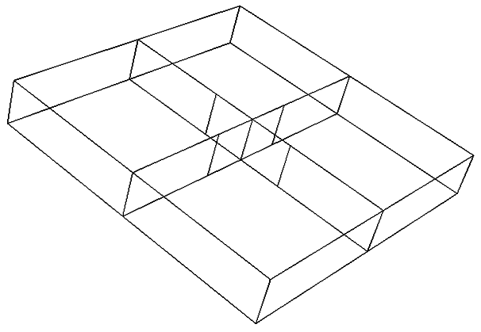
$$b_{c}$$
$$b_{w}$$
$$2a$$
$$2b$$
$$b_{w}$$
$$h$$
$$b_{c}$$
$$\left(a\right)$$
$$\left(b\right)$$

Figure 2. (a) A section of ship hull structure showing shell plating, cruciform and web girders, (b) Four web girders and a cruciform.

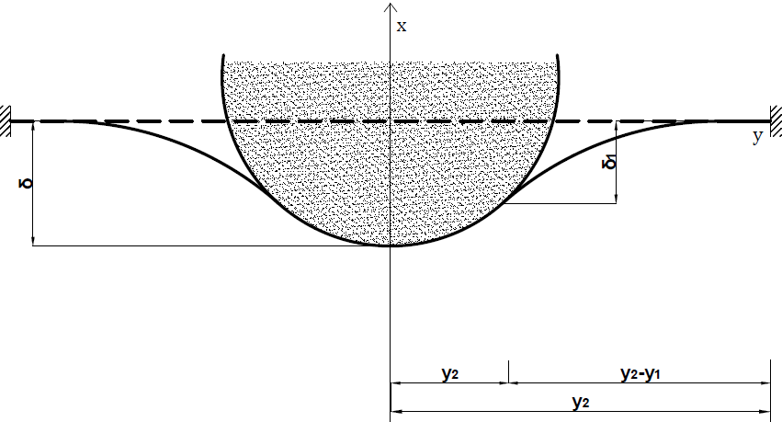
Figure 3. Plate deformation by a spherical indenter.

Figure 4. Comparison of the present model and experimental force-displacement (Lee et al. 2004) curves.

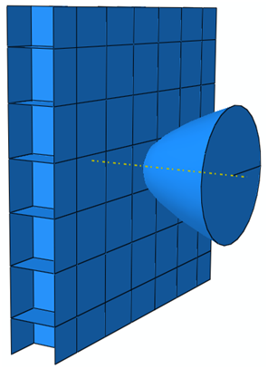
Figure 5. Collision of a double hull by a bulbous bow.

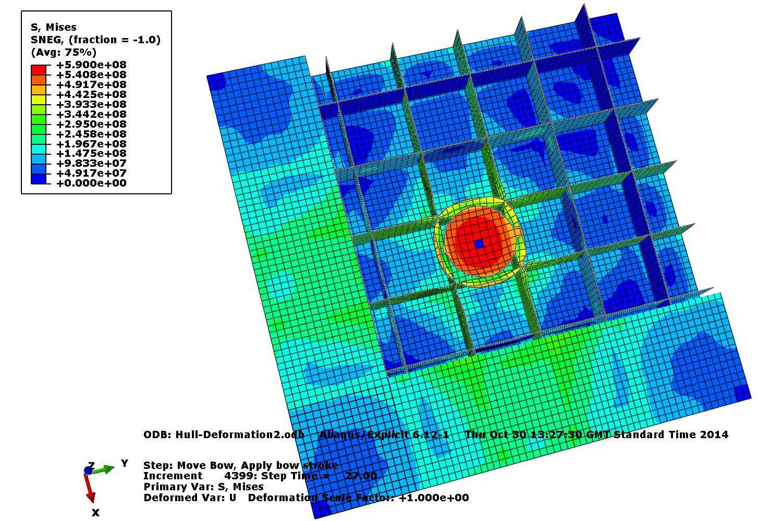
Figure 6. A cutaway view of the hull structure showing the deformed members at the onset of outer hull fracture.

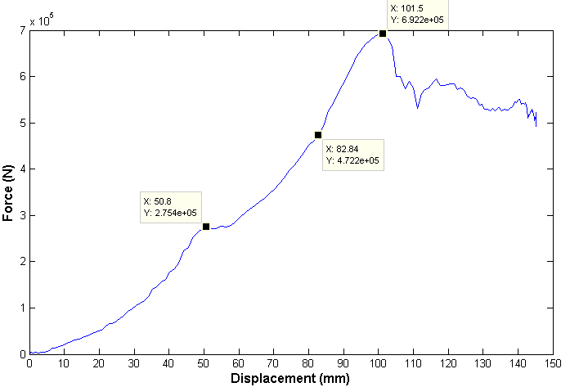
Figure 7. Force-displacement plot of the hull impact with the coordinate points indicating the end of each stage.

Figure 8. The internal energy absorbed by the ship hull structure with the coordinate points indicating the end of each stage.

Figure 9. Force-displacement curve of the hull structure: predicted by SAM expressions and comparison to the numerical simulation.

Yes
Damage distribution
Energy distribution
Stopping criteria met?
No
Find striking ship members touched by colliding bow
Probabilisitc analysis

Internal Mechanics
Compare energy
External Dynamics
Deterministic values of material and geometric properties

Variable design sets

Particulars of colliding ships
Collision scenarios
Figure 10. A simple Collision computation model procedure for a specified struck ship.

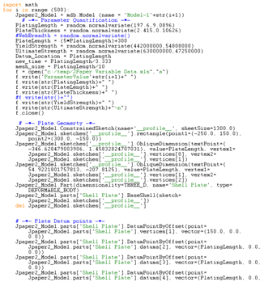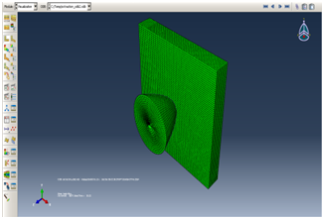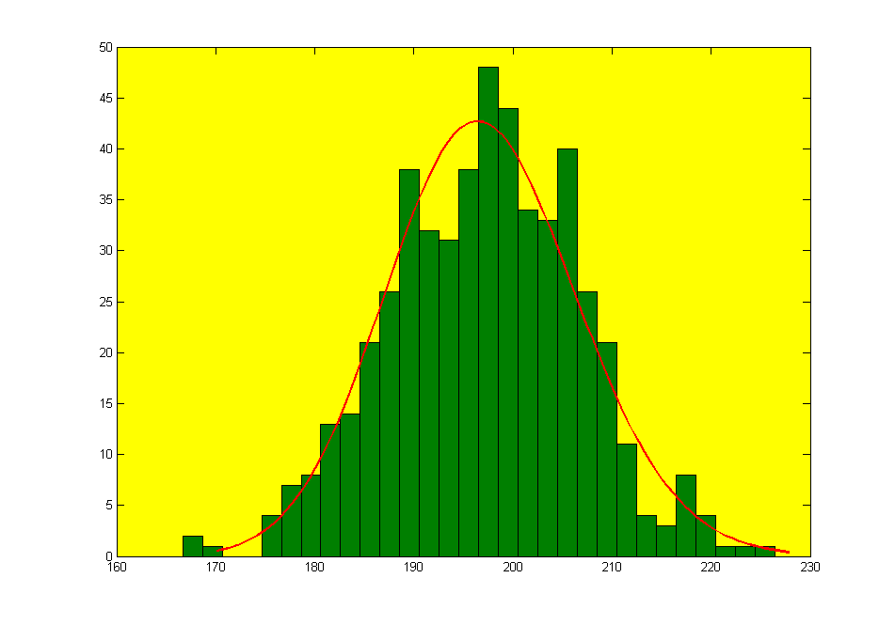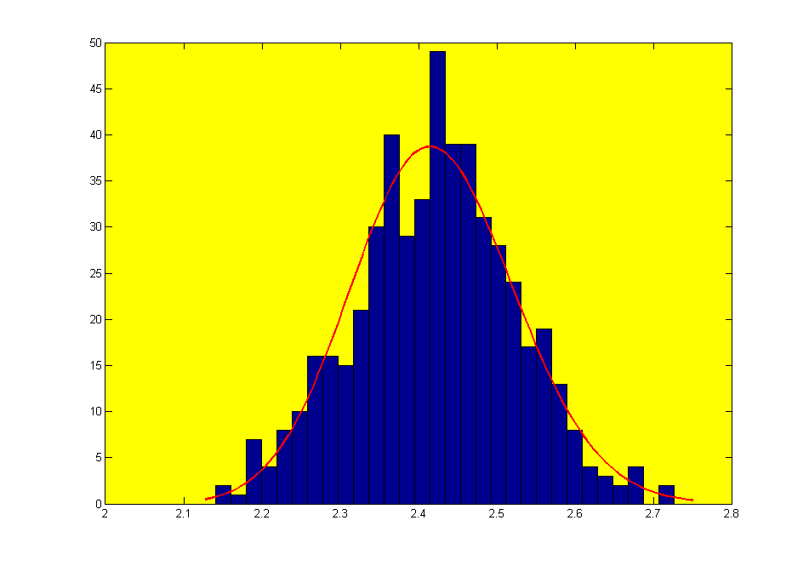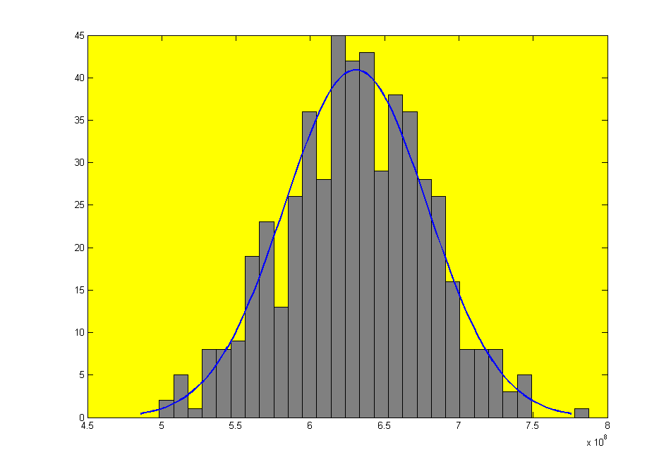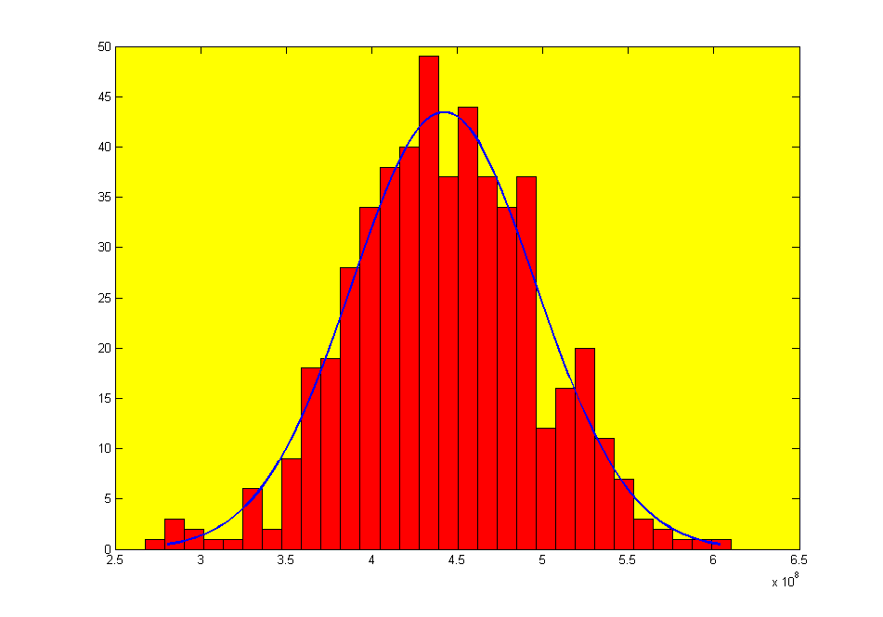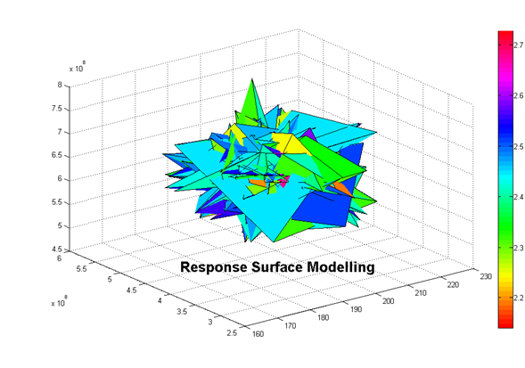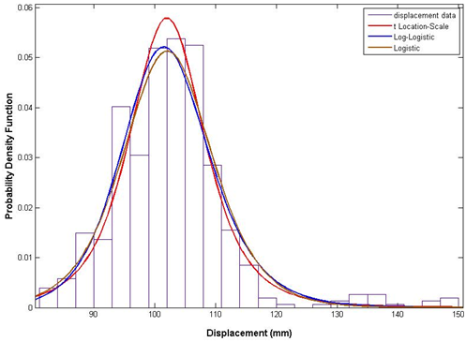
Python Scripting
Interface
Automated Abaqus solver
Yield
Stress
Ultimate
Stress
Plate
Thickness
Plate
Length
Damage Distribution at failure onset
Figure 11. Sketch of the response surface methodology application in Abaqus®.

Figure 12. Probability distributions fitted to the numerical simulation result.

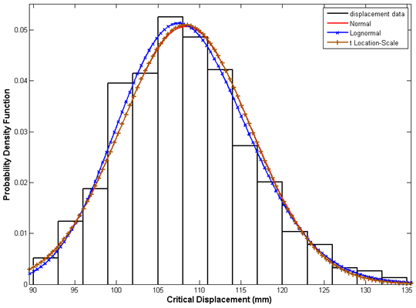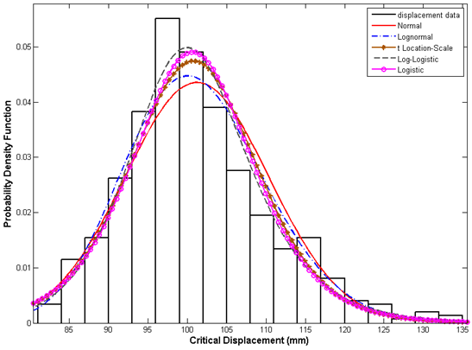
Figure 13. Probability distributions fitted to the stage three SAM result: (a) Haris and Amdahl (2012b), (b) Present model.

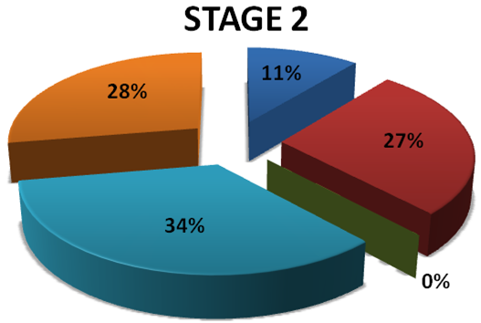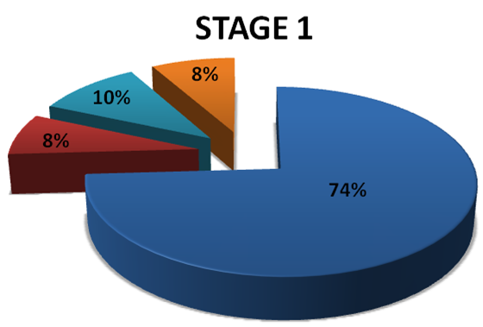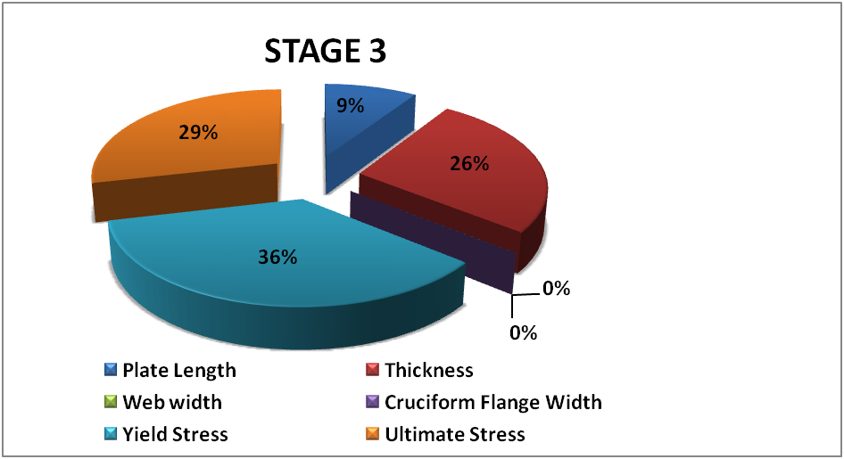
Figure 14. Sensitivity analysis of the simplified analytical model of hull structural damage at the three stages.

Corresponding author. Email: s.sriramula@abdn.ac.uk; Tel: +44(0)1224272778

