

NORTH SEA STUDY OCCASIONAL PAPER
No. 111

Incentivising Investment in the UKCS:

a Response to Supporting Investment:

a Consultation on the North Sea Fiscal Regime

Professor Alexander G. Kemp and
Linda Stephen

February, 2009 Price £25.00

DEPARTMENT OF ECONOMICS
ISSN 0143-022X

NORTH SEA ECONOMICS

Research in North Sea Economics has been conducted in the Economics Department since 1973. The present and likely future effects of oil and gas developments on the Scottish economy formed the subject of a long term study undertaken for the Scottish Office. The final report of this study, The Economic Impact of North Sea Oil on Scotland, was published by HMSO in 1978. In more recent years further work has been done on the impact of oil on local economies and on the barriers to entry and characteristics of the supply companies in the offshore oil industry.

The second and longer lasting theme of research has been an analysis of licensing and fiscal regimes applied to petroleum exploitation. Work in this field was initially financed by a major firm of accountants, by British Petroleum, and subsequently by the Shell Grants Committee. Much of this work has involved analysis of fiscal systems in other oil producing countries including Australia, Canada, the United States, Indonesia, Egypt, Nigeria and Malaysia. Because of the continuing interest in the UK fiscal system many papers have been produced on the effects of this regime.

From 1985 to 1987 the Economic and Social Science Research Council financed research on the relationship between oil companies and Governments in the UK, Norway, Denmark and The Netherlands. A main part of this work involved the construction of Monte Carlo simulation models which have been employed to measure the extents to which fiscal systems share in exploration and development risks.

Over the last few years the research has examined the many evolving economic issues generally relating to petroleum investment and related fiscal and regulatory matters. Subjects researched include the economics of incremental investments in mature oil fields, economic aspects of the CRINE initiative, economics of gas developments and contracts in the new market situation, economic and tax aspects of tariffing, economics of infrastructure cost sharing, the effects of comparative petroleum fiscal systems on incentives to develop fields and undertake new exploration, the oil price responsiveness of the UK petroleum tax system, and the economics of decommissioning, mothballing and re-use of facilities. This work has been financed by a group of oil companies and Scottish Enterprise, Energy. The work on CO2 Capture, EOR and storage is also financed by a grant from the Natural Environmental Research Council (NERC).

For 2009 the programme examines the following subjects:

  - Effects of Requirements on Investors in UKCS to purchase CO2 allowances relating to emissions from 2013 under the EU ETS
  - Least-Cost Transportation Network for CO2 in UK/UKCS
  - Comparative study of Petroleum Taxation in North West Europe/ North Atlantic (UK, Norway, Denmark, Netherlands, Ireland, Faroe Islands, Iceland and Greenland)
  - Economics of Decommissioning in the UKCS: Further Analysis
  - Economics of Gas Exploitation from West of Shetland
  - Prospective Activity levels in the UKCS to 2035
  - EOR from CO2 Injection
  - General Financial Incentives for CCS in UK

The authors are solely responsible for the work undertaken and views expressed. The sponsors are not committed to any of the opinions emanating from the studies.

Papers are available from:
The Secretary (NSO Papers)
University of Aberdeen Business School
Edward Wright Building
Dunbar Street
Aberdeen A24 3QY

Tel No: (01224) 273427
Fax No: (01224) 272181
Email: a.g.kemp@abdn.ac.uk

Recent papers published are:

OP | 98 | Prospects for Activity Levels in the UKCS to 2030: the 2005 Perspective  By A G Kemp and Linda Stephen (May 2005), pp. 52 | £20.00
OP | 99 | A Longitudinal Study of Fallow Dynamics in the UKCS  By A G Kemp and Sola Kasim, (September 2005), pp. 42 | £20.00
OP | 100 | Options for Exploiting Gas from West of Scotland  By A G Kemp and Linda Stephen, (December 2005), pp. 70 | £20.00
OP | 101 | Prospects for Activity Levels in the UKCS to 2035 after the 2006 Budget  By A G Kemp and Linda Stephen, (April 2006) pp. 61 | £30.00
OP | 102 | Developing a Supply Curve for CO₂ Capture, Sequestration and EOR in the UKCS: an Optimised Least-Cost Analytical Framework  By A G Kemp and Sola Kasim, (May 2006) pp. 39 | £20.00
OP | 103 | Financial Liability for Decommissioning in the UKCS: the Comparative Effects of LOCs, Surety Bonds and Trust Funds  By A G Kemp and Linda Stephen, (October 2006) pp. 150 | £25.00
OP | 104 | Prospects for UK Oil and Gas Import Dependence  By A G Kemp and Linda Stephen, (November 2006) pp. 38 | £25.00
OP | 105 | Long-term Option Contracts for Carbon Emissions  By A G Kemp and J Swierzbinski, (April 2007) pp. 24 | £25.00
OP | 106 | The Prospects for Activity in the UKCS to 2035: the 2007 Perspective  By A G Kemp and Linda Stephen (July 2007) pp.56 | £25.00
OP | 107 | A Least-cost Optimisation Model for CO2 capture  By A G Kemp and Sola Kasim (August 2007) pp.65 | £25.00
OP | 108 | The Long Term Structure of the Taxation System for the UK  Continental Shelf  By A G Kemp and Linda Stephen (October 2007) pp.116 | £25.00
OP | 109 | The Prospects for Activity in the UKCS to 2035: the 2008 Perspective  By A G Kemp and Linda Stephen (October 2008) pp.67 | £25.00
OP | 110 | The Economics of PRT Redetermination for Incremental Projects in the UKCS  By A G Kemp and Linda Stephen (November 2008) pp. 56 | £25.00
OP | 111 | Incentivising Investment in the UKCS: a Response to Supporting Investment: a Consultation on the North Sea Fiscal Regime  By A G Kemp and Linda Stephen (February 2009) pp.93 | £25.00

Incentivising Investment in the UKCS: a Response to Supporting Investment: a Consultation on the North Sea Fiscal Regime

Professor Alexander G. Kemp and
Linda Stephen

Contents Page

1. Introduction 2
2. Methodology and Assumptions 2
3. Results 10
A. Value Allowance Applied to All New Fields in UKCS 10
i. Number of Field Developments Triggered 10
ii. Detailed Effects of Allowance of £12.5 million 12
iii. Detailed Effects of Allowance of £50 million 22
iv. Detailed Effects of Allowance at £100 million 33
v. Effects of Value Allowance of £250 million 43
B. Value Allowance Applied to Small Fields (≤ 20 mmboe) 44
i. Numbers of Field Developments Triggered 44
ii. Detailed Effects of £12.5 million Value Allowance 45
iii. Detailed Effects of Value Allowance of £50 million 55
iv. Detailed Effects of Value Allowance of £100 million 64
C. Value Allowance Applied to West of Shetlands Fields 73
i. Number of Field Developments Triggered 73
4. Interpretation of Results 81
5. Incremental Projects 87
6. Exploration Incentives 89
7. Conclusions 90

Incentivising Investment in the UKCS: a Response to Supporting Investment: a Consultation on the North Sea Fiscal Regime

Professor Alexander G Kemp and Linda Stephen

Introduction

The publication of the Treasury consultation document Supporting Investment: a Consultation on the North Sea Fiscal Regime in November 2008 signalled the UK Government’s desire to enhance the pace of activity in the UK Continental Shelf (UKCS). It is well known that oil and gas production has been falling at a brisk pace since the peak reached in 1999. The consultation covers several subjects, the most important of which relates to incentives for new field development. The document refers in particular to small fields, heavy oil fields, HP/HT fields, and fields located West of Shetlands. Other topics raised relate to capital gains tax, where specific proposals are made with respect to licence swaps and reinvestment relief, and change of use where the Government has out set its conclusions from discussions held with the industry over the last two years. The document also refers to the question of the whole future of PRT the abolition of which, particularly through a buyout arrangement, has been discussed over the last two years.

This paper discusses the case for incentives for new field developments in detail and makes observations on other related topics including in particular the continuing need to incentivise investment in incremental projects in PRT-paying fields and further exploration.

Methodology and Assumptions

The issue of the appropriate share of the revenues from the UKCS which should be collected by the Government on behalf of the whole nation is a complex one and has been vigorously debated in the UK since the special taxation regime for the UKCS was introduced in 1975. While there is wide agreement that a share of any economic rents generated from the UKCS should accrue to the nation the measurement of the rents and the appropriate share which should be collected have proved elusive in practice. The present tax system for new field developments is essentially a cash flow one for investors who are already in a tax-paying position. This has considerable merit in terms of incentives with the post-tax rate of return (IRR) remaining equal to the pre-tax rate. But investment decisions in the petroleum industry take into account not only the expected rate of return but the materiality of the project. This is conventionally measured by the size of the net present value (NPV). Investors also increasingly examine investment opportunities in the UKCS in relation to these in other parts of the world. Given the need to allocate limited capital budgets to greatest effect projects are valued in accordance with their expected capital productivity. This is measured by the NPV/ I ratio where NPV is calculated on a post-tax basis while I is on a pre-tax basis. (This reflects the behaviour of the industry where capital is allocated on a pre-tax basis. The text book formula generally measures both NPV and I on a post-tax basis). The well-know problems in the financial markets have reduced the availability of both debt and equity capital for companies requiring external capital. This has exacerbated the capital rationing problem.

In the light of the above in this study the base case investment hurdle required by investors has been set at NPV/ I ≥ 0.3 where the NPV calculation employs a discount rate of 10% in real post-tax terms (c. 12.5% in money-of-the-day-terms), and I employs a real pre-tax discount rate of 10% (c. 12.5% in money-of-the-day-terms).

The projections of production and expenditures have been made through the use of financial simulation modelling, including the use of the Monte Carlo technique, informed by a large, field database validated by the relevant operators. The field database incorporates key, best estimate information on production, and investment, operating and decommissioning expenditures. These refer to over 300 sanctioned fields, 131 incremental projects relating to these fields, 35 probable fields, and 16 possible fields. All these are as yet unsanctioned but are currently being examined for development. An additional database contains 234 fields defined as being in the category of technical reserves. Summary data on reserves (oil/gas) and block location are available for these. They are not currently being examined for development by licensees.

Monte Carlo modelling was employed to estimate the possible numbers of new discoveries in the period to 2030. The modelling incorporated assumptions based on recent trends relating to exploration effort, success rates, sizes, and types (oil, gas, condensate) of discovery. A moving average of the behaviour of these variables over the past 5 years was calculated separately for 6 areas of the UKCS (Southern North Sea, (SNS), Central North Sea (CNS), Moray Firth (MF), Northern North Sea (NNS), West of Scotland (WOS), and Irish Sea (IS)), and the results employed for use in the Monte Carlo analysis. Because of the very limited data for WOS and IS over the period judgemental assumptions on success rates and average sizes of discoveries were made for the modelling.

It is postulated that the exploration effort depends substantially on a combination of (a) the expected success rate, (b) the likely size of discovery, and (c) oil/gas prices. In the present study 3 future oil/gas price scenarios were employed as follows:

Table 1
Future Oil and Gas Price Scenarios
 | Oil Price (real)  $/bbl | Gas Price (real)  pence/therm
High | 80 | 70
Medium | 60 | 50
Low | 40 | 30

The postulated numbers of annual exploration wells drilled for the whole of the UKCS are as follows for 2008 and 2030:

Table 2
Exploration Wells Drilled
 | 2008 | 2030
High | 45 | 35
Medium | 40 | 32
Low | 30 | 22

The annual numbers are modelled to decline in a linear fashion over the period.

It is postulated that success rates depend substantially on a combination of (a) recent experience, and (b) size of the effort. It is further suggested that higher effort is associated with more discoveries but with lower success rates compared to reduced levels of effort. This reflects the view that low levels of effort will be concentrated on the lowest risk prospects, and thus that higher effort involves the acceptance of higher risk. For the UKCS as a whole 3 success rates were postulated as follows with the medium one reflecting the average over the past 5 years.

Table 3
Success Rates for UKCS
Medium effort/Medium success rate = 25.5%
High effort/Low success rate = 24%
Low effort/High success rate = 27%

It should be noted that success rates have varied considerably across sectors of the UKCS. Thus in the CNS and SNS the averages have exceeded 30% while in the other sectors success rates have been well below the average for the whole province.
It is assumed that technological progress will maintain these success rates over the time period.

The mean sizes of discoveries made in the historic period for each of the 6 regions were calculated. They are shown in Table 4. It was then assumed that the mean size of discovery would decrease in line with recent historic experience. Such decline rates are quite modest.

Table 4
Mean Discovery Size MMboe
SNS | 9
CNS | 25
NNS | 25
MF | 20
WoS | 81
IS | 5

For purposes of the Monte Carlo modelling of new discoveries the SD was set at 50% of the mean value. In line with historic experience the size distribution of discoveries was taken to be lognormal.

Using the above information the Monte Carlo technique was employed to project discoveries in the 6 regions to 2030. For the whole period the total numbers of discoveries for the whole of the UKCS were are follows:

Table 5
Total Number of Discoveries to 2030
High effort/Low success rate 245
Medium Effort/Medium Success Rate 238
Low effort/High success rate 185

For each region the average development costs (per boe) of fields in the probable and possible categories were calculated. These reflect substantial cost inflation over the last few years. Using these as the mean values the Monte Carlo technique was employed to calculate the development costs of new discoveries. A normal distribution with a SD = 20% of the mean value was employed. For the whole of the UKCS the average development costs on this basis were nearly $14/boe with quite a wide variation. Investment costs for boe depend on several factors including not only the absolute costs in different operating conditions (such as water depth) but on the size of the fields. Thus in the SNS development costs were found to average nearly $14 per boe because of the small size of field. In the NNS they averaged $16/boe. Operating costs over the lifetime of the fields were also calculated, as were the decommissioning costs. Total lifetime field costs (excluding E and A costs) were found to average nearly $25 per boe for the whole of the UKCS, and averaged over $21 per boe in the SNS, nearly $25 per boe in the CNS, and $29 per boe in the NNS.

For new discoveries annual operating costs were modelled as a percentage of accumulated development costs. This percentage varied according to field size. It was taken to increase as the size of the field was reduced reflecting the presence of economies of scale in the exploitation costs. Thus the field lifetime costs in small fields could become very high on a per boe basis.

With respect to fields in the category of technical reserves it was recognised that many have remained undeveloped for a long time, so the mean development costs in each of the basins was set at $5/boe higher than the mean for the new discoveries in that basin. Thus for the CNS the mean development costs are $17/boe and in NNS $21/boe. For purposes of Monte Carlo modelling a normal distribution of the recoverable reserves for each field with a SD = 50% of the mean was assumed. With respect to development costs the distribution was assumed to be normal with a SD = 20% of the mean value.

The annual numbers of new field developments were assumed to be constrained by the physical and financial capacity of the industry. This subject is currently very pertinent in the UKCS. The ceilings were assumed to be linked to the oil/gas scenarios with maxima of 20, 17, and 13 respectively under the High, Medium, and Low Price Cases. These constraints do not apply to incremental projects which are additional to new field developments.

A noteworthy feature of the 131 incremental projects in the database validated by operators is the expectation that the great majority will be executed over the next 3 or 4 years. It is virtually certain that in the medium and longer-term many further incremental projects will be designed and executed. They are just not yet at the serious planning stage. Such projects can be expected not only linked to currently sanctioned fields, but also to those presently classified as in the categories of probable, possible, technical reserves, and future discoveries.

Accordingly, estimates were made of the potential extra incremental projects from all these sources. Examination of the numbers of such projects and their key characteristics (reserves and costs) being examined by operators over the past 5 years indicated a decline rate in the volumes. On the basis of this, and from a base of the information of the key characteristics of the projects in the database, it was felt that, with a decline rate reflecting historic experience, further portfolios of incremental projects could reasonably be expected. As noted above such future projects would be spread over all categories of host fields. Their sizes and costs reflect recent trends.

The above modelling was conducted under the current tax system. The outputs of the modelling showed expected production, field investment, operating and decommissioning costs. Tax revenues were also calculated. It should be stressed that from a national viewpoint the effects of the incentive should not be assessed in terms of tax revenues. The key effects which attention should be concentrated are on economic production and investment. This is consistent with the various PILOT objectives which are stated in terms of production and investment. The effects of various sizes of value allowances for the Supplementary Charge (SC) were then calculated with the results highlighting the changes to oil and gas production, investment and operating expenditures and tax revenues. The acceptable field investments are thus on a post-corporation tax basis. Clearly more would be viable on a pre-tax basis. The value allowances were all modelled on a per field basis. The values employed were (1) £2.5 million per year for 5 years, (2) £10 million per year for 5 years, (3) £20 million per year for 5 years, and (4) £50 million per year for 5 years. In some cases the relevant income for SC purposes was insufficient to absorb all the value allowance. The results are shown for all categories of new fields (probable, possible, technical reserves, and new discoveries). Given the concern expressed in the consultation document with small fields the results are shown separately for fields with recoverable reserves of ≤ 20 mmboe under the $60,50 pence price case. The results of the very high value allowance are shown separately for fields located West of Shetland given the particularly high costs of developing (including transporting) oil and gas in that area.

Given the clear need to obtain maximum economic recovery from the UKCS the situation with respect to incremental projects in mature fields is also discussed. The tax position in relation to projects subject to PRT as well as corporation tax and SC has recently been examined in detail by the present authors and the lessons for the present position of the industry are highlighted.

Results

Value Allowance Applied to All New Fields in UKCS

Number of Field Developments Triggered

The effects of the value allowance in triggering new field developments across the UKCS in the period from 2009 to 2035 inclusive are shown in summary form in Table 6.

Table 6

Number of Fields Triggered by value allowance in period to 2035
 | Probable | Possible | Technical Reserves | New Exploration | Total
$40,30p SCT Allowance £2.5m x 5 | 3 | 1 | 4 | 8 | 16
$40,30p SCT Allowance £10m x 5 | 6 | 3 | 9 | 27 | 45
$40,30p SCT Allowance £20m x 5 | 8 | 3 | 13 | 34 | 58
$60,50p SCT Allowance £2.5m x 5 | 4 | 1 | 14 | 13 | 32
$60,50p SCT Allowance £10m x 5 | 4 | 2 | 29 | 21 | 56
$60,50p SCT Allowance £20m x 5 | 5 | 2 | 31 | 23 | 61
$80,70p SCT Allowance £2.5m x 5 | 1 | 0 | 6 | 0 | 7
$80,70p SCT Allowance £10m x 5 | 1 | 0 | 17 | 1 | 19
$80,70p SCT Allowance £20m x 5 | 1 | 0 | 18 | 1 | 20

It is seen that under the $40,30p price case the total numbers of incentivised fields are 16 with the £12.5 million allowance, 45 with the £50 million allowance, and 58 with the £100 million case. The majority of the incentivised developments are in the category of new discoveries. The policy conclusion is that the allowance could provide a worthwhile incentive for further exploration. It is also clear that the £12.5 million allowance is inadequate to provide a worthwhile difference to new field developments.

Under the $60,50p price case the numbers of incentivised developments are substantially greater, being 32, 56, and 61 under the 3 sizes of allowance. In this scenario it is seen that large numbers of fields in the technical reserves category as well as substantial numbers of new discoveries are incentivised. Worthwhile numbers of fields in the probable/possible field categories are also incentivised. These are currently being assessed by the industry, and the fact that they do not meet the investment hurdle under the current tax system is clearly of concern. Again it is clear that the higher levels of allowance produce substantially more new developments than the £12.5 million one.

Under the $80,70p price case significant numbers of fields in the category of technical reserves are incentivised under the £50 million and £100 million allowances.

Detailed Effects of Allowance of £12.5 million

In Charts 1 – 3 the effects of the value allowance on production under the $40,30p case are shown. The increases in total hydrocarbon production are seen to be quite modest, and it is not until well into the 2020’s that they grow to reach a peak of 30,000 boe/d in 2026 (Chart 3). The aggregate increase in production to 2035 is 134 mmboe.

Chart 1
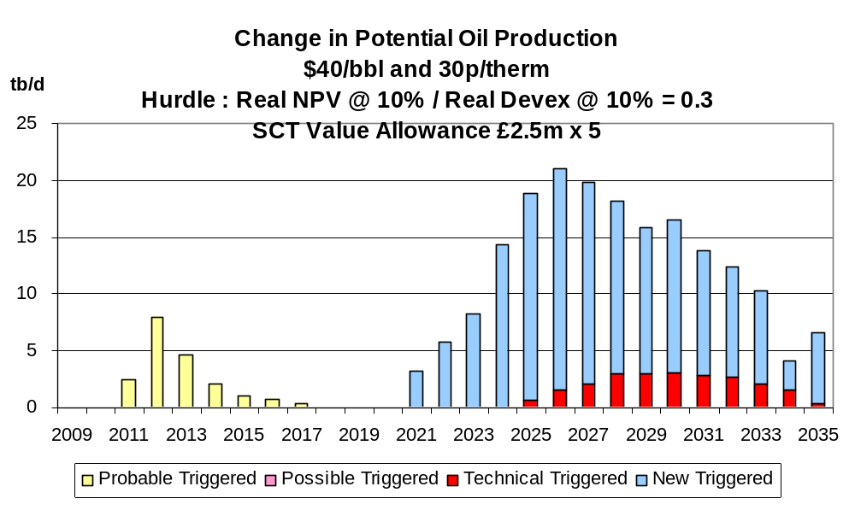
Chart 2
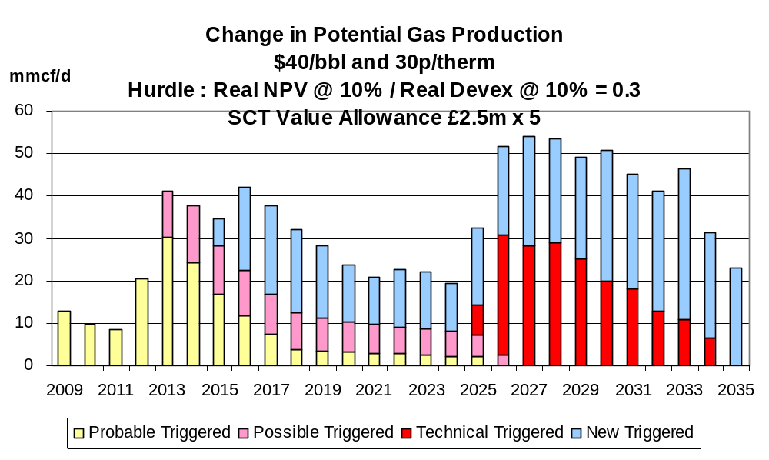

Chart 3
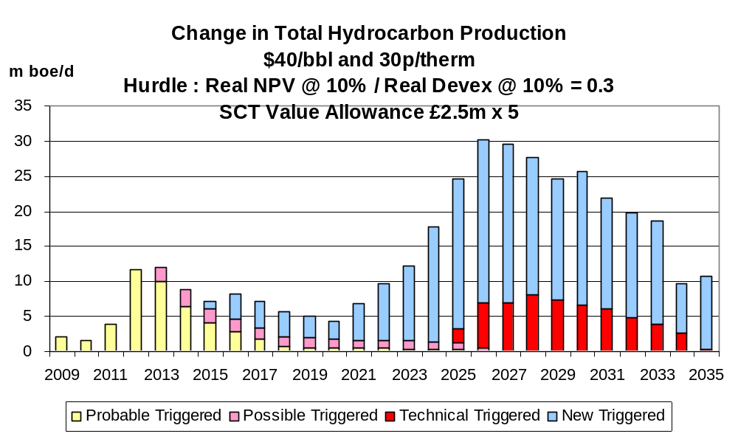

The increase comes predominantly from new discoveries. The increase in field development expenditure (Chart 4) is correspondingly small, especially in the period before 2024. The changes in total tax revenues are shown in Chart 5 where both the positive and negative elements are indicated. The positive elements show the increases in revenues emanating from the development of the fields triggered by the allowance. The negative element shows the loss of revenues from the development of fields which would have occurred in the absence of the allowance. It is seen (Chart 6) that on the probable/possible fields the increase in tax revenues broadly matches the reduction from fields which would in any case be developed.

Chart 4
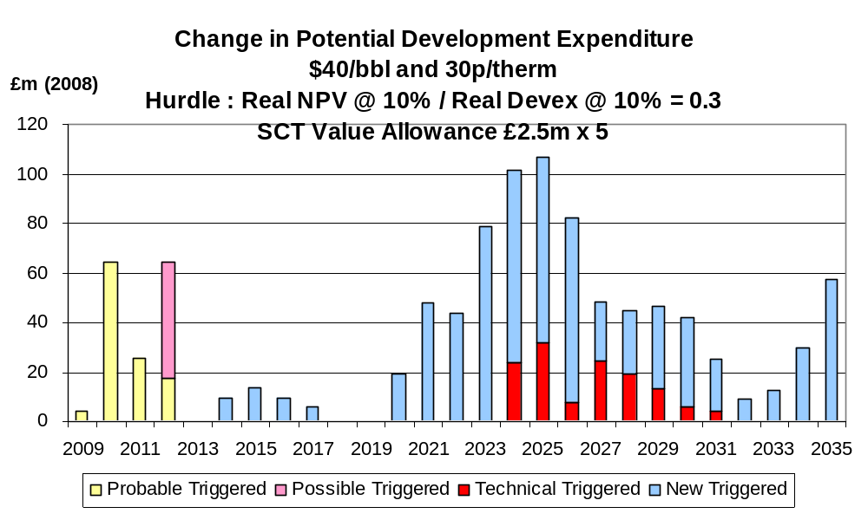

Chart 5
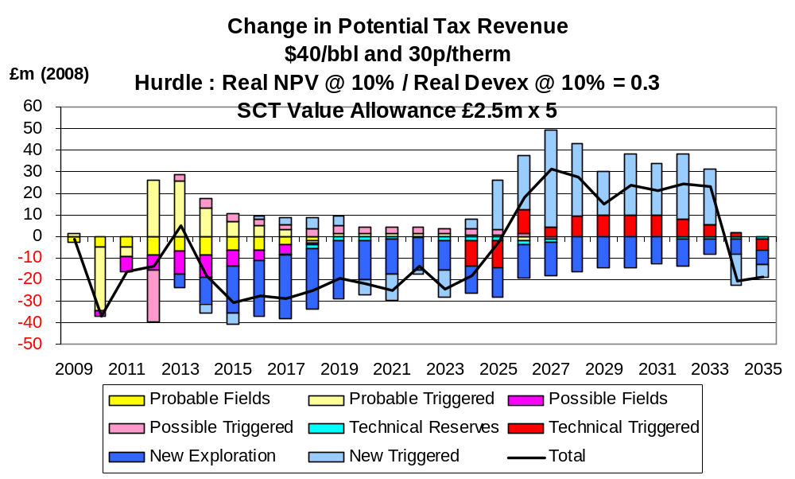

Chart 6
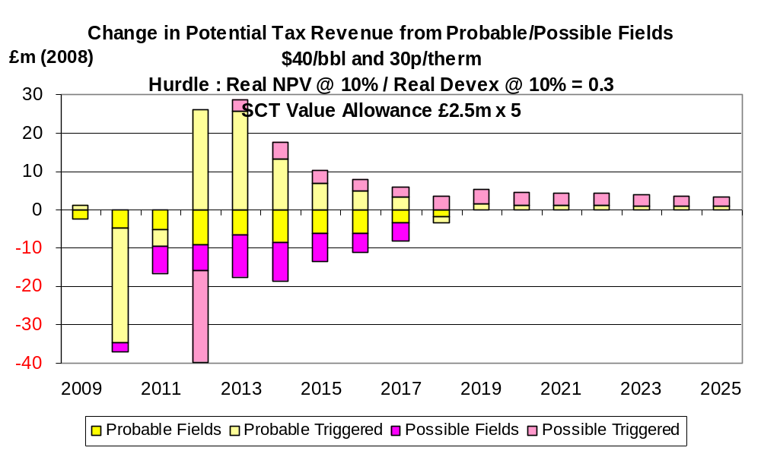

The increases in production under the $60,50p price case are shown in Charts 7 – 9. The average increase in total hydrocarbon production is over 15,000 boe/d over the whole period 2009 – 2035, which is considerably more compared to the $40,30p scenario. The aggregate increase in production to 2035 is 225 mmboe. Similarly, the increase in field investment (Chart 10) is greater than under the low price case. In Chart 11 the changes in tax revenues, including both the gains from triggered field developments and the losses from those which would in any case proceed are shown.

Chart 7
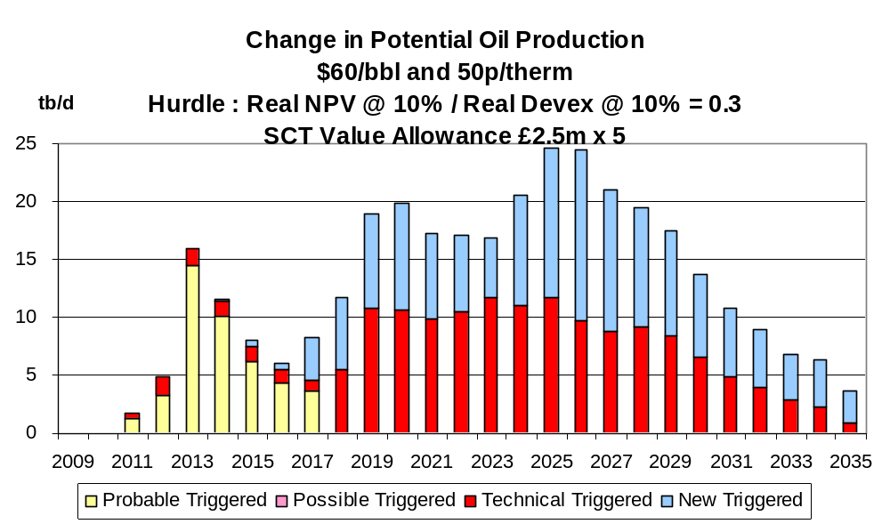

Chart 8
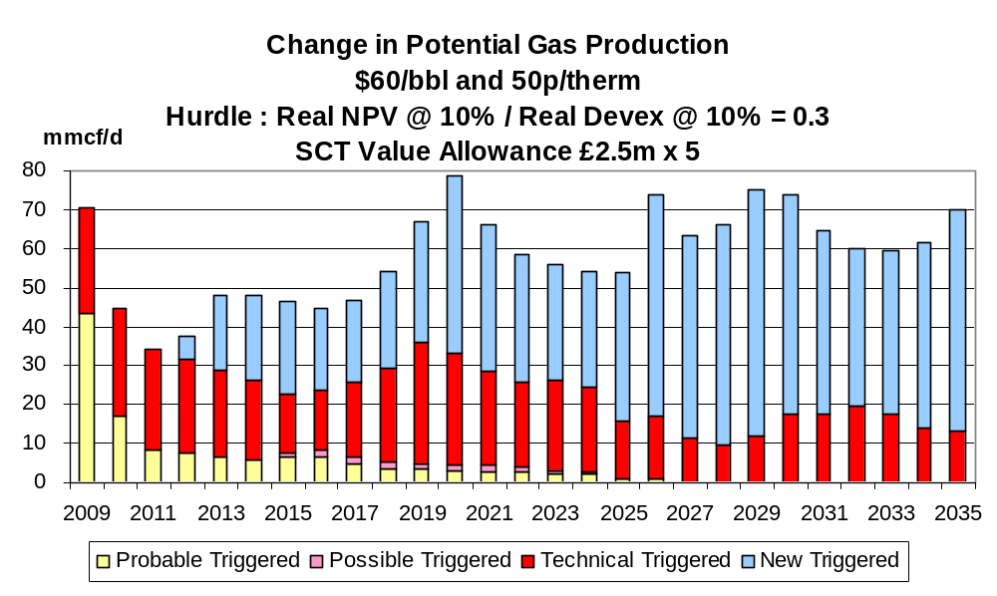

Chart 9
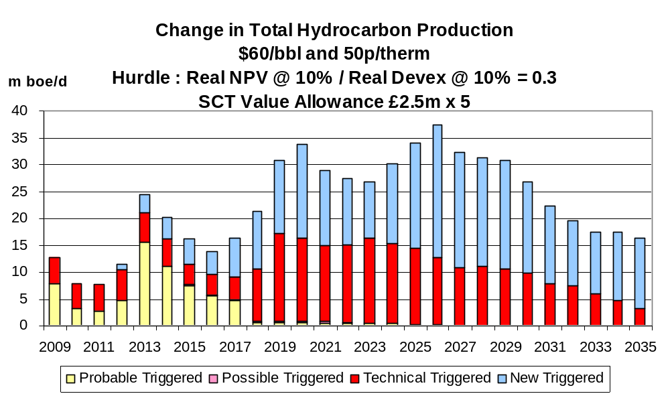

Chart 10
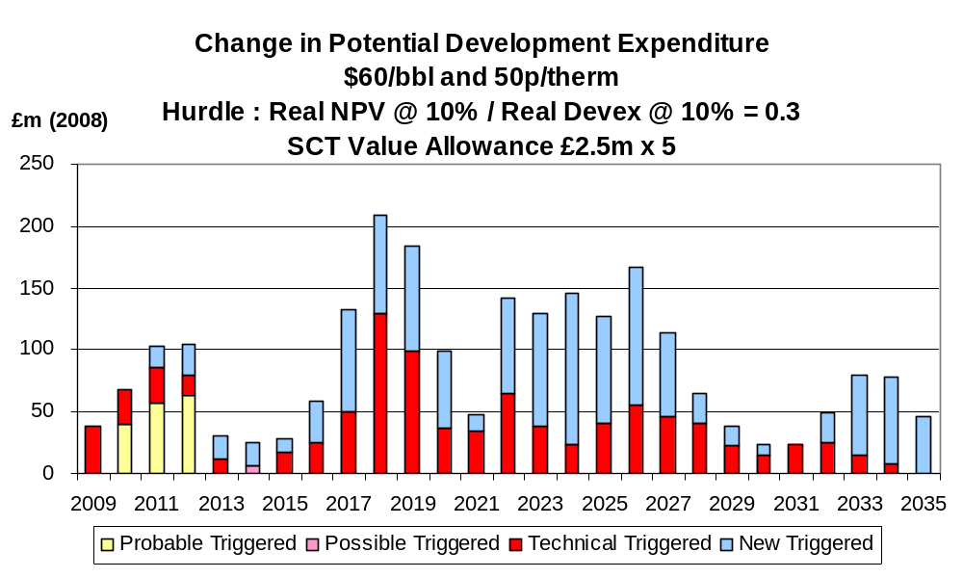

Chart 11
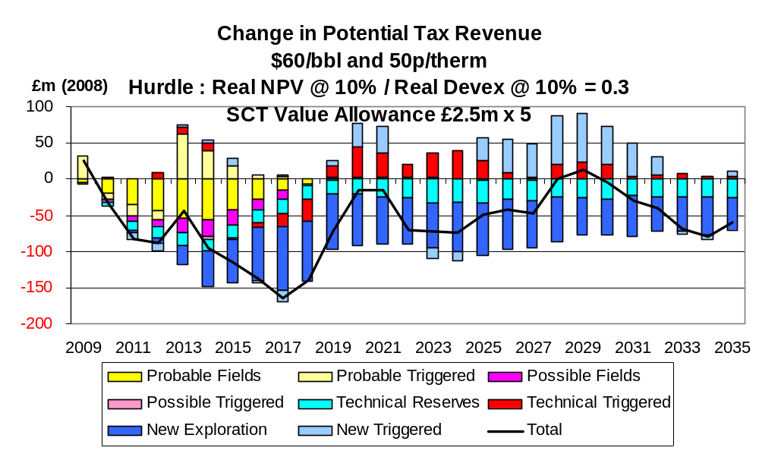
The increases in production under the $80,70p case are shown in Charts 12 – 14. They are seen to be very small, reflecting the fact that very few developments are triggered. The aggregate increase to 2035 is 48 mmboe. It should be stressed that this is not because all fields are in any case economic in this scenario. Large number of fields in the category of technical reserves remain non-commercial with the small value allowance. Many become viable with the larger allowances (see below). The overall increase in field development expenditure (Chart 15) is modest, but the extra in 2009 is seen to be worthwhile.

Chart12
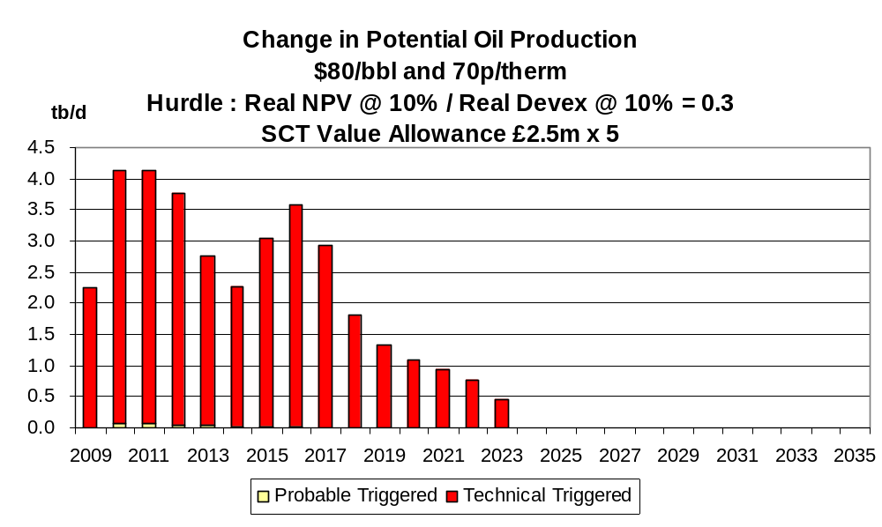

Chart 13
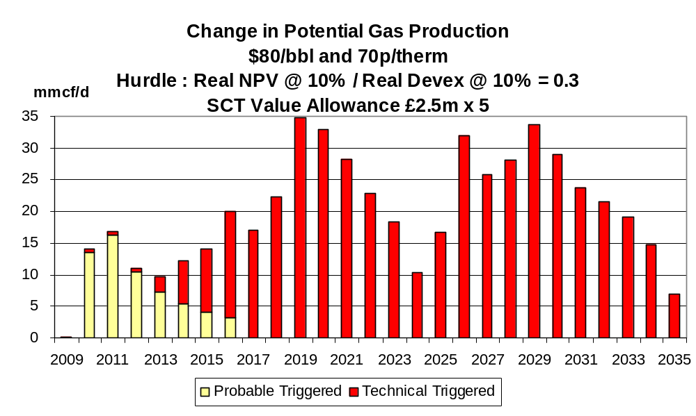

Chart 14
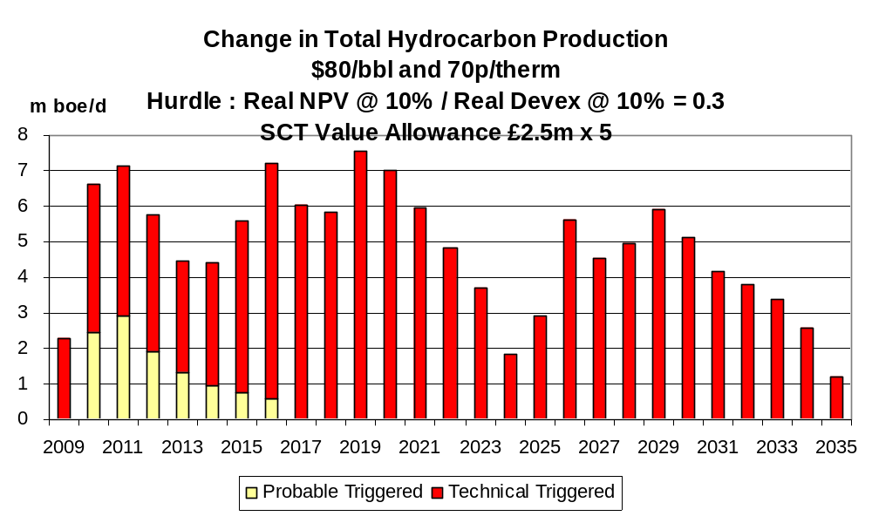

Chart 15
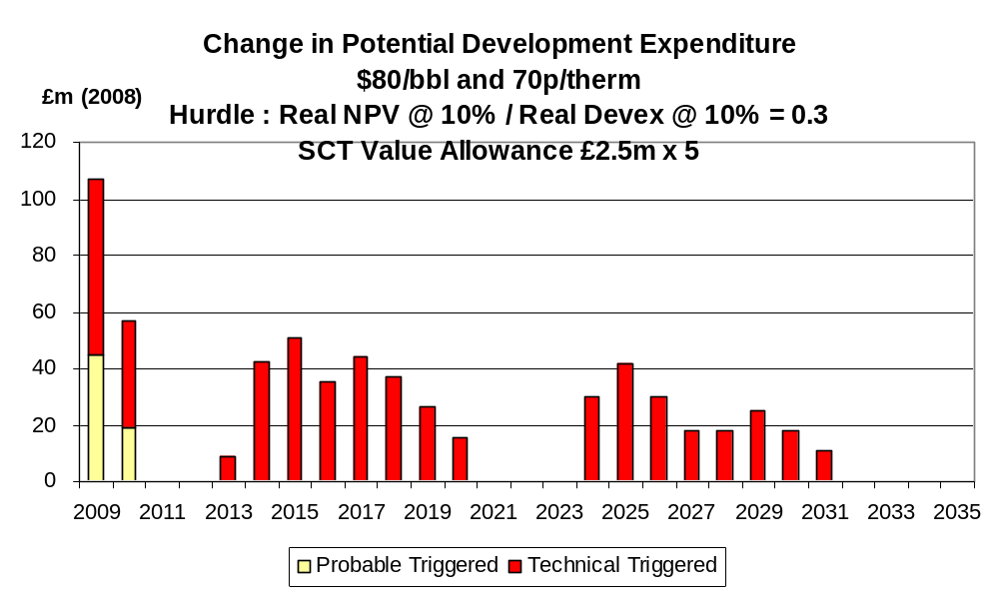

Detailed Effects of Allowance of £50 million

The effects of the value allowance of £50 million on production are shown in Charts 16 – 18 under the $40,30 pence case. The increase may be described as substantial with the extra total hydrocarbon output from fields in the probable/possible category averaging over 40,000 boe/d for 4 years in the period 2012 – 2025. The aggregate increase to 2035 is 544 mmboe. Further, in the period 2021 – 2033 inclusive the average increase in production is well in excess of 60,000 boe/d. The corresponding increase in development investment is also substantial (Chart 19). In the 4-year period 2009 – 2012 inclusive the increase is around £840 million at 2008 prices. This would come at a very welcome time period for the contracting sector. The changes in tax revenues from all categories of fields are shown in Chart 20. The net effect is negative. It is noteworthy that this outcome results from the loss of revenues from future discoveries. When the fields in the probable/possible categories are considered (Chart 21) it is seen that there is little net loss in tax revenues over the period. Similarly, when fields in all categories except new discoveries are considered (Chart 22), the increase in tax revenues broadly equals the loss from fields which would otherwise proceed.
Chart 16
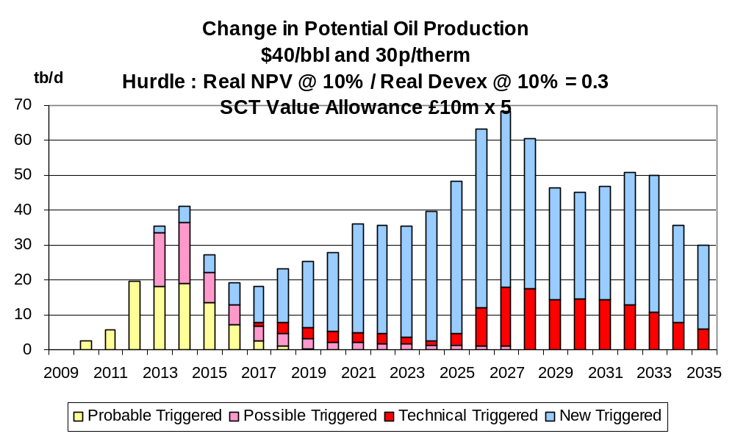

Chart 17
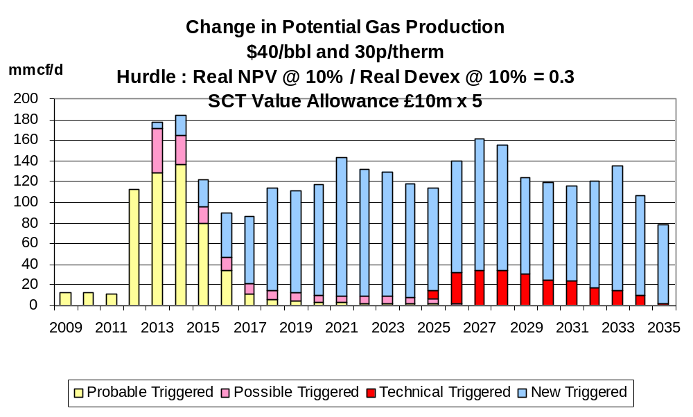

Chart 18

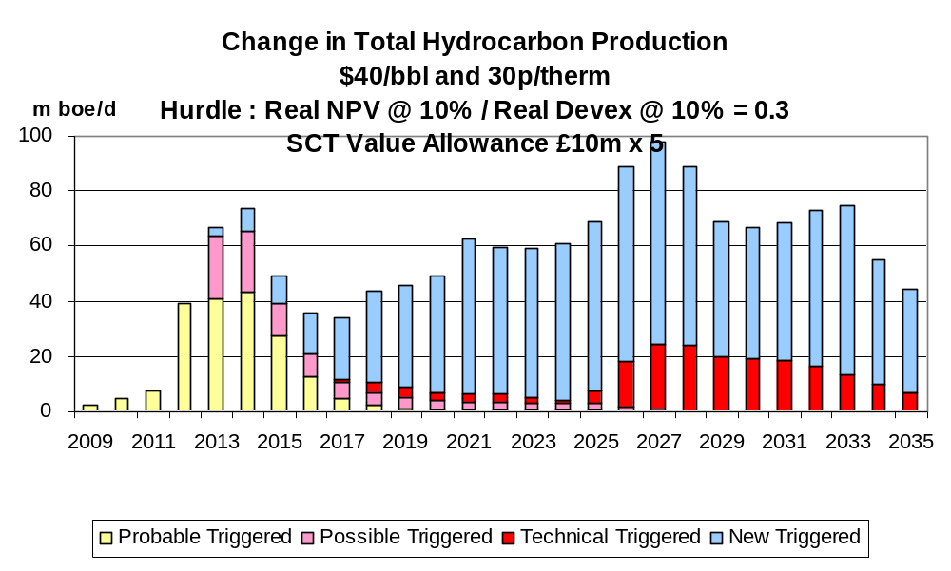

Chart 19
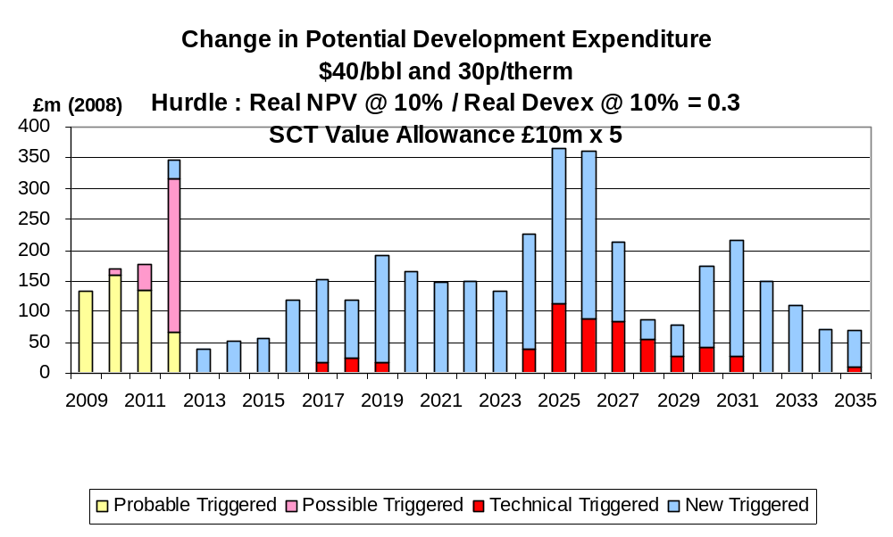

Chart 20
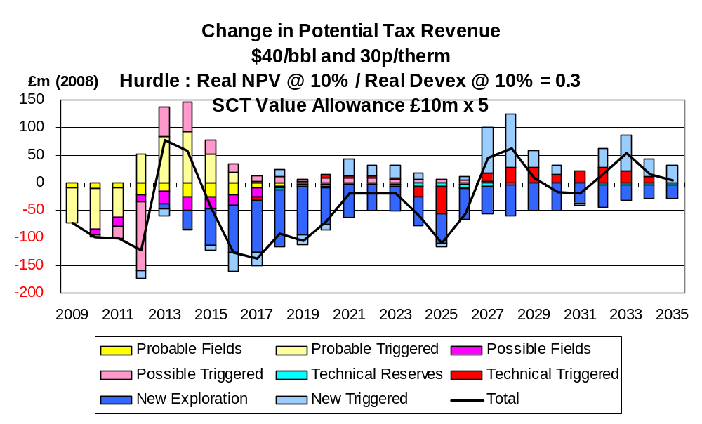

Chart 21

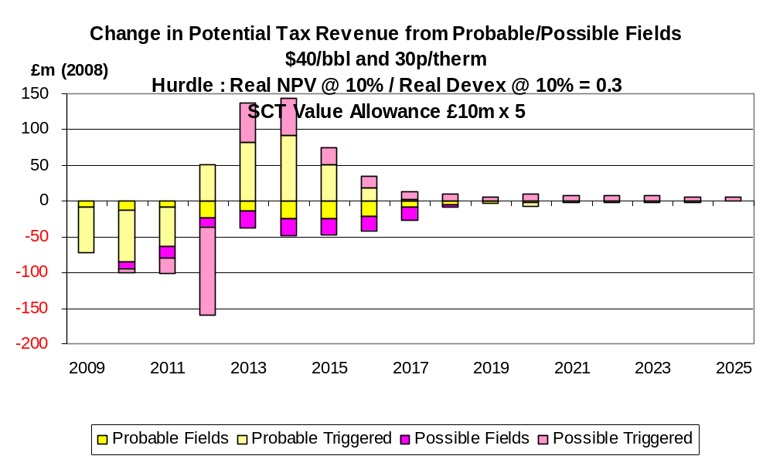
Chart 22
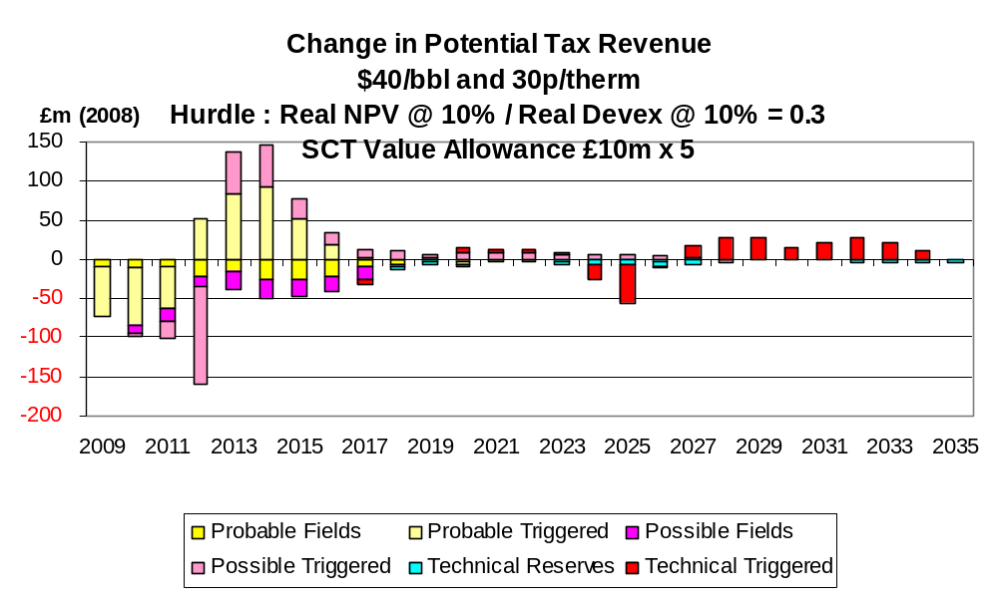

Under the $60,50 pence price scenario the changes in production from the £50 million allowance are shown in Charts 23-25. The effect is very substantial. The increase in total hydrocarbon production over the whole period 2009 – 2035 on average exceeds 50,000 boe/d which constitutes a very worthwhile contribution to ultimate recovery from the UKCS. The aggregate increase in the period to 2035 is 529 mmboe. Likewise the increase in field investment (Chart 26) is impressive, being over £1 billion (at 2008 prices) in the period 2009 – 2012. Throughout the period the increase remains substantial. The changes in tax revenues are shown in Chart 27. The net effect is noticeably negative, but this is due to the loss of revenues from fields in the category of new discoveries. If these are excluded because of the uncertainties surrounding their characteristics the net reduction is very much less (Chart 28).
Chart 23
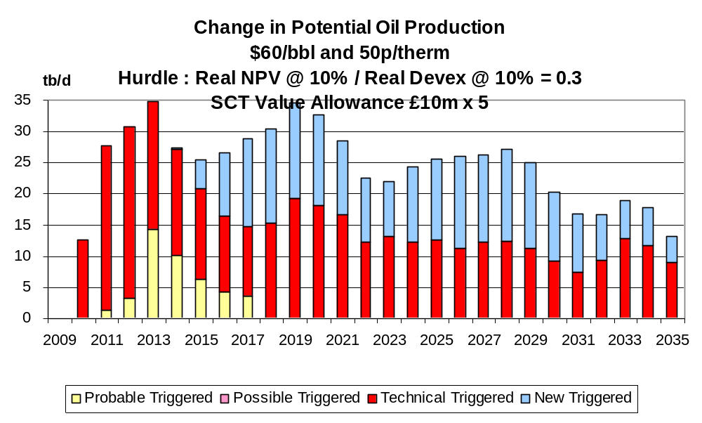

Chart 24
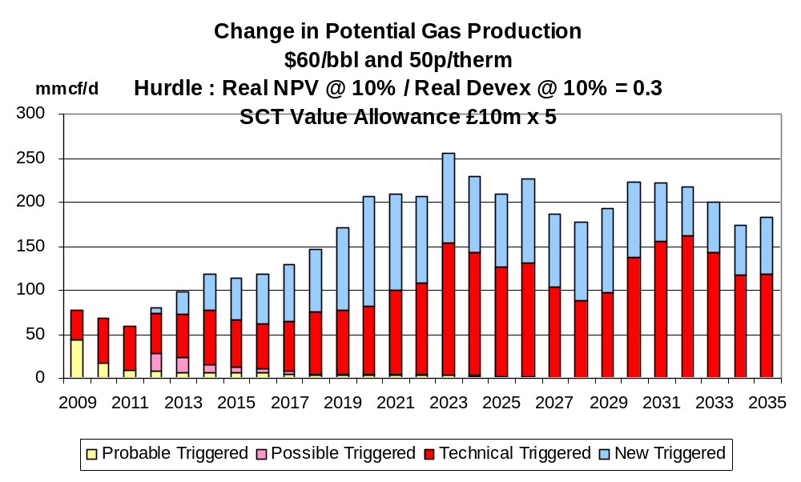

Chart 25
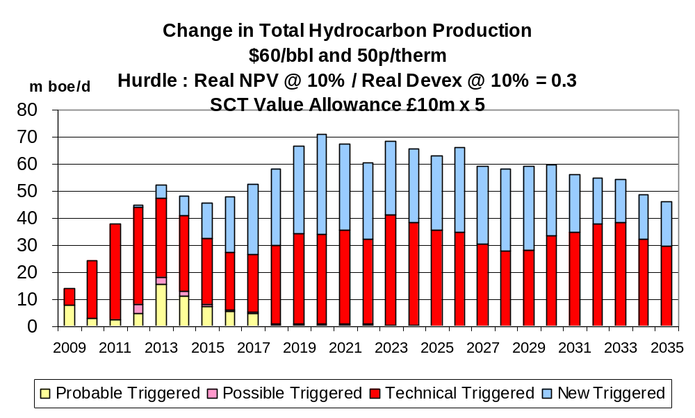

Chart 26
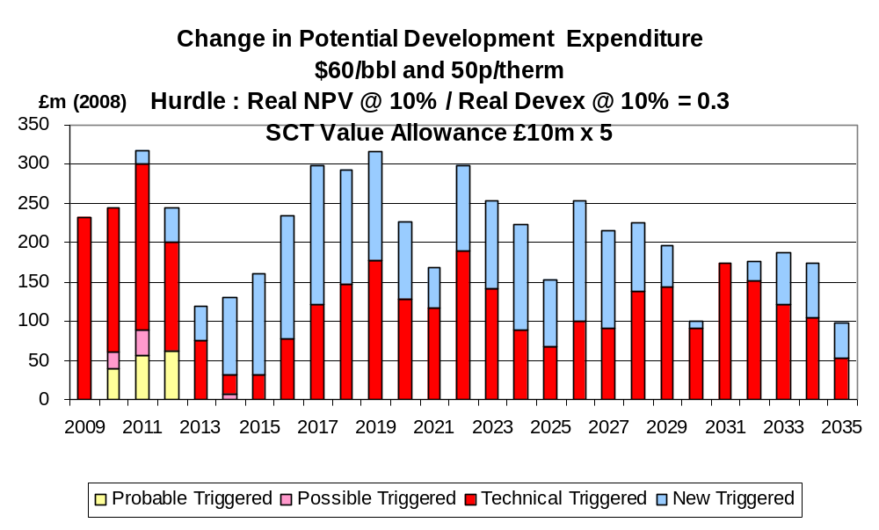
Chart 27

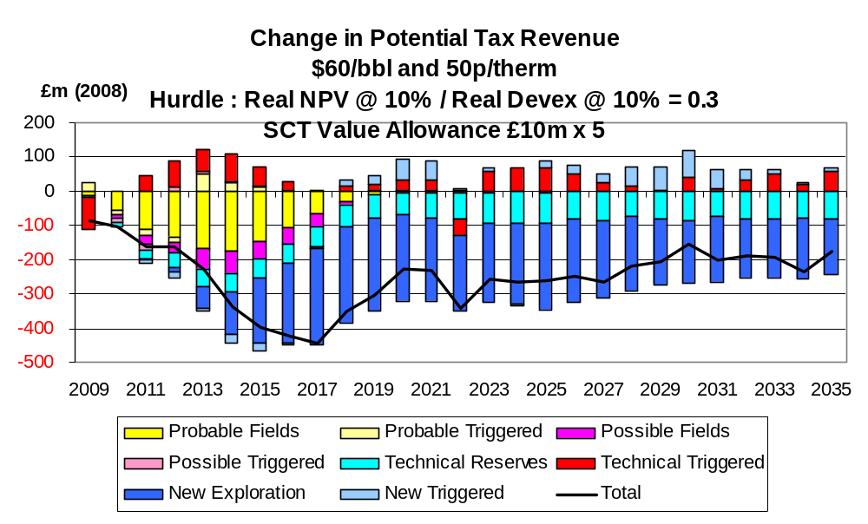

Chart 28
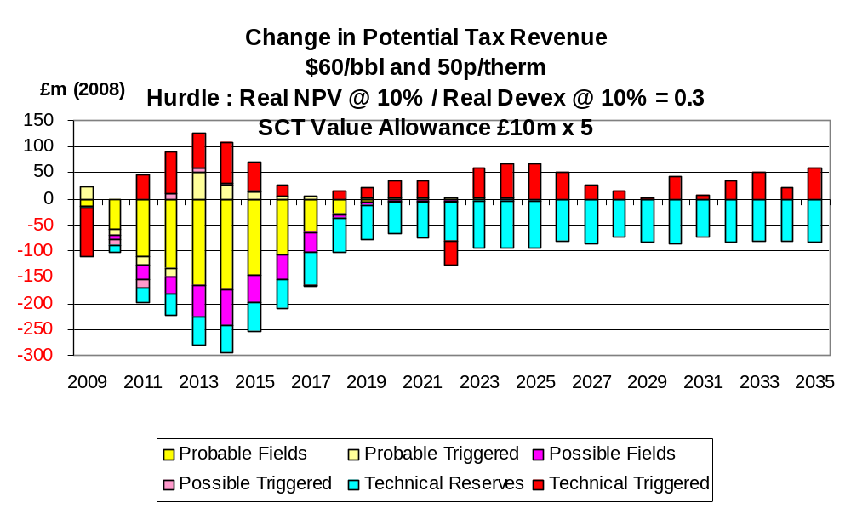
The changes in production from the £50 million allowance under the $80,70p price case are shown in Charts 29 – 31. The increases are not so large as with the $60,50p case because more of the fields pass the investment hurdle without the allowance. Nevertheless over the whole period the increase in total hydrocarbon production is nearly 25,000 boe/d. The aggregate increase to 2035 is 258 mmboe. The increase in field investment (Chart 32) is much less than under the $60,50p case but remains significant, exceeding £150 million in a considerable number of years. The net change in tax revenues is substantially negative (Chart 33) reflecting the fact that many fields pass the investment hurdle under the current tax system.

Chart 29

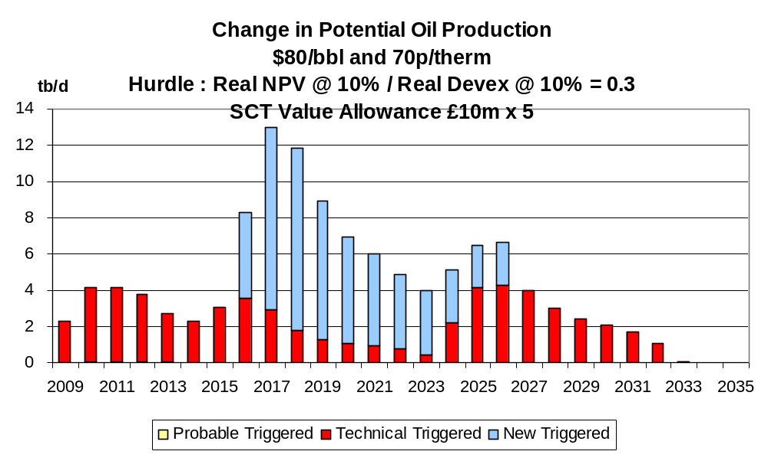

Chart 30
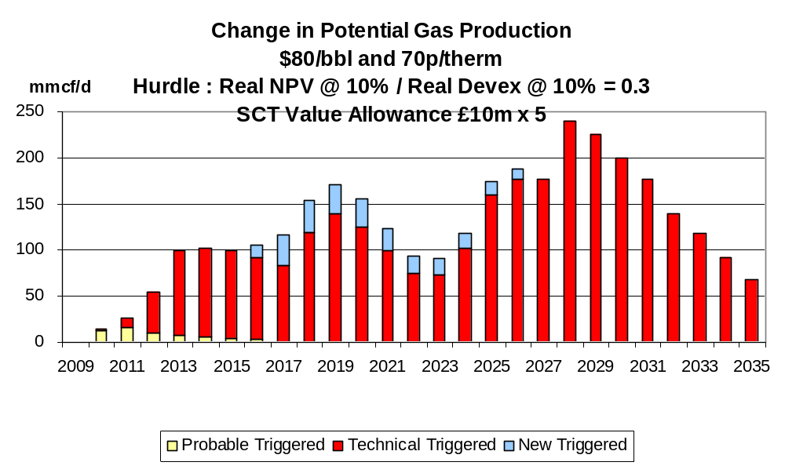

Chart 31
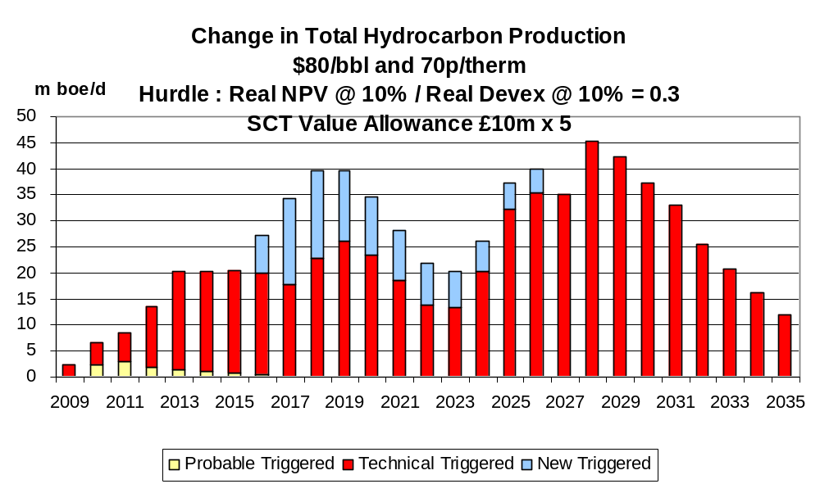

Chart 32
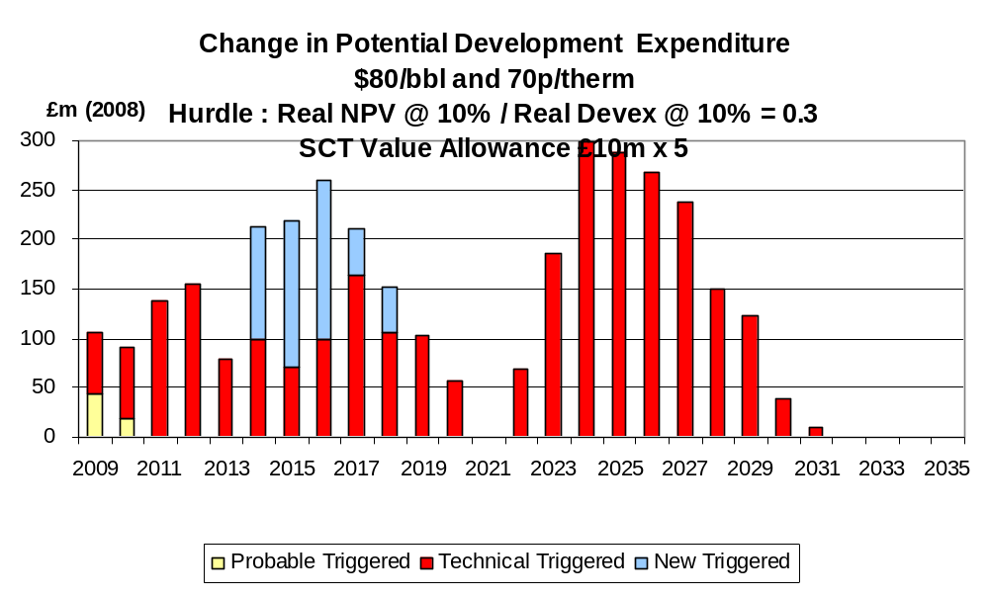

Chart 33
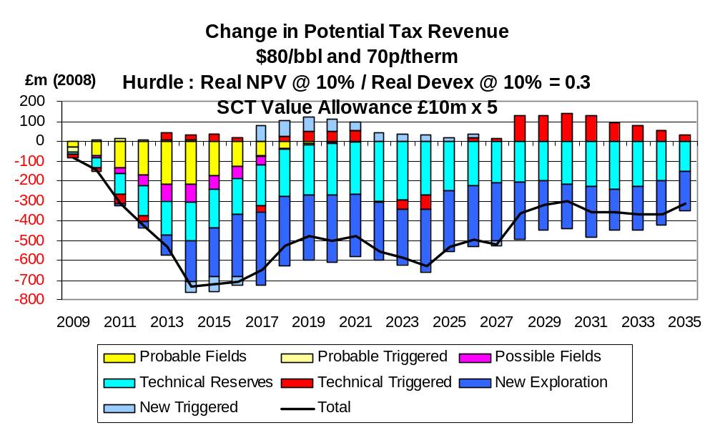

Detailed Effects of Allowance at £100 million

The effects of a value allowance of £100 million on production under the $40,30p price case are shown in Charts 34 – 36. The effect is seen to be fairly dramatic with the increase in total hydrocarbon production over the whole period averaging well in excess of 80,000 boe/d. The aggregate increase in the period to 2035 is 825 mmboe. In a significant number of years the increase exceeds 100,000 boe/d. The increase in field investment is correspondingly impressive (Chart 37). In the period 2009 – 2012 the total increase exceeds £1 billion at 2008 prices. In the great majority of years the increase exceeds £200 million. The net change in tax revenues from all categories of fields is negative (Chart 38). It is noticeable, however, that, if the fields in the category of new discoveries are excluded because of the uncertainties regarding their characteristics, the net change in tax revenues is quite small (Chart 39).

Chart 34
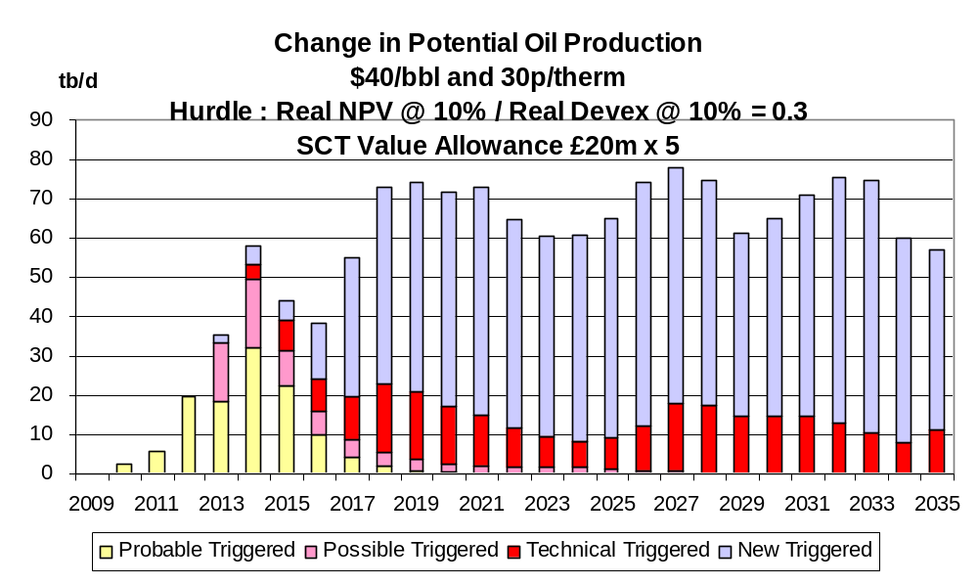

Chart 35
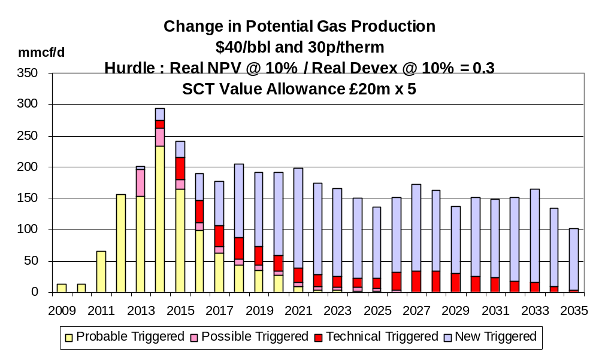

Chart 36
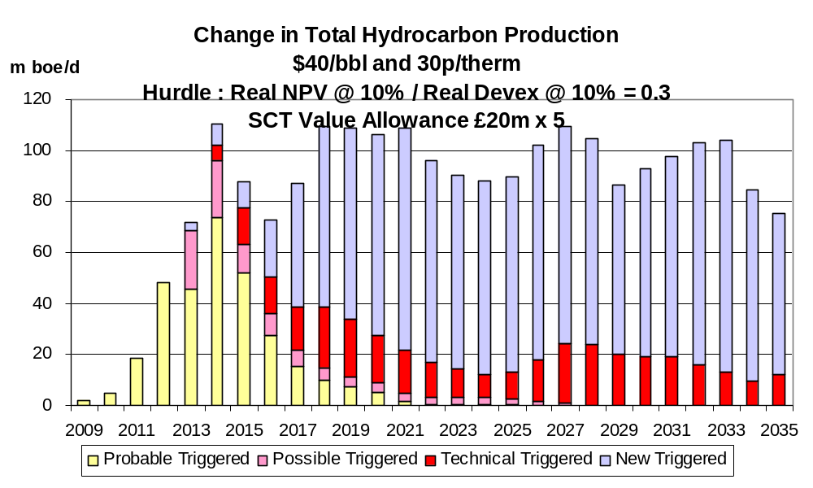

Chart 37
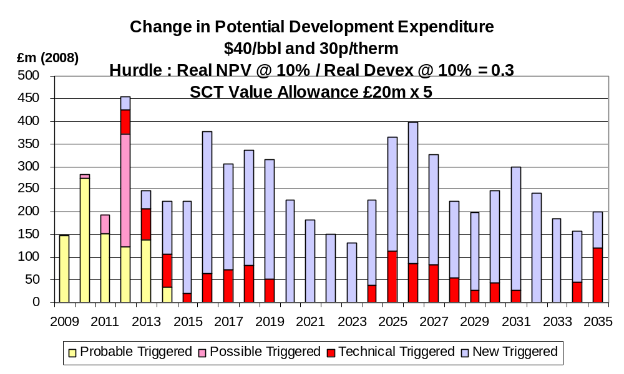

Chart 38
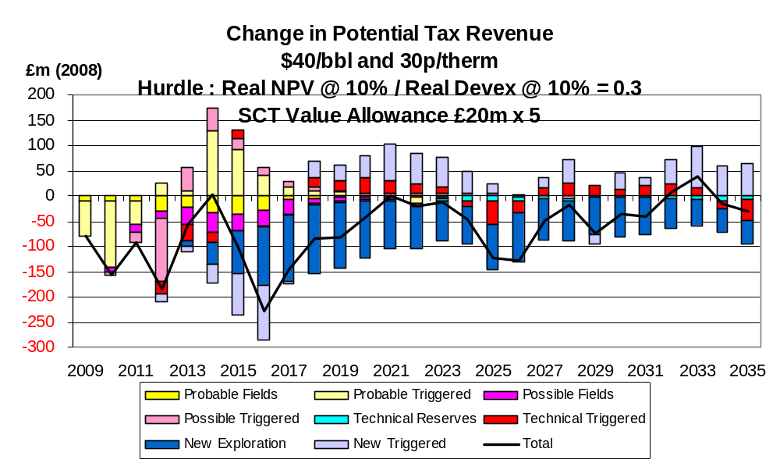

Chart 39
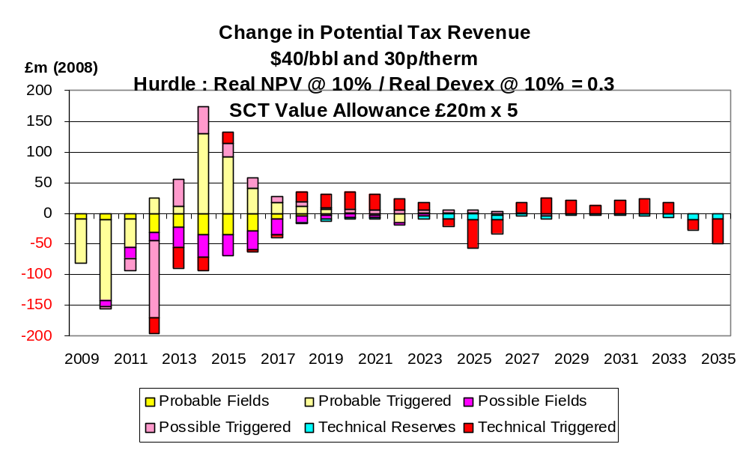

The effects of the £100 million allowance on production under the $60,50p case are shown in Charts 40 – 42. The increases are seen to be very considerable with the average for total hydrocarbon production being around 65,000 boe/d over the period to 2035. In 7 of the years the increase exceeds 80,000 boe/d. The aggregate increase in the period to 2035 is 652 mmboe. The increase in field investment is correspondingly substantial (Chart 43). In the period 2009 – 2013 inclusive the increase is £1.3 billion (at 2008 prices). Over the whole period the annual average increase is over £250 million. The net change in tax revenues is substantially negative (Chart 44), but if the fields in the new discoveries category are excluded because of the uncertainties surrounding their characteristics the net loss is much less (Chart 45).

Chart 40
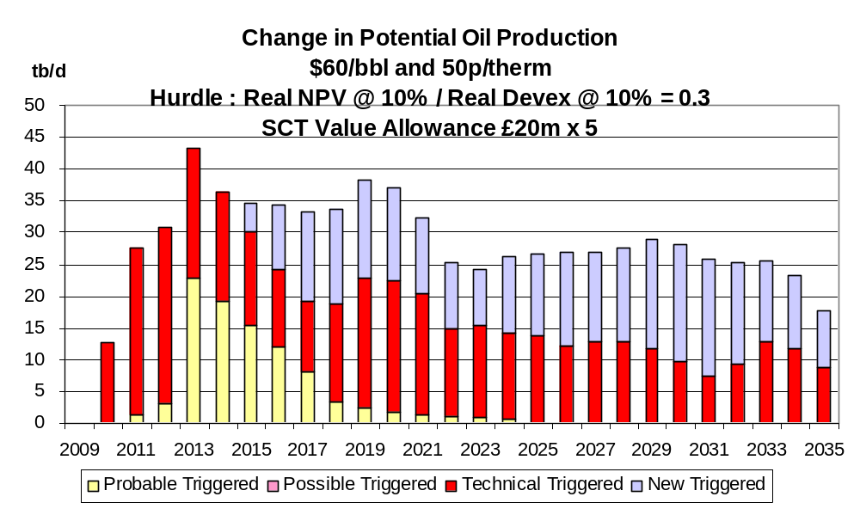

Chart 41
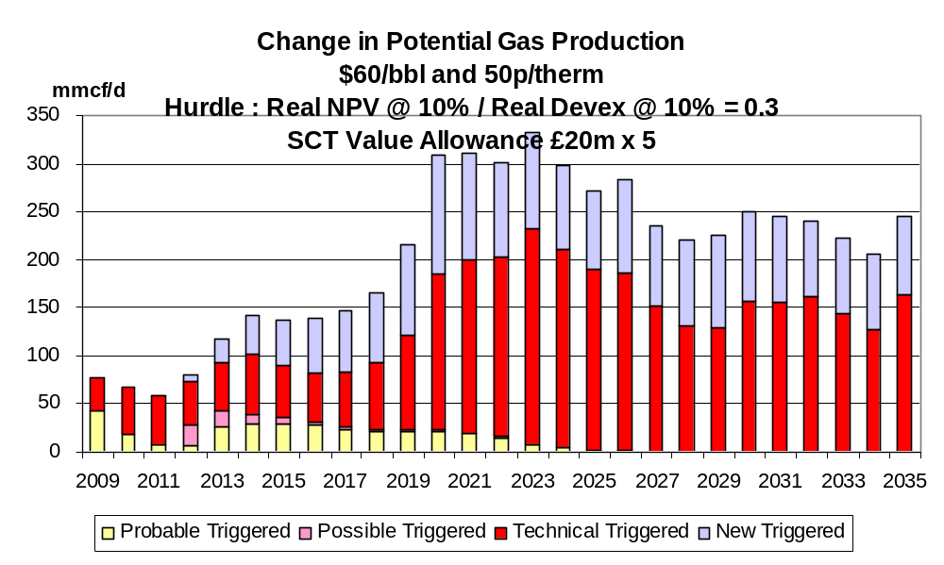

Chart 42

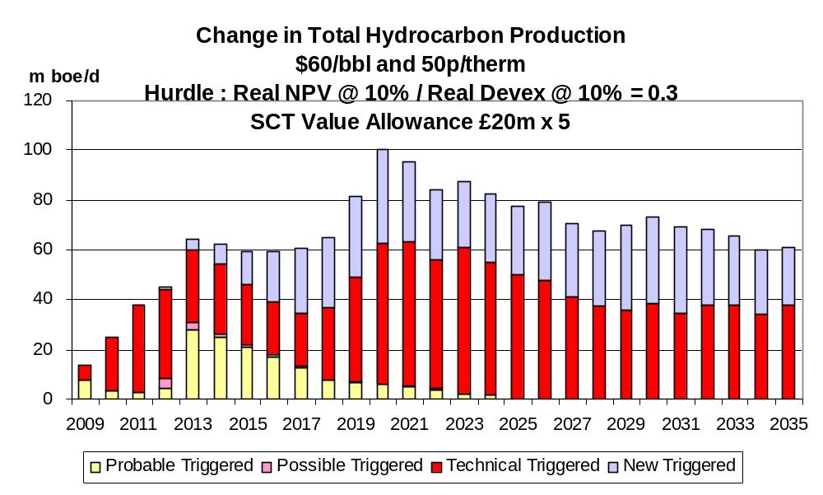

Chart 43
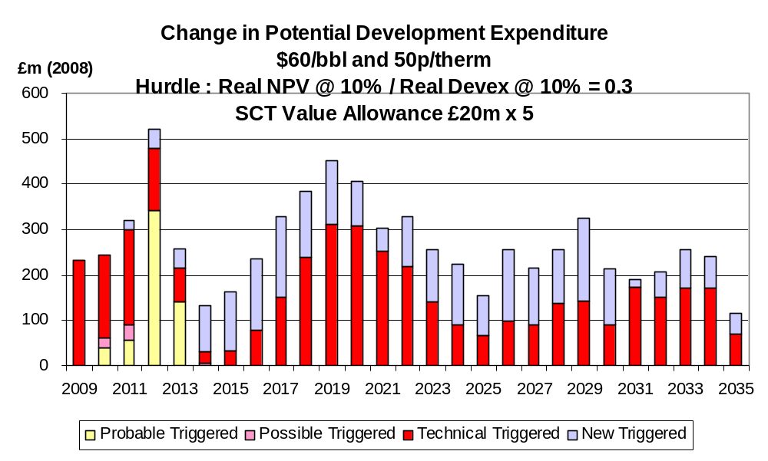

Chart 44

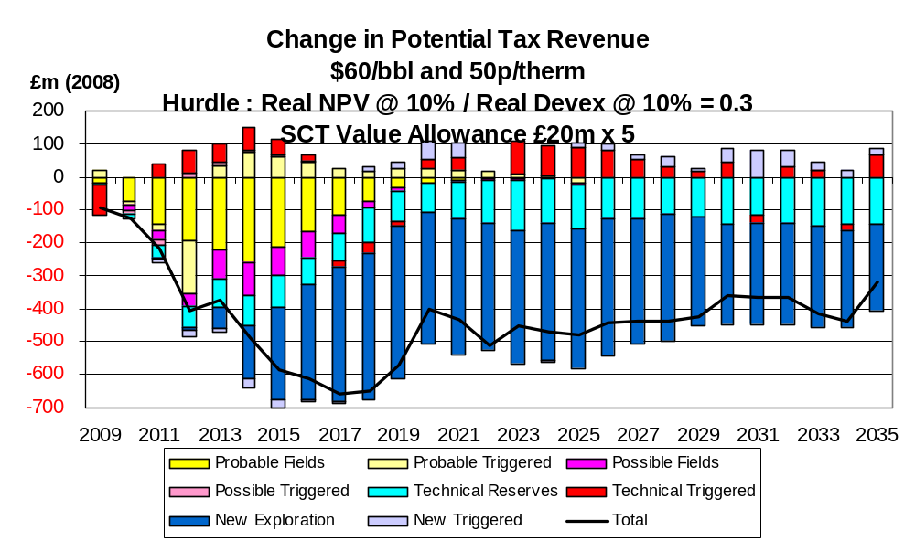

Chart 45
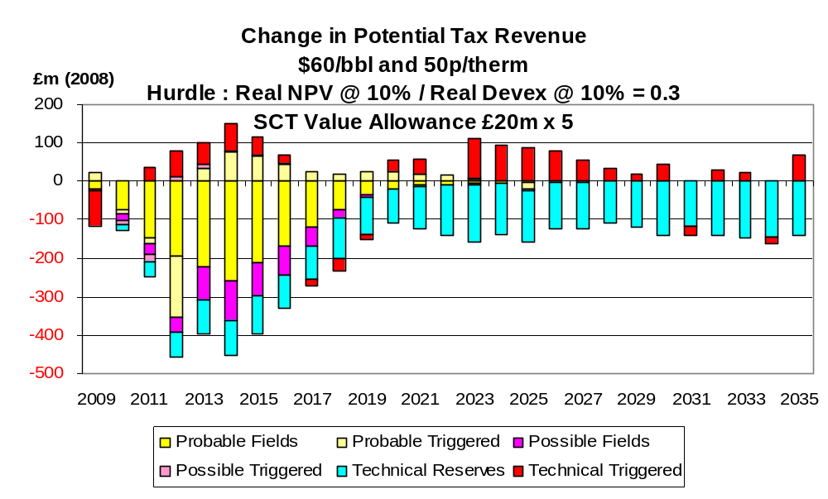
The increases in production from the £100 million allowance under the $80,70p price case are shown in Charts 46 – 48. The increase is relatively modest in the years to 2015 but becomes much larger in the 2020’s, exceeding 50,000 boe/d for a considerable number of years when the development of a substantial number of fields in the category of technical reserves is triggered. The aggregate increase in the period to 2035 is 352 mmboe. The increase in field investment is substantial (Chart 49). In several years in the 2020’s the annual increase exceeds £300 million. The net change in tax revenues is substantially negative (Chart 50), though it is much less when the future discoveries are excluded (Chart 51).

Chart 46
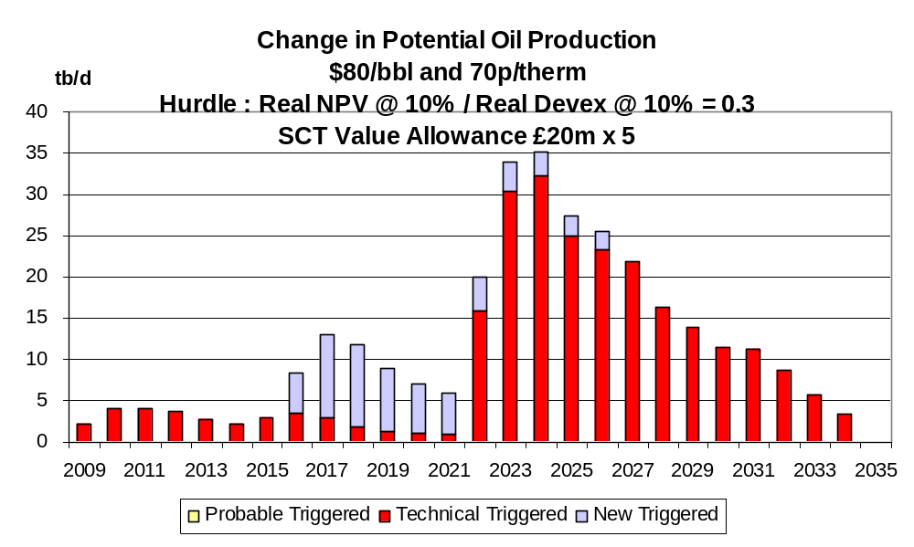

Chart 47
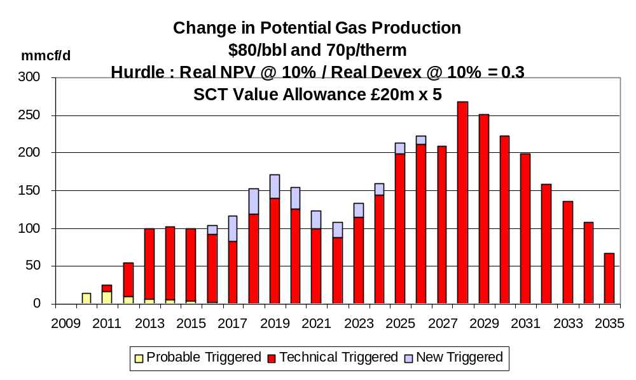

Chart 48
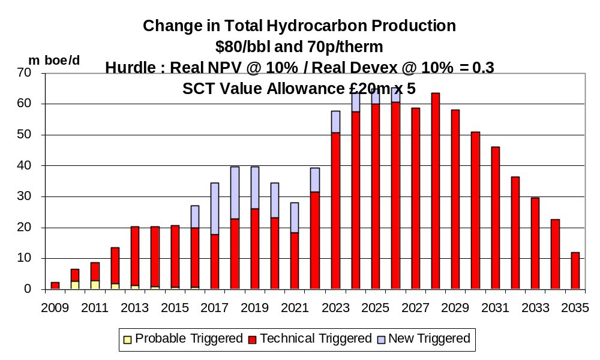

Chart 49
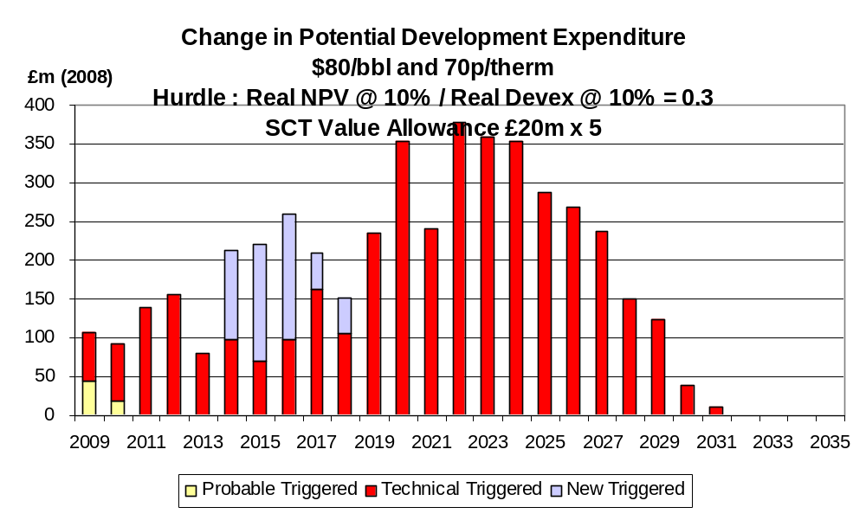

Chart 50
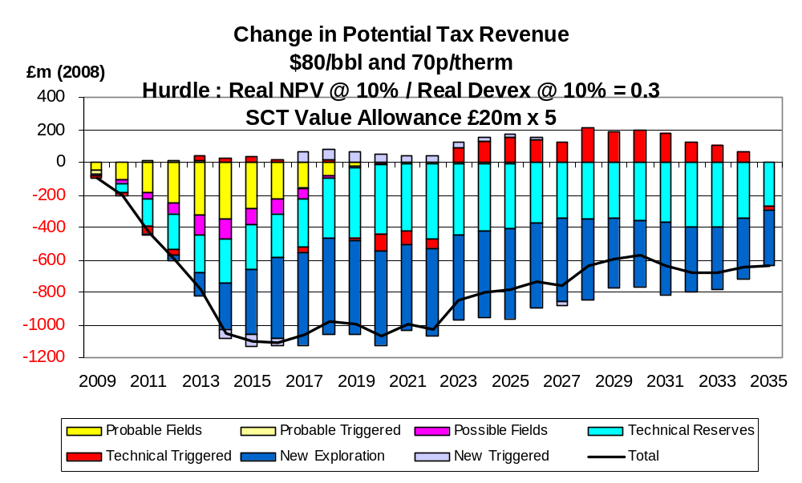

Chart 51
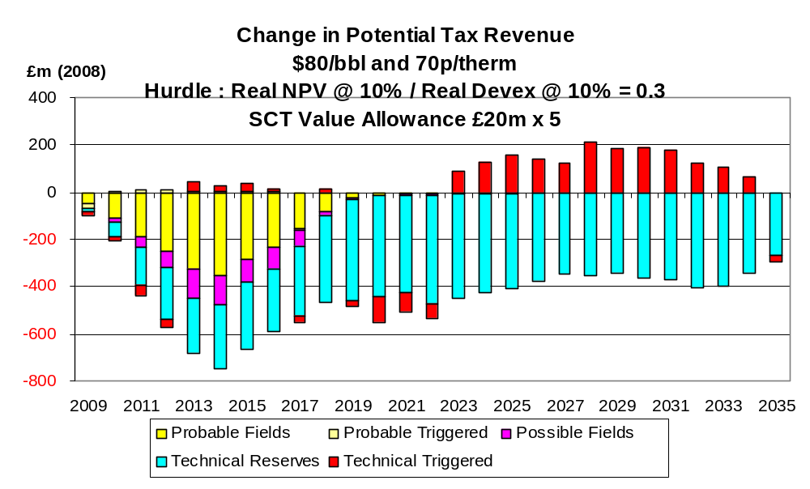

Effects of Value Allowance of £250 million

The effects of a very large value allowance (£250 million) were also modelled but are not presented here in detail. It is noteworthy that under the $40,30 pence case the aggregate increase in production in the period to 2035 is 899 mmboe. Under the $60,50 pence case the corresponding increase is 901 mmboe, and under the $80,70 pence case the aggregate increase is 455 mmboe.

Value Allowance Applied to Small Fields (≤ 20 mmboe)

- Numbers of Field Developments Triggered

The results in the case where the various value allowance are given only to small fields (defined as those with recoverable reserves of ≤ 20 mmboe) are now discussed. The numbers of new field developments which are triggered by the allowance in the period to 2035 are shown in Table 7 classified according to category.

Table 7
Number of small fields (≤ 20 mmboe) Triggered by Value Allowance to 2035

 | Probable | Possible | Technical Reserves | New Exploration | Total
$40,30p SCT Allowance £2.5m x 5 | 3 | 1 | 4 | 7 | 15
$40,30p SCT Allowance  £10m x 5 | 5 | 2 | 8 | 20 | 35
$40,30p SCT Allowance  £20m x 5 | 6 | 2 | 8 | 22 | 38
$60,50p SCT Allowance £2.5m x 5 | 4 | 1 | 14 | 12 | 31
$60,50p SCT Allowance  £10m x 5 | 4 | 2 | 26 | 19 | 51
$60,50p SCT Allowance  £20m x 5 | 4 | 2 | 27 | 21 | 54
$80,70p SCT Allowance £2.5m x 5 | 1 | 0 | 6 | 0 | 7
$80,70p SCT Allowance  £10m x 5 | 1 | 0 | 15 | 0 | 16
$80,70p SCT Allowance  £20m x 5 | 1 | 0 | 15 | 0 | 16

Under the $40,30p case it is seen that the £12.5 million allowance triggers 15 developments over the period. The £50 allowance triggers 35 new developments, and the £100 million one triggers 38. In both cases the majority of the developments are in the category of new discoveries. Under the $60,50 pence case the £12.5 million allowance triggers 31 new developments, while the £50 million allowance triggers 51, and the £100 million one triggers 54 developments. It is seen that very substantial numbers of developments in the categories of technical reserves and new discoveries are triggered with the higher levels of allowance. Under the $80,70p case it is seen that the £12.5 million allowance triggers very few developments, while the larger ones each trigger 16 new fields, the great majority being in the technical reserves category.

- Detailed Effects of £12.5 million Value Allowance

The effects of the small value allowance of £12.5 million in procuring extra production are shown in Charts 52 -54. The general effect is quite modest, with the extra total hydrocarbon production averaging around 12,000 boe/d over the whole period. The aggregate increase in the period to 2035 is 108 mmboe. In the later part of the period for some years it is in the range 15,000 – 20,000 boe/d. The increase in new field investment (Chart 55) is correspondingly small. The changes in tax revenues across all categories of fields are shown in Chart 56. Reflecting the changes in activity they are very small throughout the period. The net effect on fields in the probable/possible categories is positive (Chart 57).

Chart 52
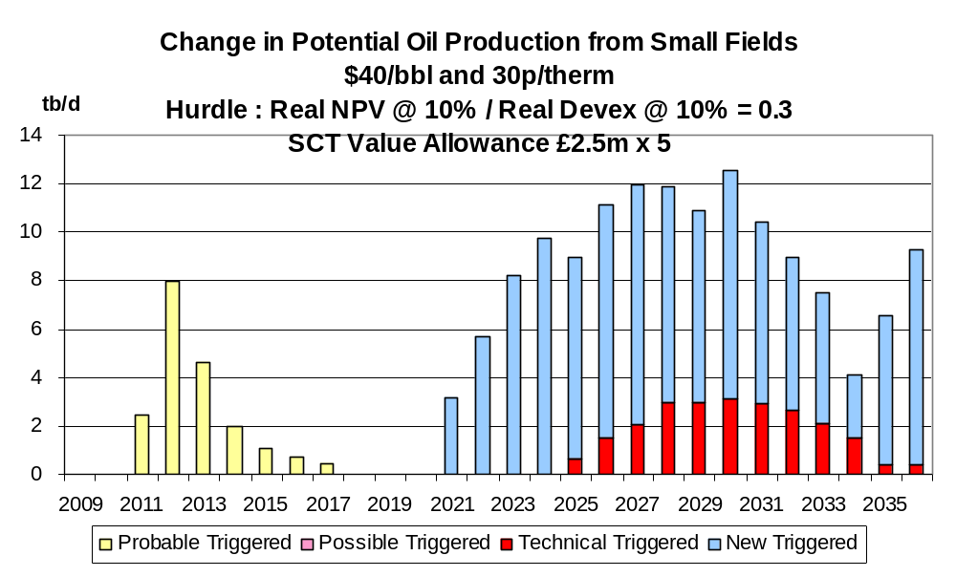

Chart 53
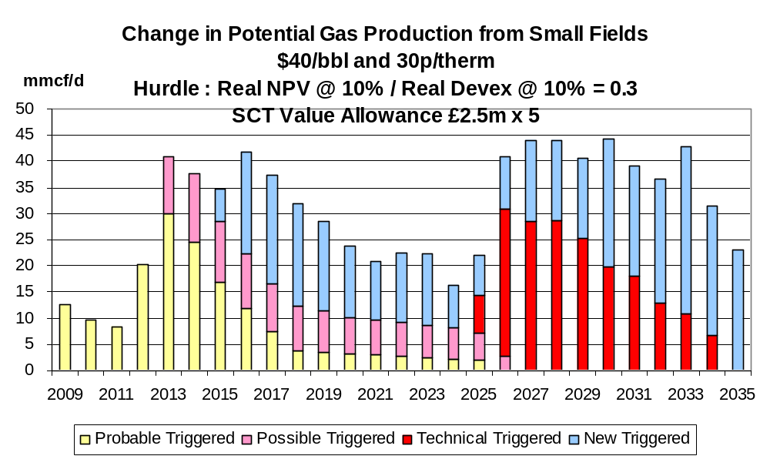

Chart 54
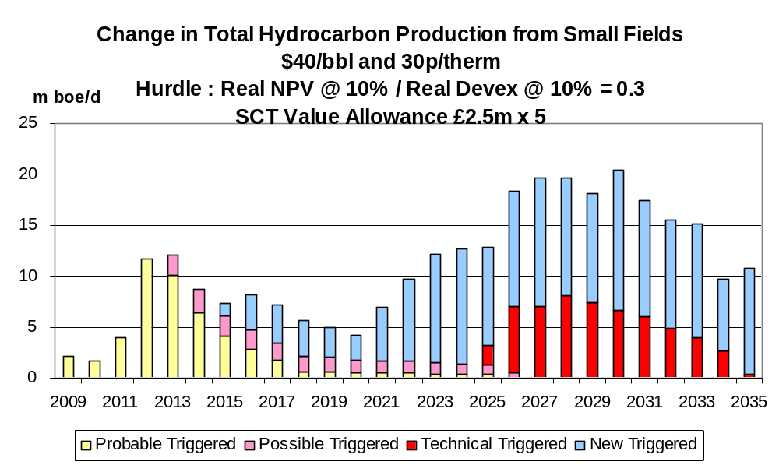

Chart 55
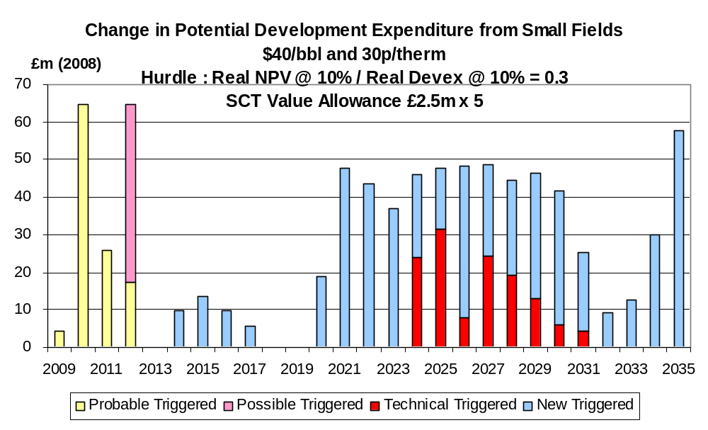

Chart 56
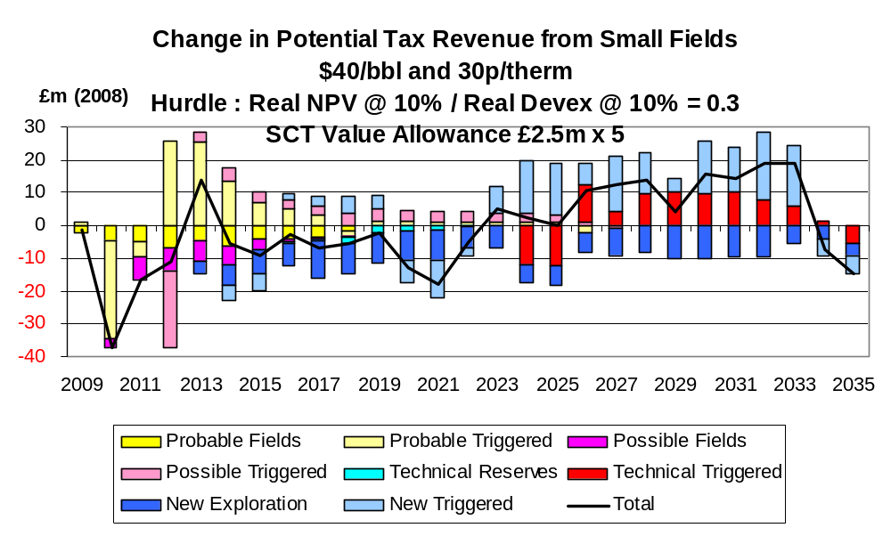

Chart 57

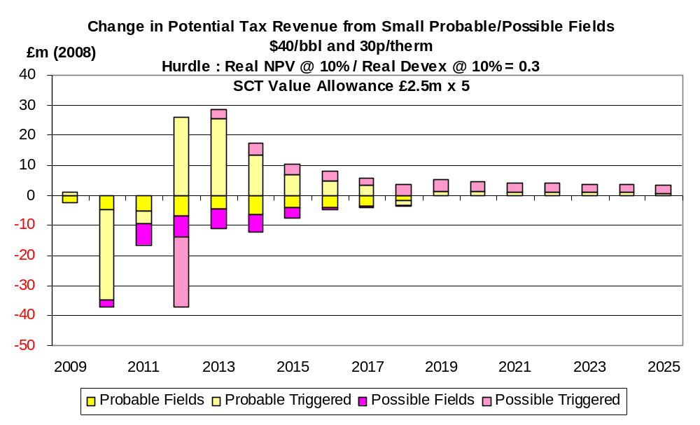

The effects of the £12.5 million allowance on production under the $60,50 pence case are shown in Charts 58 – 60. The increase in total hydrocarbon production averages more than 20,000 boe/d over the whole period. The aggregate increase in the period to 2035 is 195 mmboe. In several years it exceeds 25,000 boe/d. The increase in field investment (Chart 61) may be defined as modest though certainly worthwhile. The change in total tax revenues is shown in Chart 62 where it is seen that the net effect is negative.

Chart 58
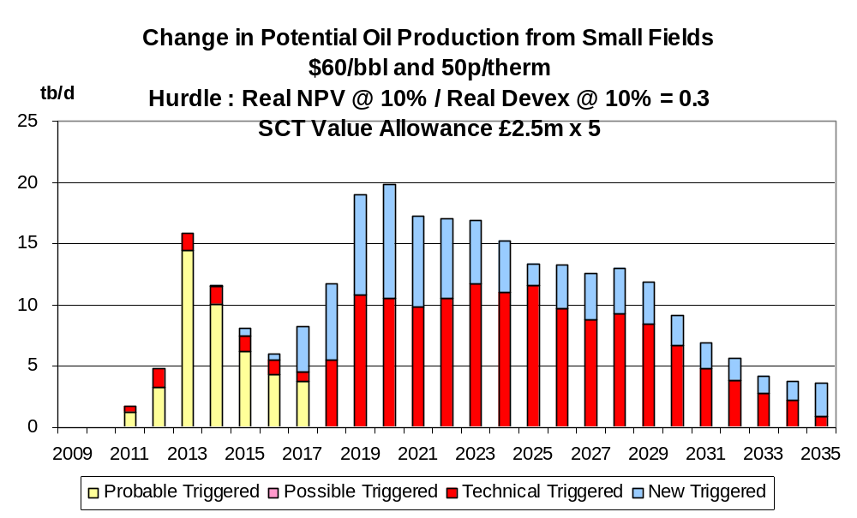

Chart 59

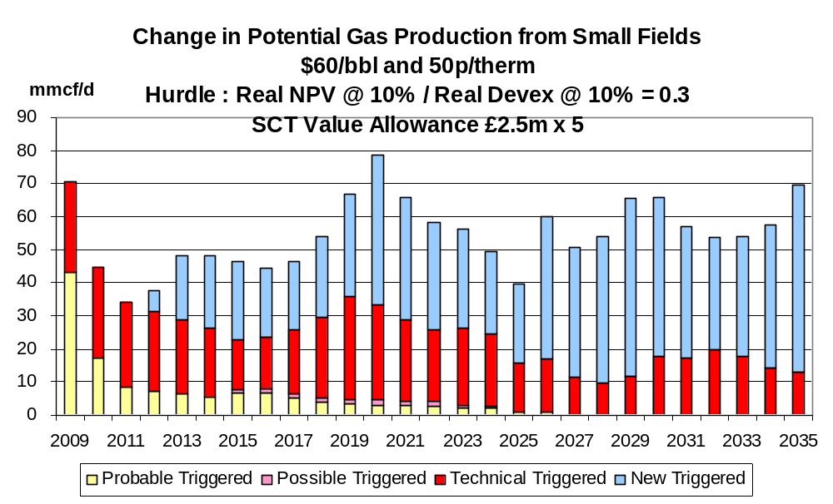

Chart 60
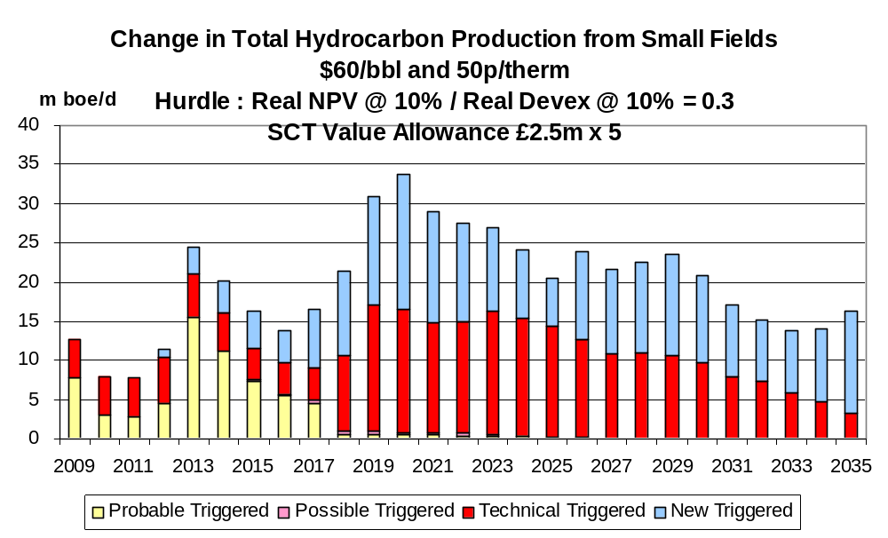
Chart 61

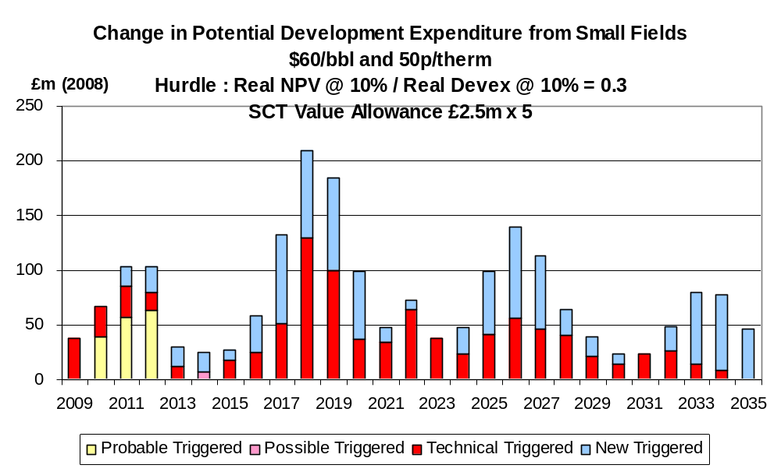

Chart 62
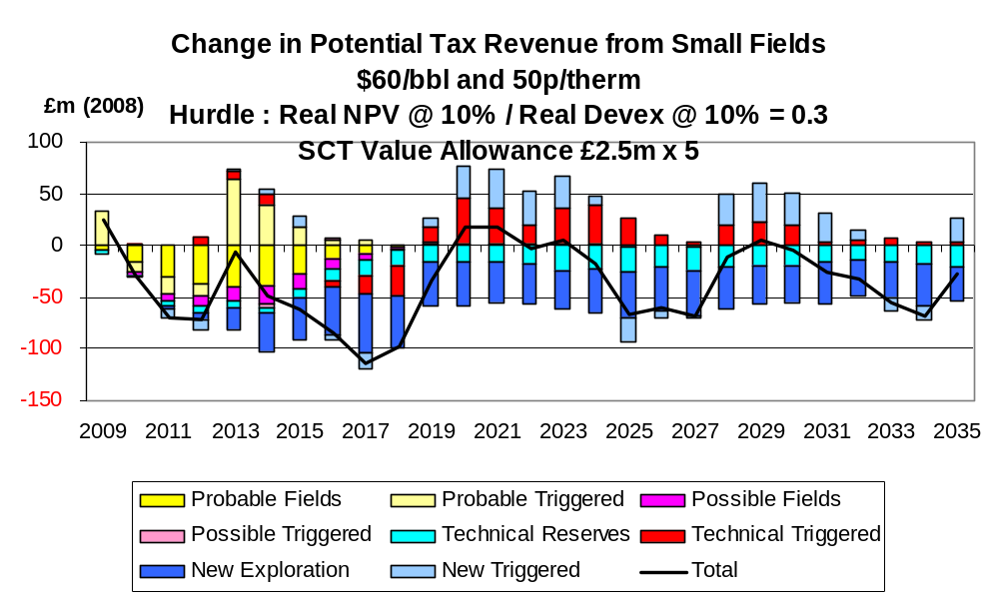

The increase in production under the $80,70 pence case with the £12.5 million allowance is shown in Charts 63 – 65. The effects are seen to be extremely small. The aggregate increase in the period to 2035 is only 48 mmboe. This is reflected in the related increase in field investment (Chart 66). There is a clear loss of net tax revenues (Chart 67).

Chart 63
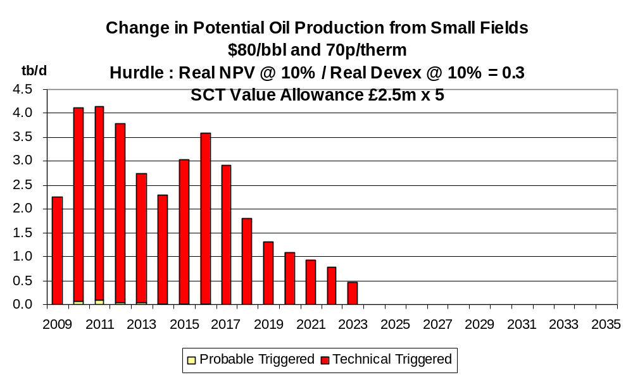

Chart 64
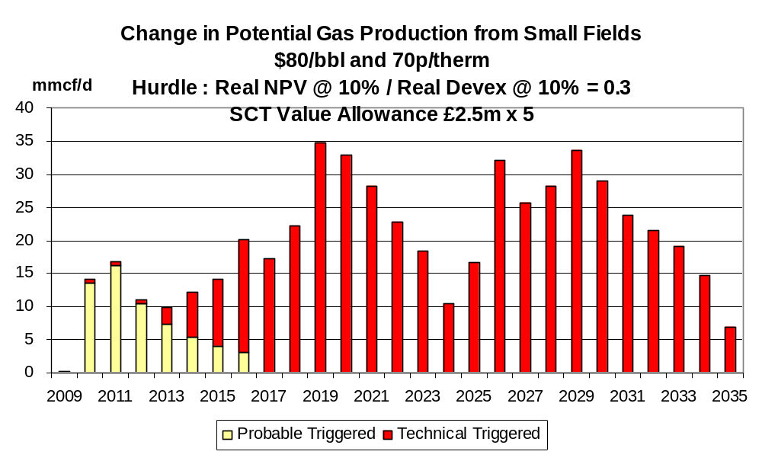

Chart 65
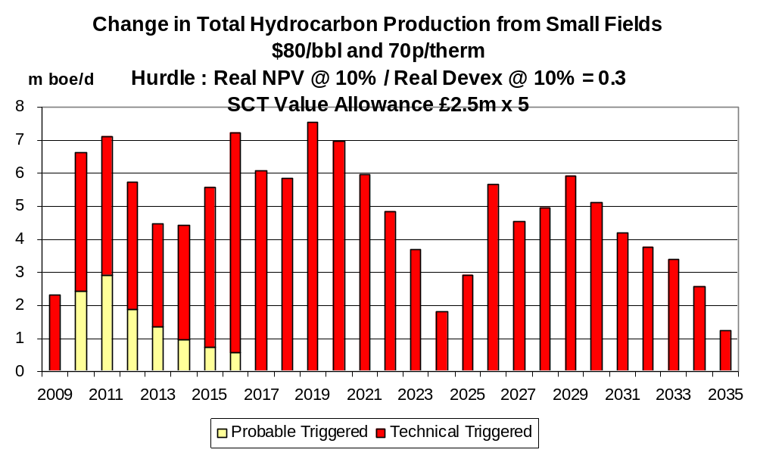

Chart 66
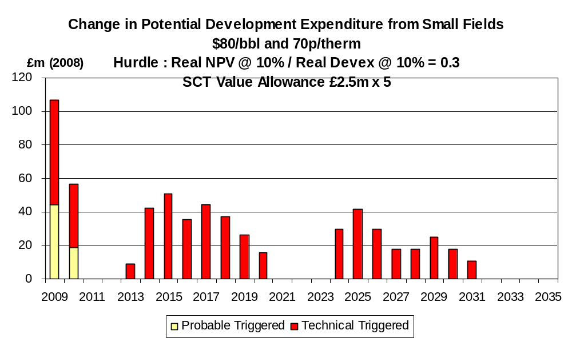

Chart 67
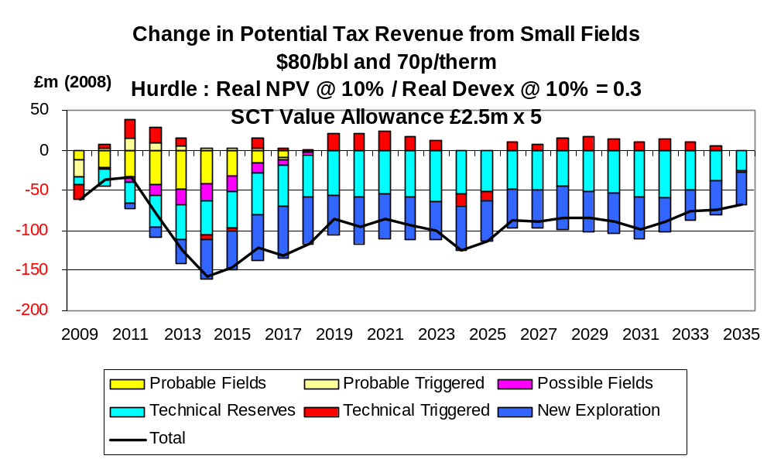
- Detailed Effects of Value Allowance of £50 million

The effects of a value allowance of £50 million on production under the $40,30 pence price case are shown in Charts 68 – 70. Total hydrocarbon production is seen to increase by over 30,000 boe/d across the whole period. In 7 of the years the increase exceeds 40,000 boe/d with much of the increase in the longer term coming from fields in the category of new discoveries. The aggregate increase in the period to 2035 is 313 mmboe. The increase in field investment (Chart 71) averages just under £100 million per year over the whole period with £365 million (at 2008 prices) coming in the period 2009 – 2012 inclusive. The changes in total tax revenues (Chart 72) are seen to be relatively small.

Chart 68
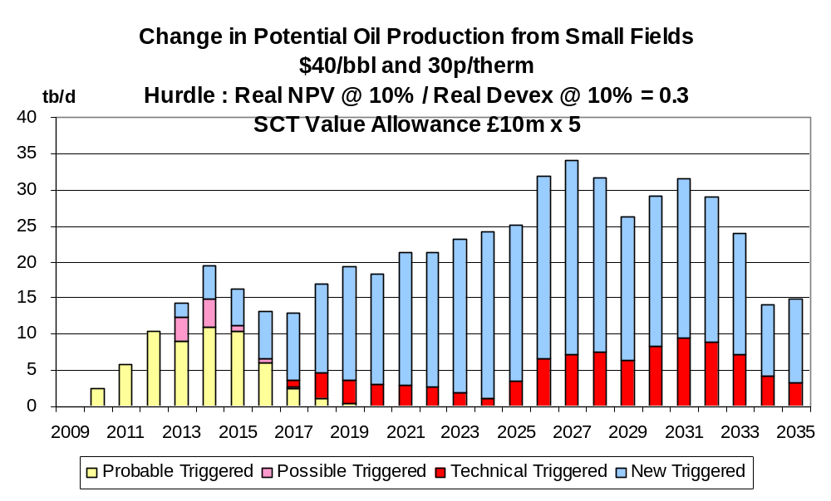

Chart 69
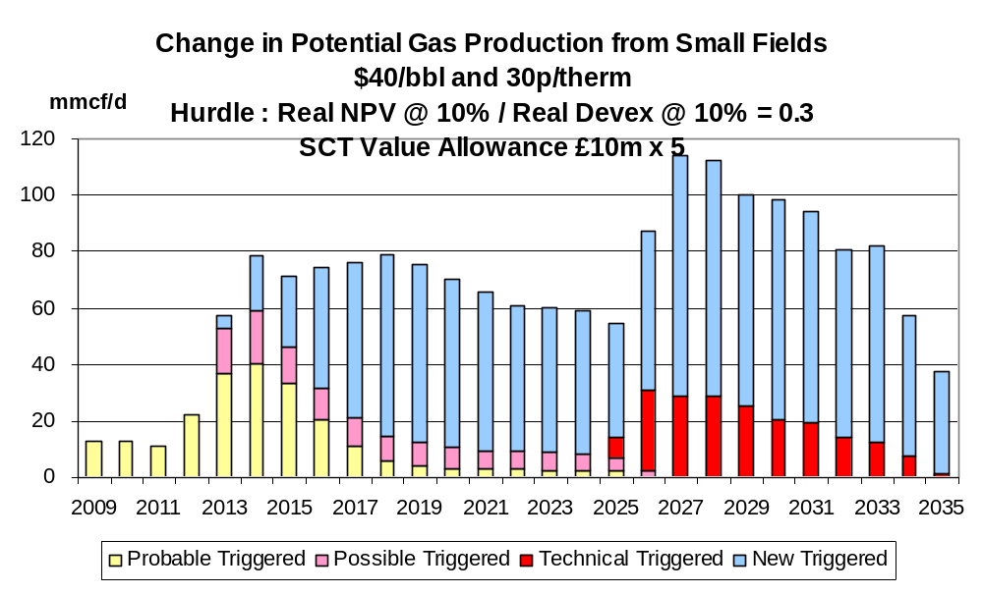

Chart 70
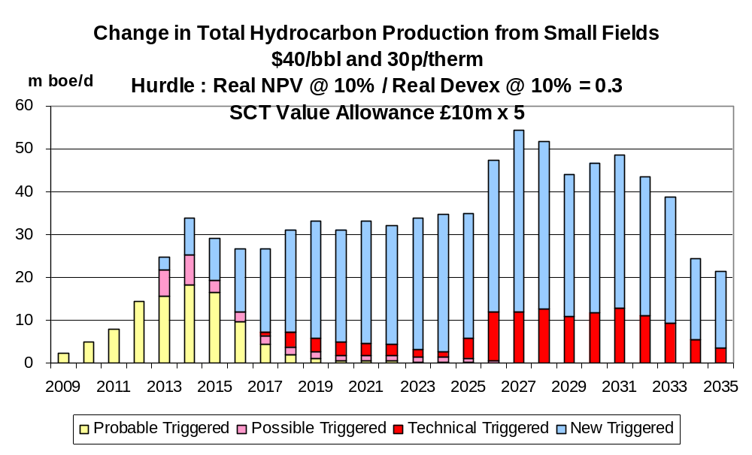

Chart 71
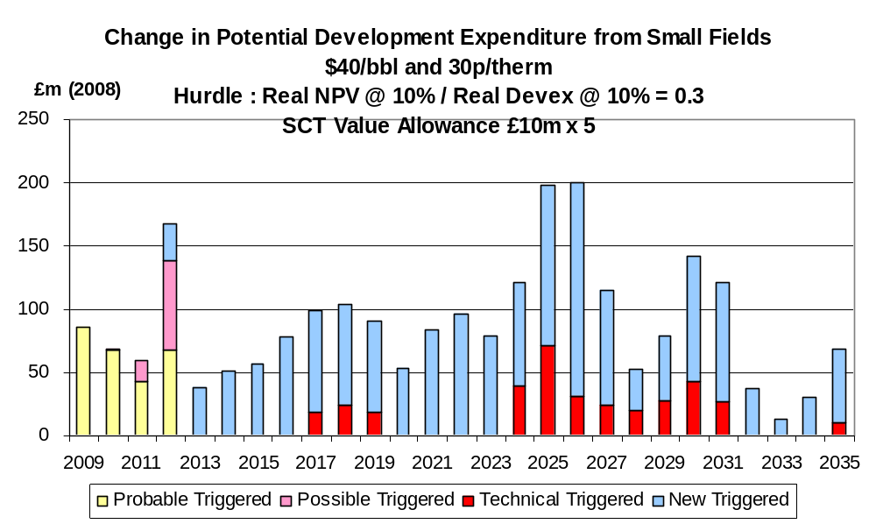

Chart 72
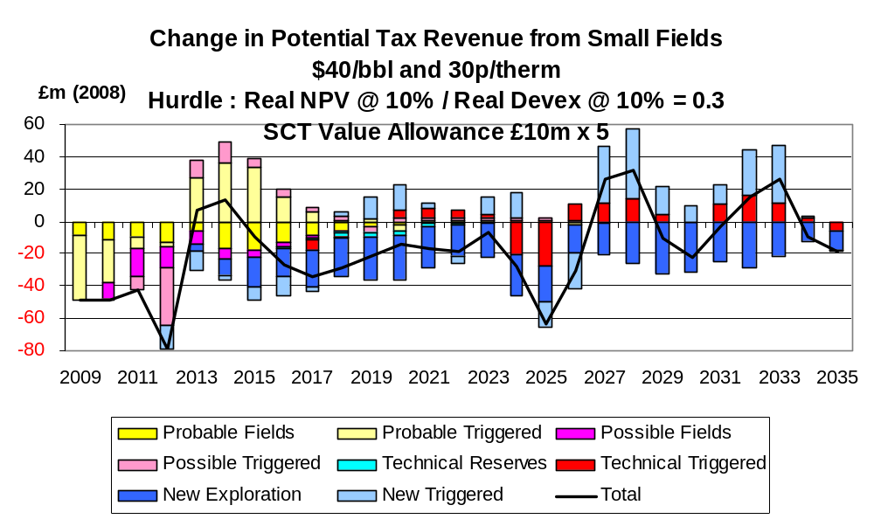

The effects of the £50 million allowance under the $60,50 pence case on production are shown in Charts 73 -75. The increase in total hydrocarbon production is around 35,000 boe/d over the whole period and in 4 years the increase exceeds 50,000 boe/d. The aggregate increase in the period to 2035 is 359 mmboe. In this scenario significant extra production comes from fields in the category of technical reserves as well as from new discoveries. The related increase in field investment (Chart 76) exceeds £100 million per year on average with the annual value exceeding £250 million in some years. The change in tax revenues (Chart 77) is seen to be significantly negative.

Chart 73
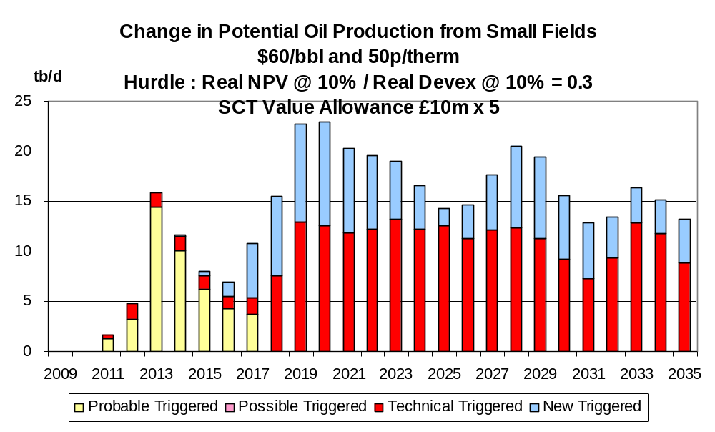

Chart 74
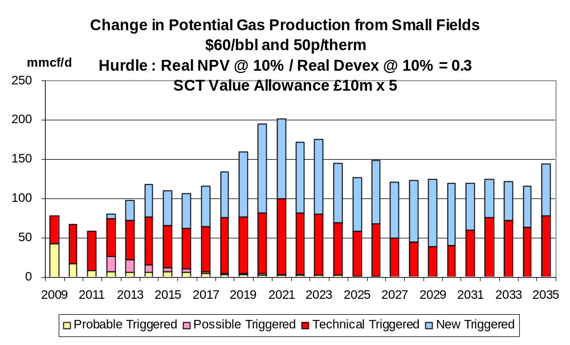

Chart 75
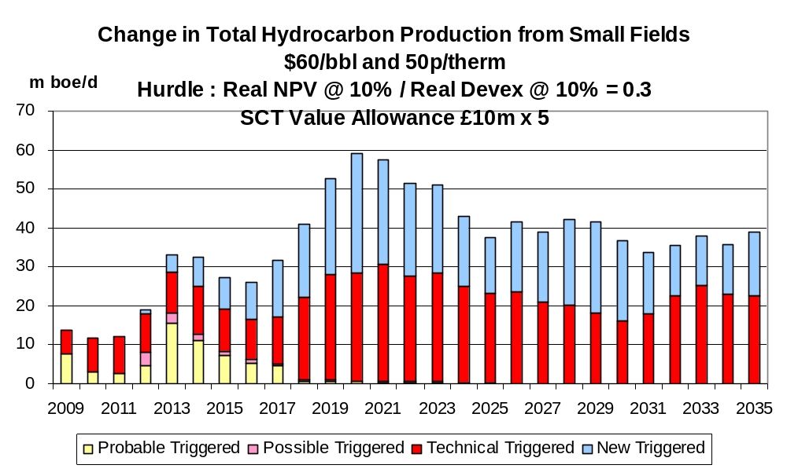

Chart 76
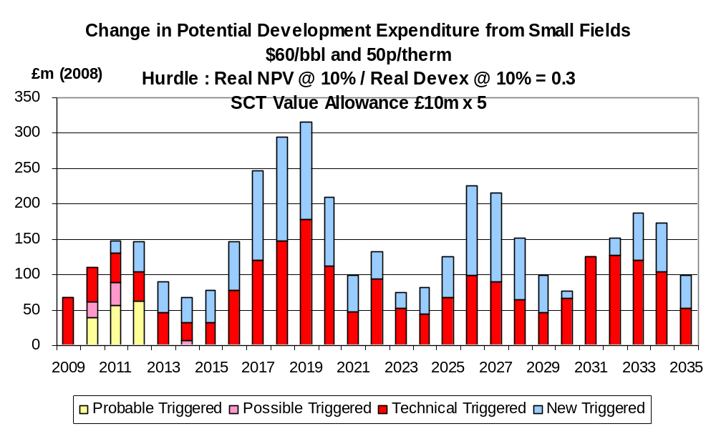

Chart 77
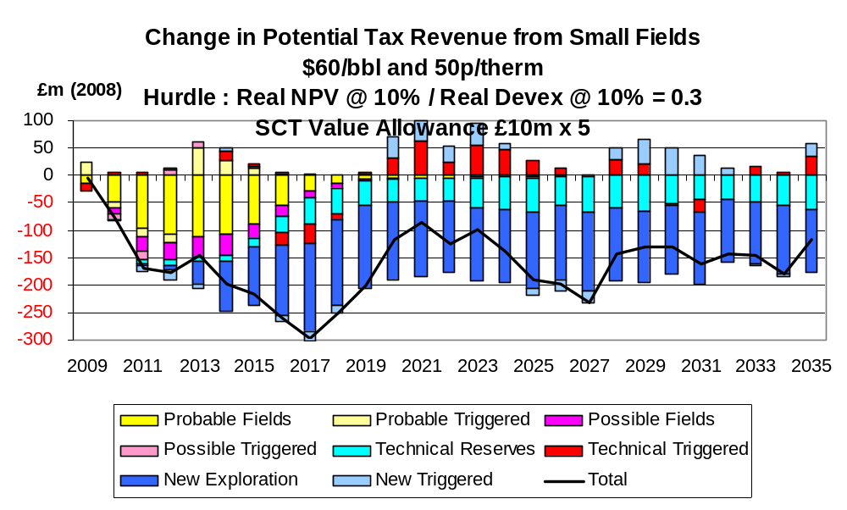
The changes in production form the £50 million allowance under the $80,70 pence case are shown in Charts 78 – 80. The increase averages nearly 15,000 boe/d over the whole period with virtually all the extra production coming from fields in the category of technical reserves. The aggregate increase over the period to 2035 is 157 mmboe. The increase in field investment (Chart 81) is relatively high compared to the modest increase in production, reflecting the high costs of fields in this category. The changes in tax revenues (Chart 82) are seen to be significantly negative.

Chart 78
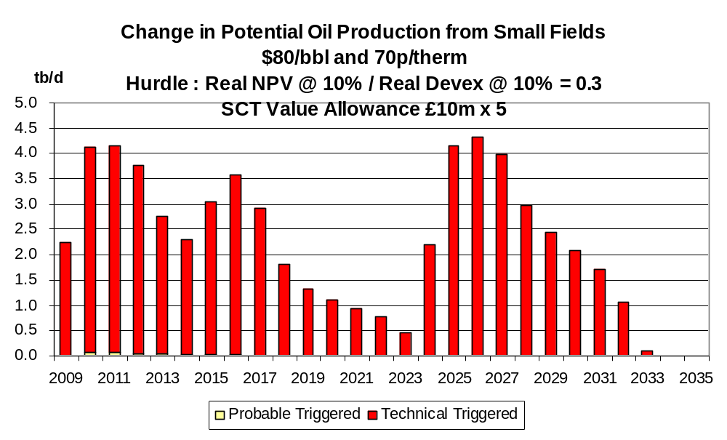

Chart 79
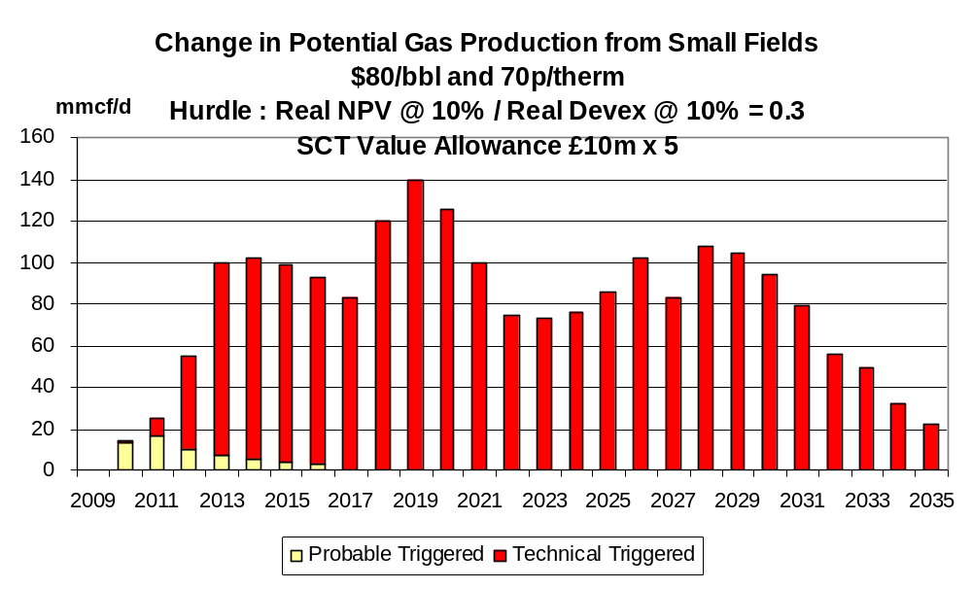

Chart 80
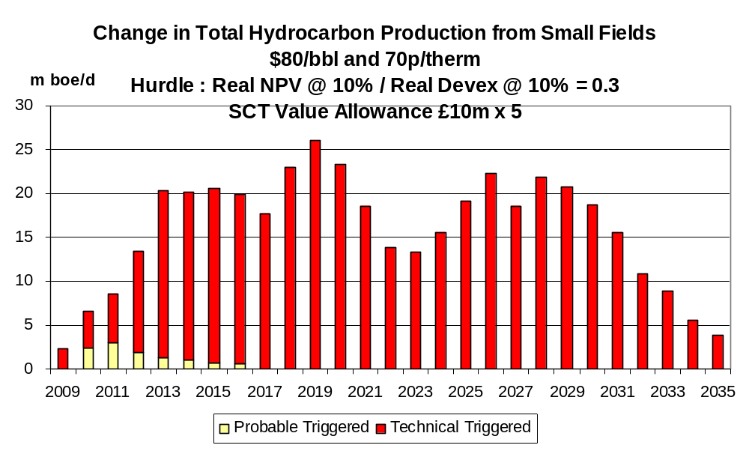

Chart 81
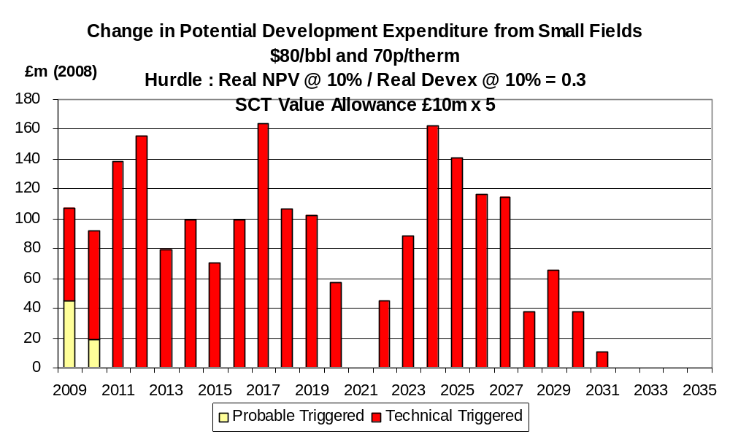

Chart 82
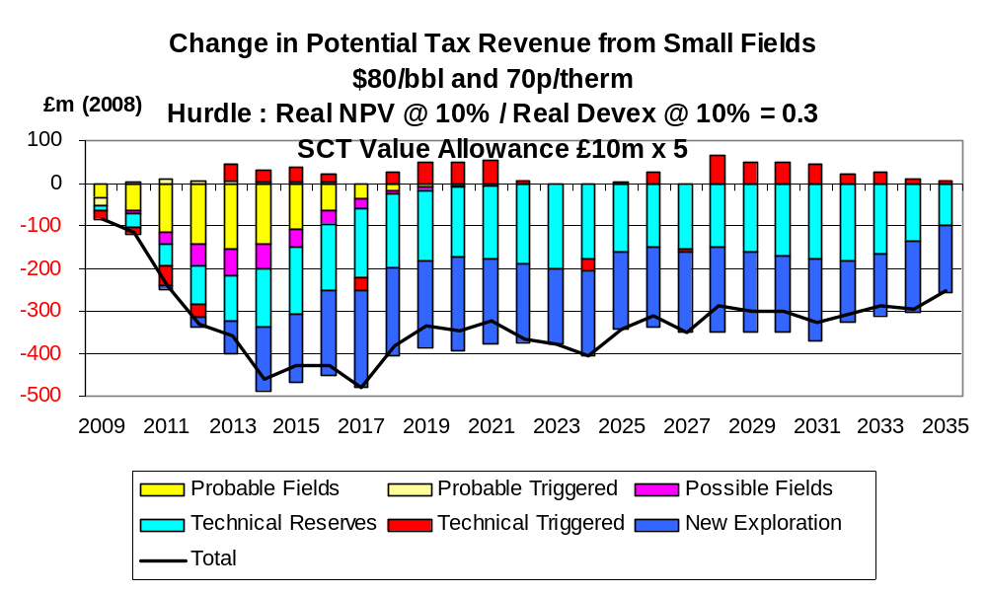

- Detailed Effects of Value Allowance of £100 million

The changes in production emanating from a value allowance of £100 million are shown in Charts 83 -85 under the $40,30 pence case. The increase in total hydrocarbon production exceeds 30,000 boe/d over the whole period. The aggregate increase over the period to 2035 is 355 mmboe. In the near term there are worthwhile increases from fields in the probable/possible field categories and in the longer term the increase is mostly from fields in the category of new discoveries. The yearly increase in field investment averages around £100 million. In the period 2009 – 2012 the total increase is around £490 million (Chart 86). The change in total tax revenues (Chart 87) is seen to be quite small.

Chart 83
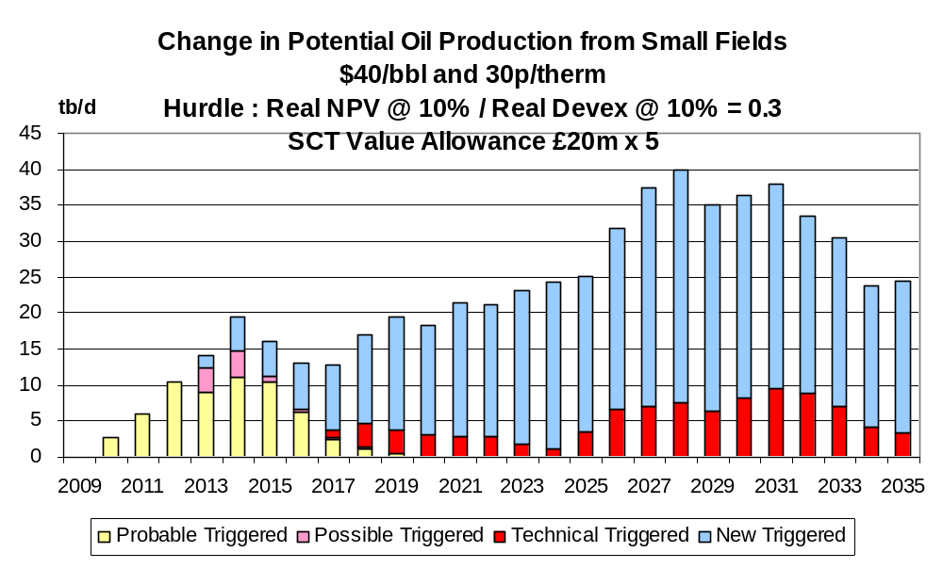

Chart 84
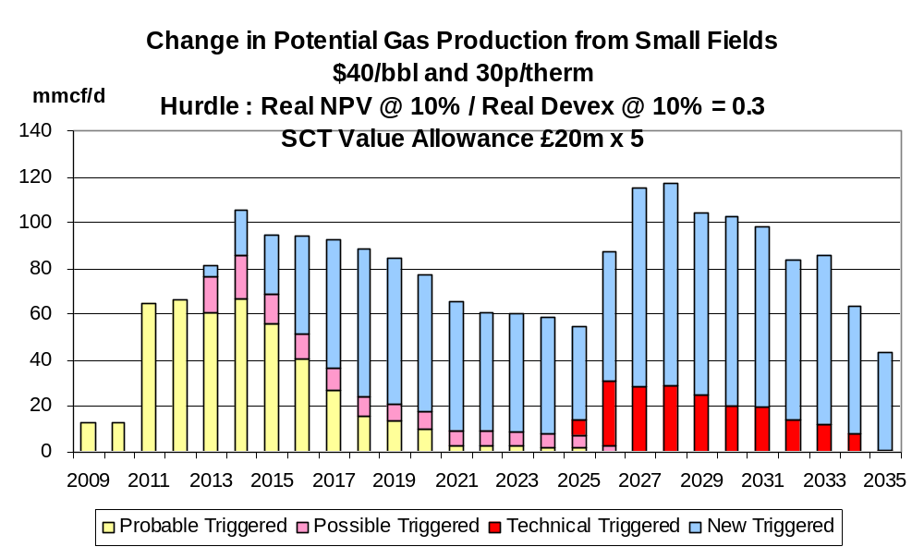

Chart 85
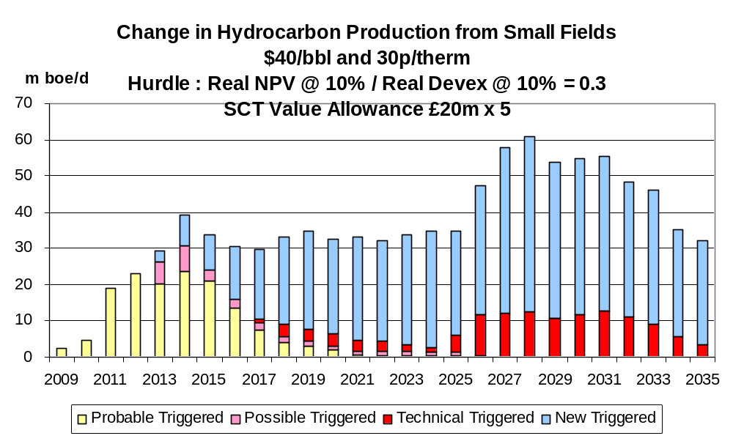
Chart 86
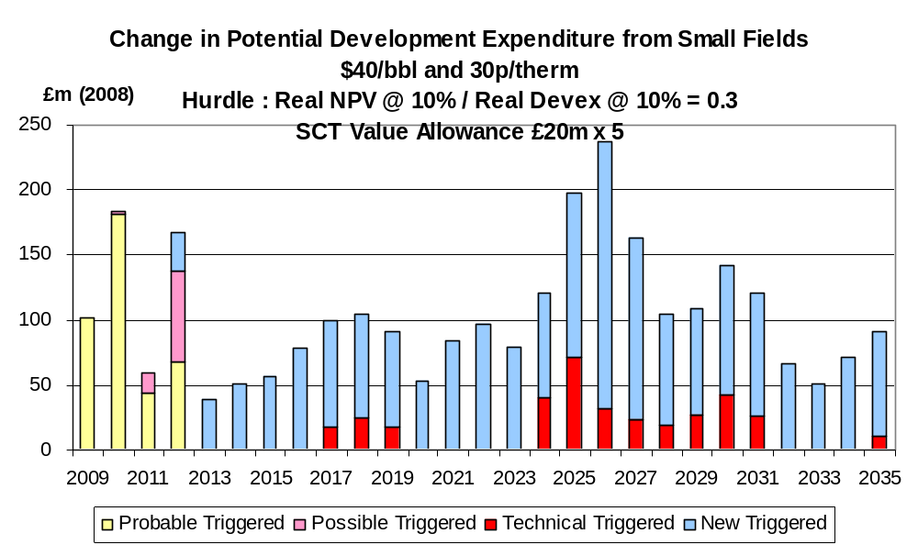

Chart 87
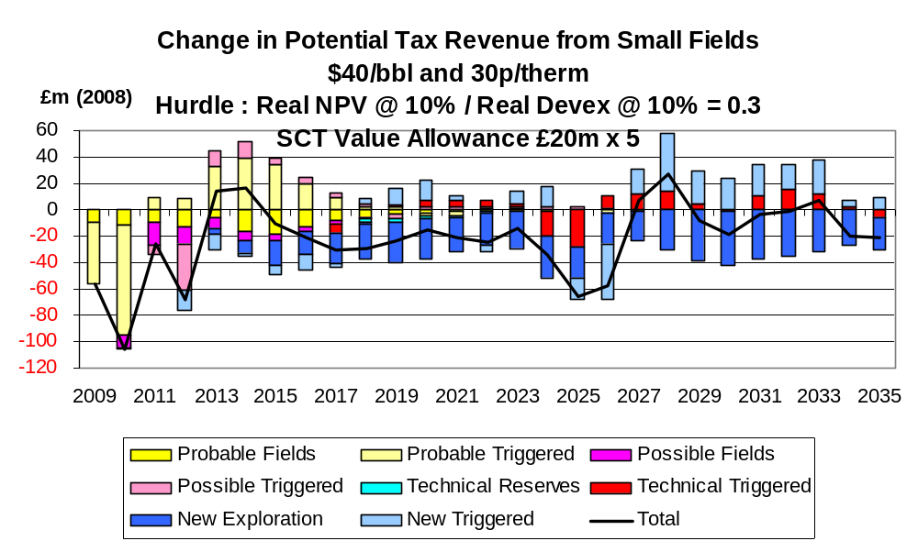

The changes to production under the $60,50 pence case with the £100 million allowance are shown in Charts 88 – 90. The average increase in total hydrocarbon production is nearly 40,000 boe/d over the period. The aggregate increase over the period to 2035 is 387 mmboe. The corresponding increase in field investment (Chart 91) is very substantial averaging around £150 million per year over the period. In 9 years the increase exceeds £200 million. The net change in tax revenues (Chart 92) is significantly negative.

Chart 88
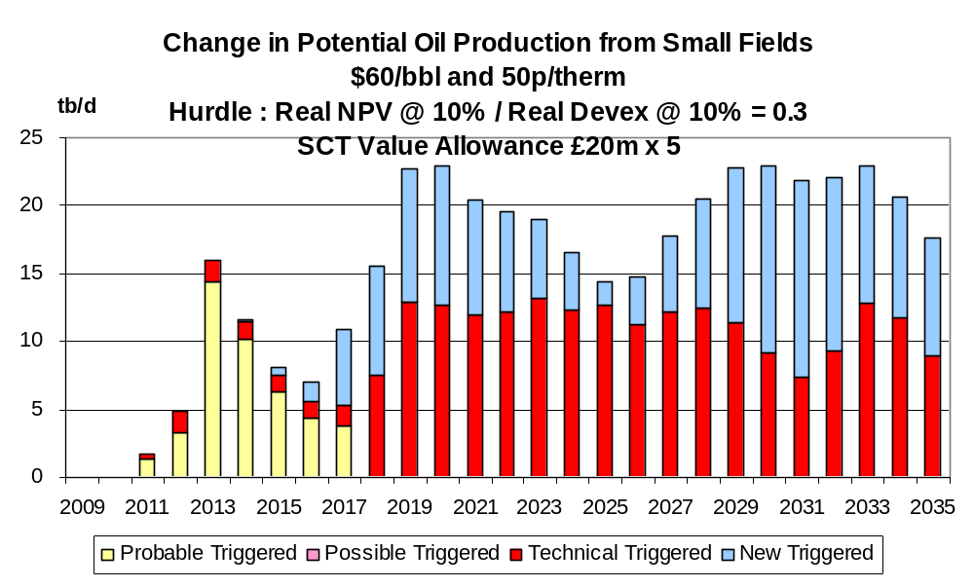

Chart 89
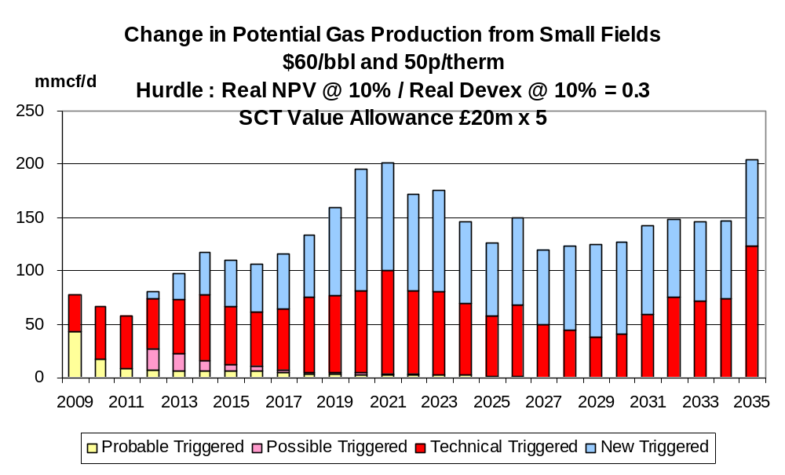

Chart 90
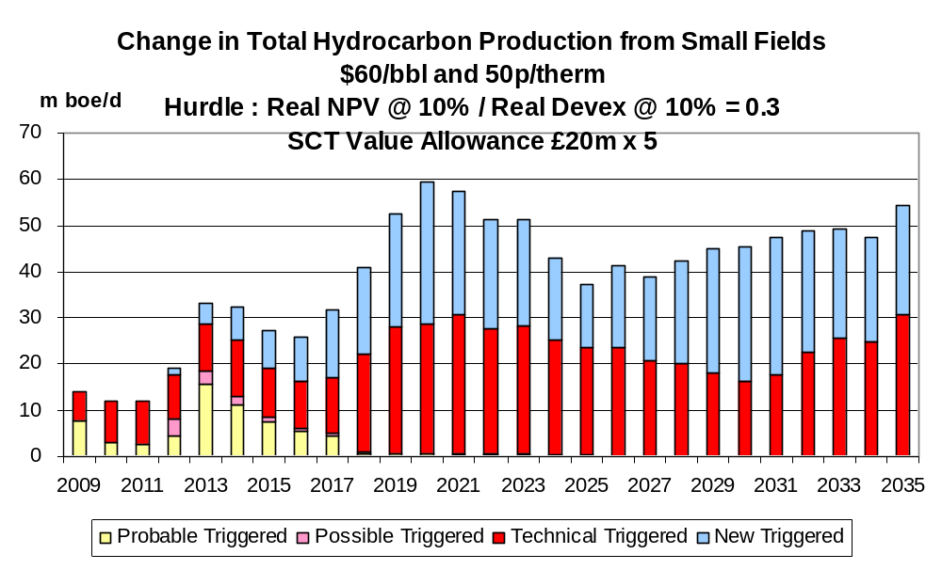

Chart 91
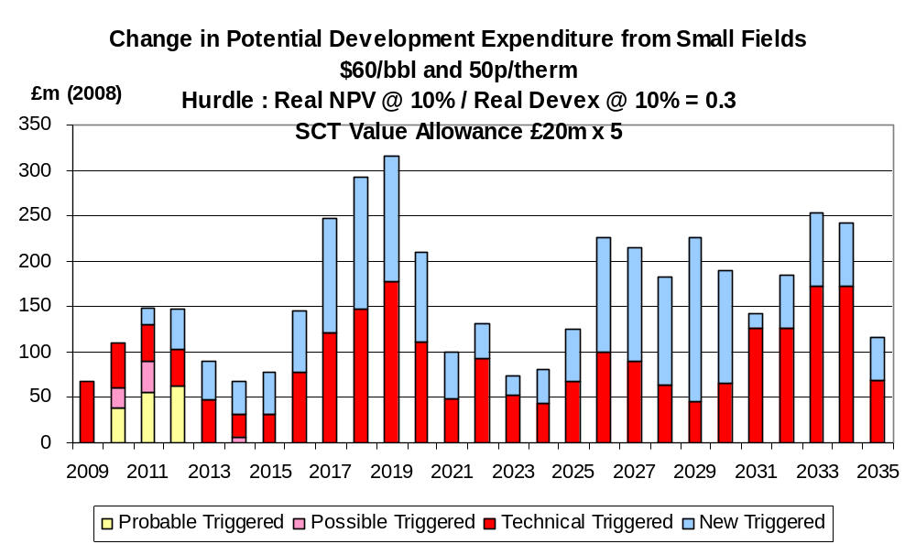

Chart 92
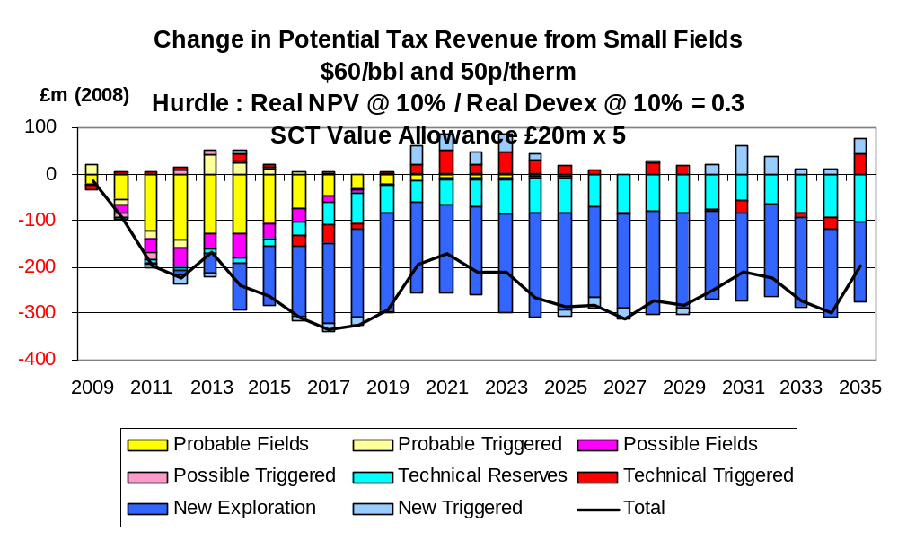

The changes to production under the $80,70 pence case with the £100 million allowance are shown in Chart 93 – 95. The increase in total hydrocarbon production averages around 15,000 boe/d over the period with all the output coming from fields in the category of technical reserves. The aggregate increase in the period to 2035 is 157 mmboe. The increase in field investment (Chart 96) is relatively large in relation to the production because of the high costs of the fields in this category. The change in tax revenues (Chart 97) is significantly negative.

Chart 93
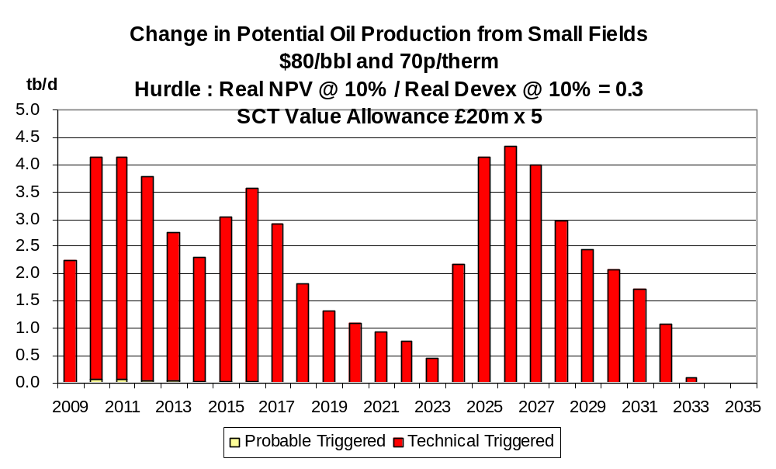

Chart 94
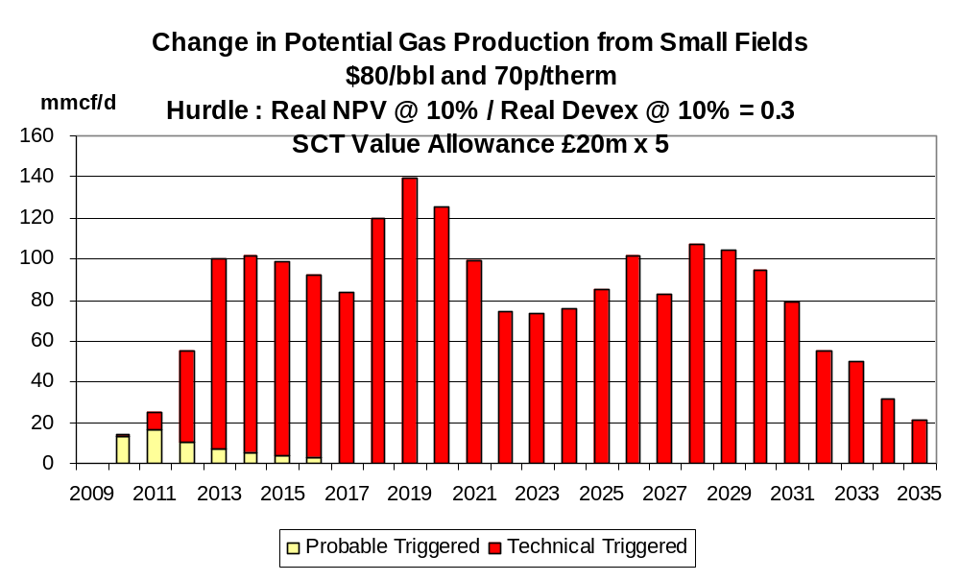

Chart 95
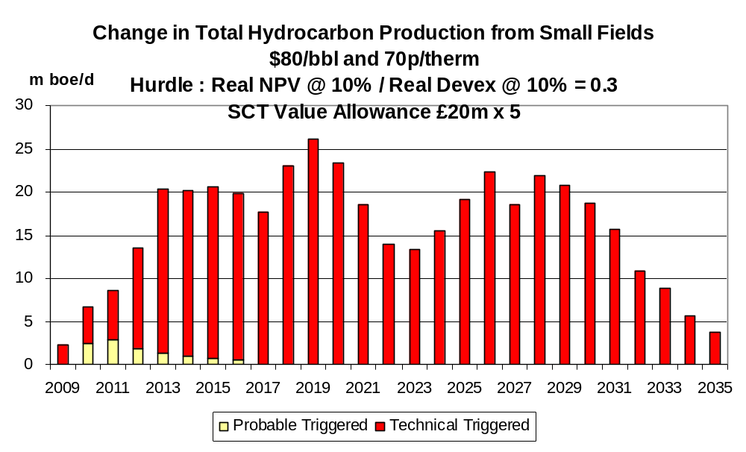
Chart 96
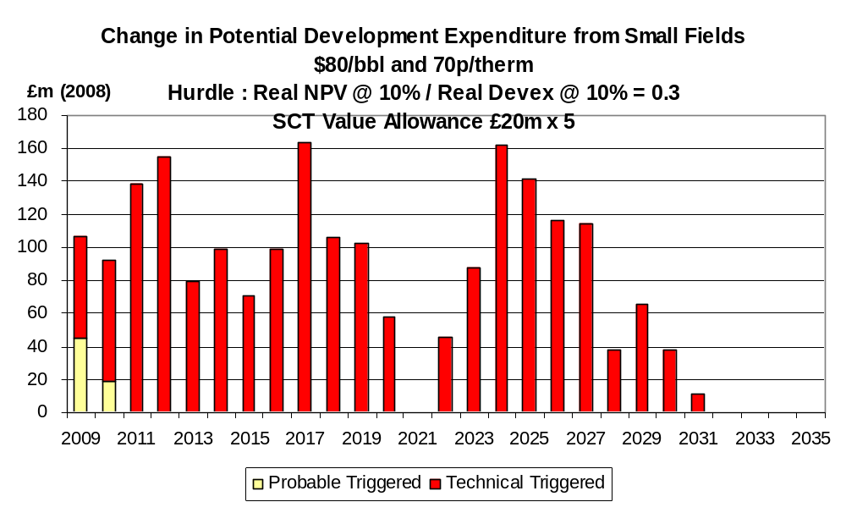

Chart 97
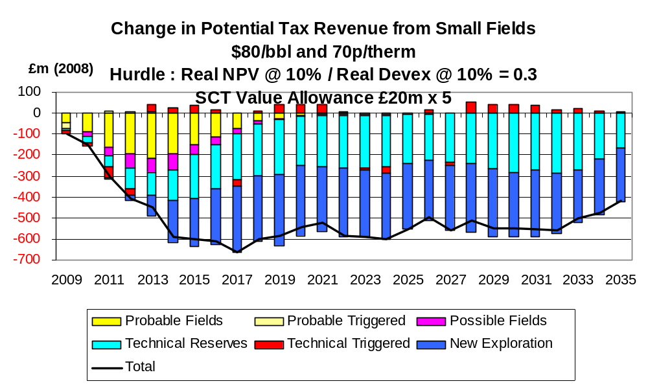

Value Allowance Applied to West of Shetlands Fields

- Number of Field Developments Triggered

The results for this part of the analysis require extra explanation. The costs of the new field developments are very high with the average development costs being around $20/ boe. A considerable number of the undeveloped fields are in the category of technical reserves where the development costs are recognised to be high. The position under the present tax system is summarised in Table 8.

Table 8

Number of Field Developments Passing and Failing Investment Hurdle under Present Tax System

$40,30 | pence | $60,50 | pence | $80,70 | pence
Fail | Pass | Fail | Pass | Fail | Pass
25 | 1 | 15 | 21 | 3 | 35

The findings in Table 8 help to explain the results of the introduction of various sizes of value allowances in triggering new developments which are shown in Table 9. It is seen that the introduction of the value allowance (even the very large one of £250 million) has little effect on the numbers of developments being triggered. Under the $40,30 pence nearly all the projects fail with the allowance. Under the $60,50 pence case some projects pass without the allowance but a substantial number fail even with a large allowance. On the other hand under the $80,70 pence case the great majority of projects pass the hurdle under the present tax system and a significant value allowance triggers the development of the remaining few fields. Thus for different reasons the effects of the value allowance is fairly modest in all the scenarios examined.

It follows from the above that the effects of the value allowance on activity levels are quite modest. It should be stressed that this is not to be interpreted as a generalised conclusion. There are very many permutations of oil/gas prices, investment hurdles and their interaction with the tax system and only representative selection can be analysed here in details. From Table 9 it is seen that under the $40,30 pence scenario no new developments are triggered with the 2 smaller value allowances and only 1 is triggered with the 2 higher levels of allowance.

Table 9

Numbers of Fields in West of Shetlands Triggered by Value Allowance to 2035

 | Probable | Possible | Technical Reserves | New Exploration | Total
$40,30p SCT Allowance  £2.5m x 5 | 0 | 0 | 0 | 0 | 0
$40,30p SCT Allowance  £10m x 5 | 0 | 0 | 0 | 0 | 0
$40,30p SCT Allowance  £20m x 5 | 0 | 0 | 0 | 1 | 1
$40,30p SCT Allowance  £50m x 5 | 0 | 0 | 0 | 1 | 1
$60,50p SCT Allowance  £2.5m x 5 | 0 | 0 | 0 | 0 | 0
$60,50p SCT Allowance  £10m x 5 | 0 | 0 | 1 | 0 | 1
$60,50p SCT Allowance  £20m x 5 | 0 | 0 | 1 | 0 | 1
$60,50p SCT Allowance  £50m x 5 | 0 | 0 | 3 | 0 | 3
$80,70p SCT Allowance  £2.5m x 5 | 0 | 0 | 0 | 0 | 0
$80,70p SCT Allowance  £10m x 5 | 0 | 0 | 3 | 0 | 3
$80,70p SCT Allowance  £20m x 5 | 0 | 0 | 3 | 0 | 3
$80,70p SCT Allowance  £50m x 5 | 0 | 0 | 3 | 0 | 3
Under the $60,50 pence scenario only 1 new development is triggered with the £50 million and £100 million allowances. With the £250 million allowance 3 new developments in the category of technical reserves are triggered. The resulting increases in production are shown in Charts 98 – 100. For the whole period where the increase is effective the average increment is around 15,000 boe/d and in 4 of the years it exceeds 20,000 boe/d. The aggregate increase in the period to 2035 is 91 mmboe. The increase in field development expenditures is shown in Chart 101 and the change in total tax revenues in Chart 102.

Chart 98

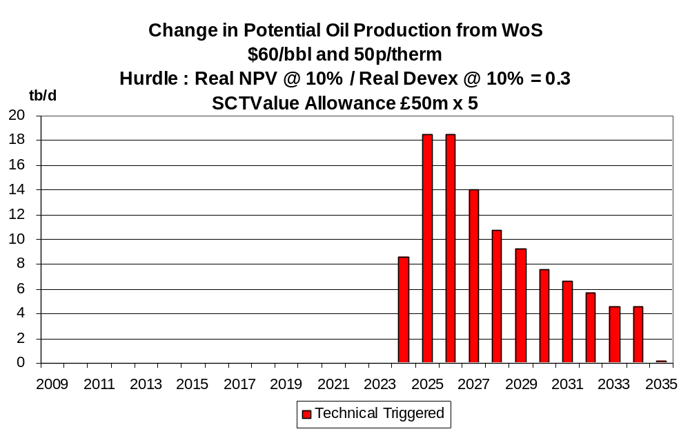

Chart 99
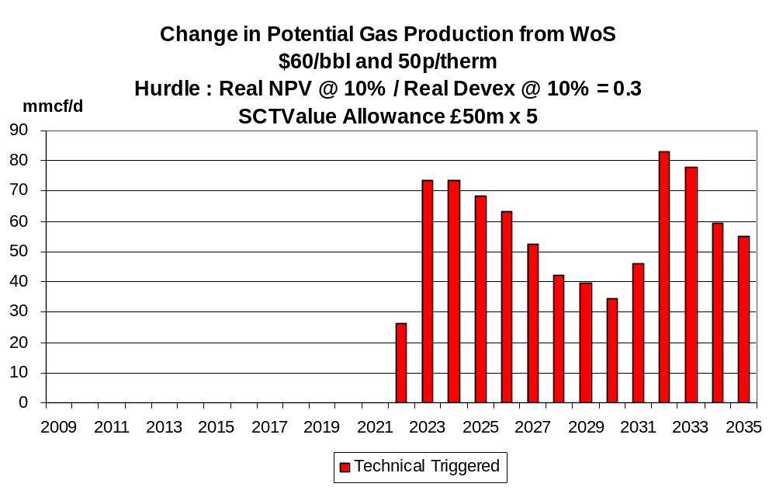

Chart 100
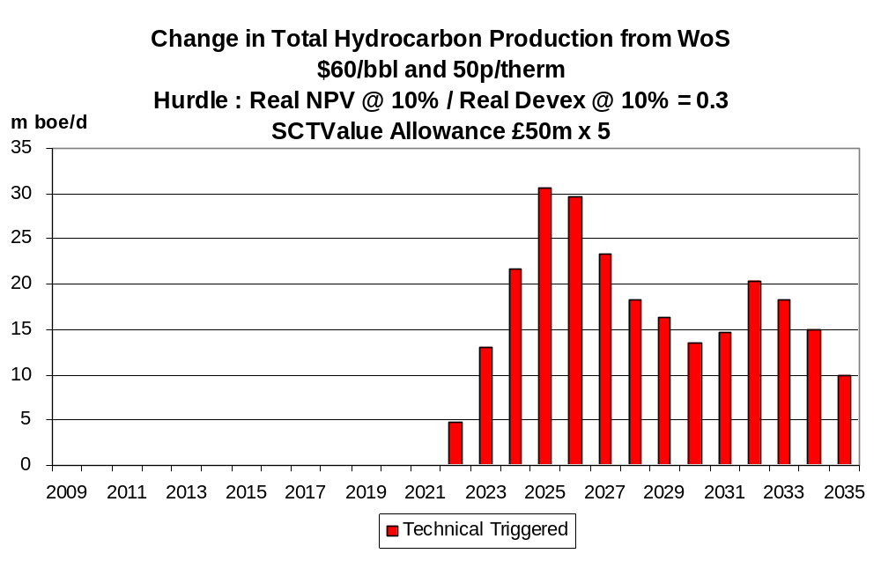
Chart 101
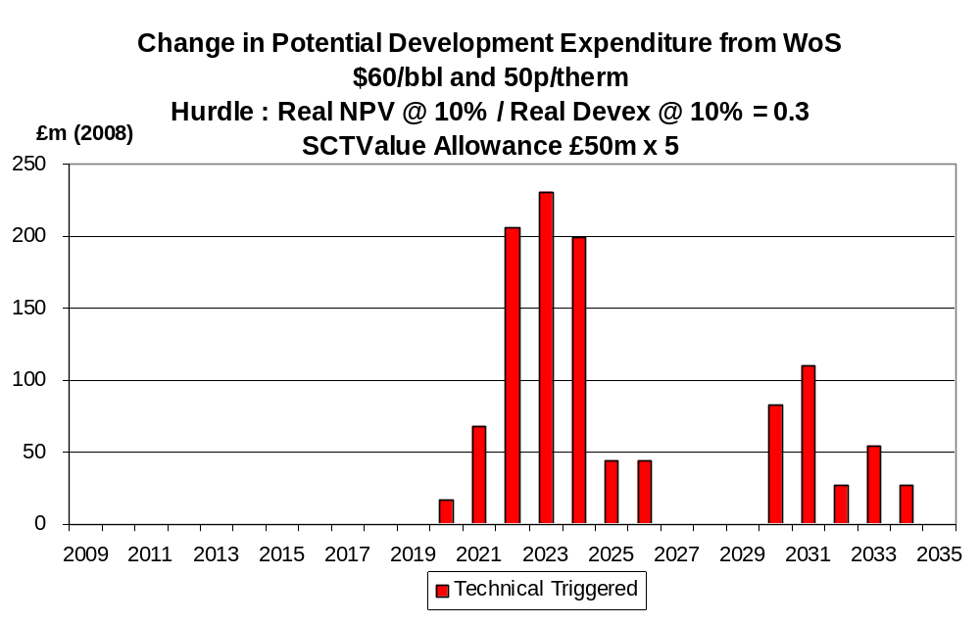

Chart 102
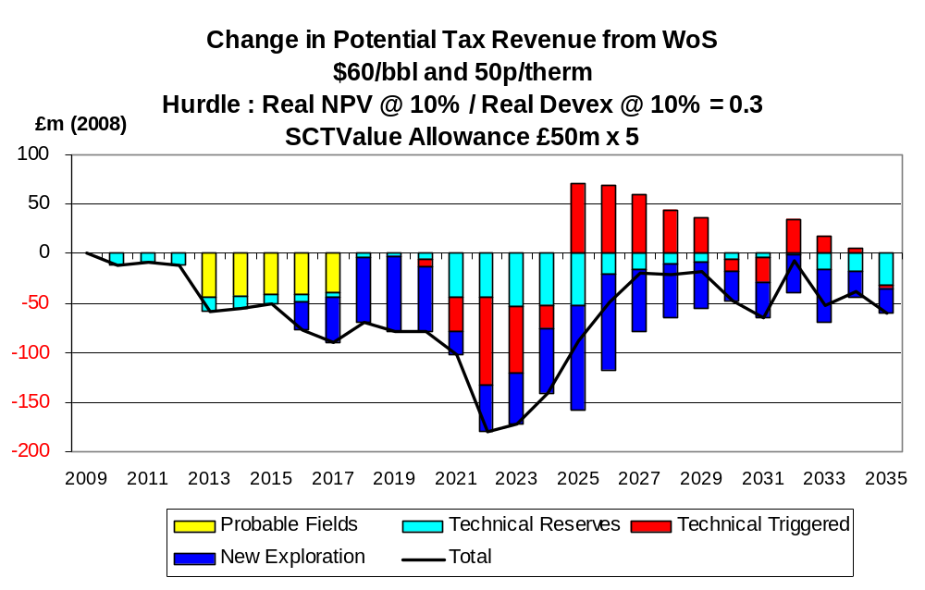
Under the $80,70 pence case, while the number of field developments triggered by the £250 million allowance is the same as under the $60,50 pence case their composition is not the same. The increases in production under the high price scenario are shown in Charts 103 – 105. A key difference compared to the $60,50 pence case is that an early gas field development is triggered (Chart 104). In the current difficult investment environment in the West of Shetlands region this could contribute to the triggering of the cluster development which is necessary for the full exploitation of gas. The extra development could thus be worth considerably more to the nation than its individual size would indicate. The increase in field investment is shown in Chart 106 and the total change in tax revenues in Chart 107. The net change in tax revenues is seen to be negative.

Chart 103
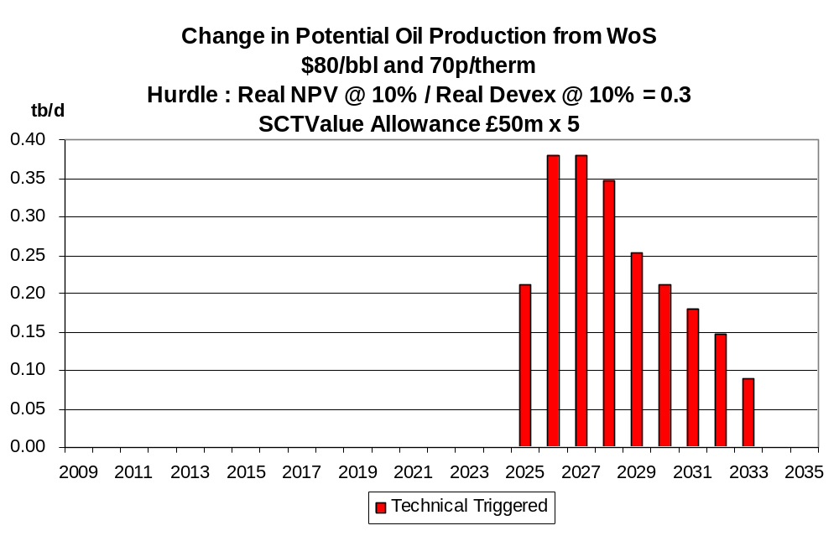
Chart 104
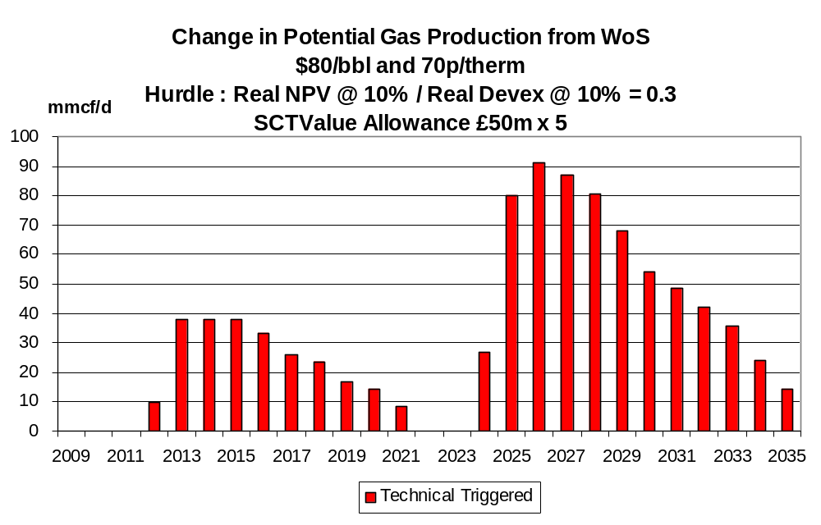

Chart 105
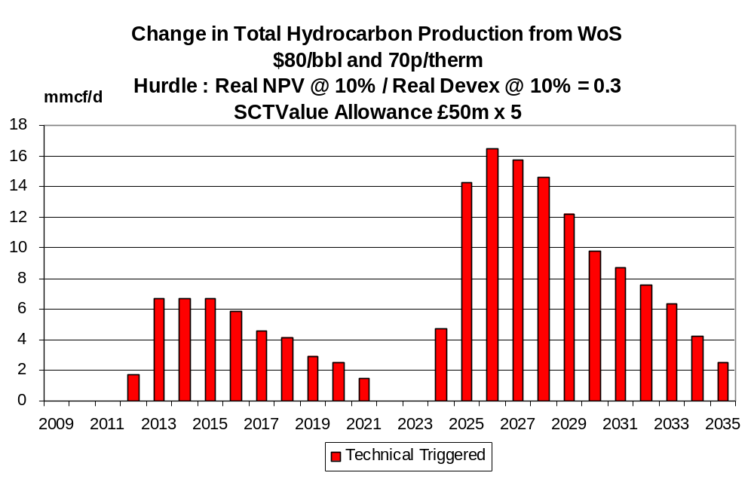
Chart 106
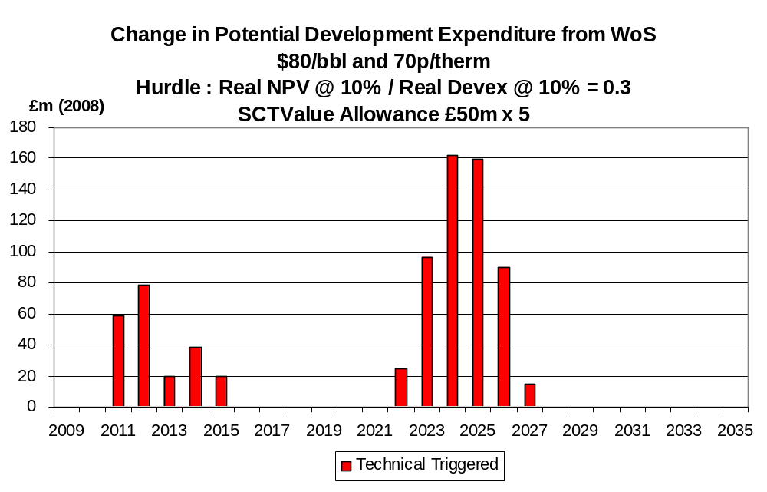

Chart 107
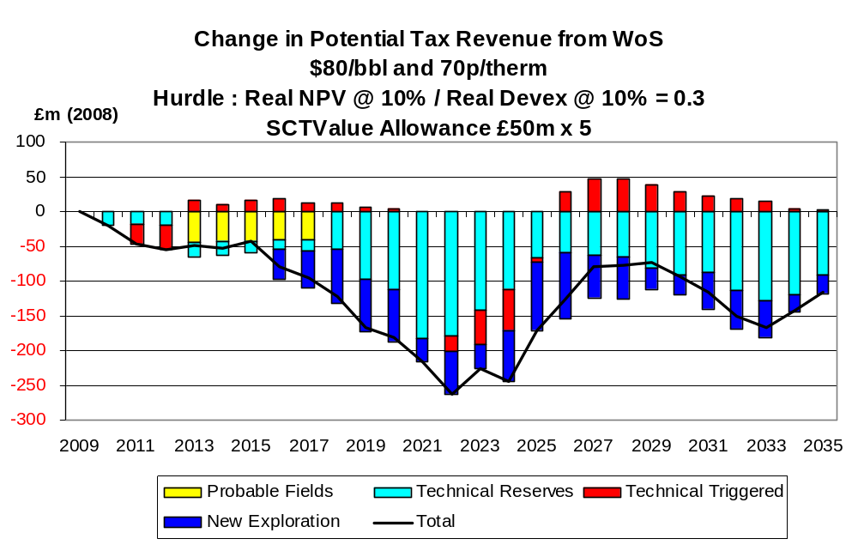

Interpretation of Results

The results of the detailed modelling in Section 3 clearly indicate that the introduction of the value allowance for the SC can enhance activity levels as measured by economic production and field investment. It is also clear that the magnitude of the increased activity depends on the size of the value allowance and the oil/ gas price scenario chosen to evaluate the effect. Of the 3 price scenarios examined the effect is found to be greatest under the $60,50 pence case. While worthwhile production is incentivised under the $40,30 pence case less fields are viable under this price scenario. Relief from the SC is insufficient to make many more projects viable. With the $80,70 pence price scenario more projects are in any case viable without the benefit of the value allowance and thus less are incentivised on account of it. It is clear from the results that the higher the allowance the greater the number of field developments incentivised. Thus the £12.5 million allowance has a much smaller effect than the £50 million one which in turn has a smaller effect than the £100 million one. It should be emphasised that the incentivised fields generally still pay tax at the 30% rate on the working assumption employed that the allowance is restricted to the field in question. A relevant consideration in determining how big the allowance should be is the need to incentivise fields in the category of technical reserves. Many of these are relatively high cost (per boe) because they are located far from existing infrastructure or are relatively small or have technical problems (such as HP/ HT characteristics). It was thus found that under the $80,70 pence price case substantial numbers in this category were non-viable under the present tax system and needed a large value allowance to render them acceptable (Table 6).

The consultation document makes specific reference to small fields. These now (numerically) dominate the remaining potential in the UKCS. Adopting a definition of ≤ 20 mmboe and undertaking the modelling on the same basis as for the totality of new fields revealed a consistent pattern of results. Thus the numbers of fields incentivised increased with the size of the allowance and more developments were triggered under the $60,50 pence price scenarios than under the other two. Under the $80,70 pence case many fields in the category of technical reserves required a substantial allowance to render them viable.

In the case of the fields located West of Shetlands the modelling of the scenarios indicated that substantial allowances were required to make a worthwhile impact on the number of viable new developments given the relatively high costs per boe of the undeveloped fields. The modelling underestimated the potential potency of triggering new developments because under the $60,50 pence case even the very large (£250 million) allowance left many fields non-viable while under the $80,70 pence case most fields were found to pass the investment hurdle without the allowance. Thus at price scenarios between $60,50 pence and $80,70 pence the value allowance would have been much more potent.

It should be stressed that the detailed modelling has been undertaken using discount rates of 10% in real terms and minimum acceptable NPV/ I ratios of 0.3. Given the current problems in the financial markets, the resulting capital scarcity could well mean that these assumptions do not fully reflect the tough conditions facing some investors. The effects of raising the discount rates and the minimum capital productivity index (NPV/ I) have been modelled under the current tax system. The results for discount rates of 12.5% and 15% and minimum NPV/ I ratios of 0.5 in terms of numbers of viable new fields (and incremental projects) are shown in Table 10 (excluding any value allowance). The numbers of viable fields/ projects are seen to be particularly sensitive to an increase in the minimum NPV/ I ratio from 0.3 to 0.5. The effects on total production in the period 2008 – 2035 from raising the discount rate from 10% to 12.5% and the minimum NPV/ I ration from 0.3 to 0.5 are shown in Tables 11 – 14. It is seen that the decrease in cumulative production from an increase in the capital productivity index is very substantial.

Table 10

Number of Field Developments and Projects Passing
under Different Investment Hurdle Rates
Price  and  Category | Discount rate  Min.NPV/I | 10%  0.3 | 10%  0.5 | 12.5%  0.3 | 12.5%  0.5 | 15%  0.3 | 15%  0.5
$40,30 pence
Incremental Projects |  | 78 | 69 | 79 | 66 | 78 | 64
Probable fields |  | 5 | 2 | 4 | 2 | 4 | 2
Possible fields |  | 5 | 5 | 5 | 5 | 5 | 5
New exploration finds |  | 48 | 23 | 39 | 18 | 34 | 14
Technical reserves fields |  | 5 | 0 | 4 | 0 | 3 | 0
Total |  | 141 | 99 | 131 | 91 | 124 | 85
$60,50 pence
Incremental Projects |  | 103 | 92 | 99 | 88 | 98 | 85
Probable fields |  | 28 | 18 | 25 | 16 | 21 | 11
Possible fields |  | 10 | 8 | 10 | 8 | 9 | 5
New exploration finds |  | 207 | 173 | 205 | 154 | 200 | 136
Technical reserves fields |  | 103 | 50 | 93 | 44 | 81 | 41
Total |  | 451 | 341 | 432 | 310 | 409 | 278
$80, 70 pence
Incremental Projects |  | 110 | 105 | 107 | 103 | 106 | 101
Probable fields |  | 32 | 32 | 32 | 32 | 32 | 29
Possible fields |  | 15 | 10 | 13 | 11 | 13 | 10
New exploration finds |  | 244 | 241 | 244 | 235 | 243 | 227
Technical reserves fields |  | 212 | 163 | 203 | 154 | 191 | 142
Total |  | 613 | 551 | 599 | 535 | 585 | 509

Table 11
 | Cumulative Potential Production from 2008 to 2035 (Mmboe)
 | Hurdle : Real NPV @ 10% / Real Devex @ 10% = 0.3
 | Standard case
 | Sanctioned | Current Incremental | Future Incremental | Probable Fields | Possible Fields | Technical Reserves | New Exploration | TOTAL
$40/bbl and 30p/therm | 7106 | 664 | 1107 | 187 | 174 | 44 | 931 | 10212
$60/bbl and 50p/therm | 7244 | 1044 | 1898 | 838 | 240 | 1581 | 3102 | 15947
$80/bbl and 70p/therm | 7352 | 1344 | 2680 | 901 | 249 | 3804 | 3553 | 19884

Table 12
 | Cumulative Potential Production from 2008 to 2035 (Mmboe)
 | Hurdle : Real NPV @ 10% / Real Devex @ 10% = 0.5
 | Standard case
 | Sanctioned | Incremental | Future Incremental | Probable Fields | Possible Fields | Technical Reserves | New Exploration | TOTAL
$40/bbl and 30p/therm | 7106 | 578 | 968 | 153 | 174 | 0 | 401 | 9381
$60/bbl and 50p/therm | 7244 | 792 | 1543 | 560 | 212 | 1090 | 2708 | 14148
$80/bbl and 70p/therm | 7352 | 1047 | 2227 | 868 | 240 | 2969 | 3518 | 18222

Table 13
 | Cumulative Potential Production from 2008 to 2035 (MMboe)
 | Hurdle : Real NPV @ 12.5% / Real Devex @ 12.5% = 0.3
 | Standard case
 | Sanctioned | Incremental | Future Incremental | Probable Fields | Possible Fields | Technical Reserves | New Exploration | TOTAL
$40/bbl and 30p/therm | 7106 | 664 | 1109 | 176 | 174 | 43 | 741 | 10013
$60/bbl and 50p/therm | 7244 | 928 | 1782 | 793 | 240 | 1467 | 3086 | 15540
$80/bbl and 70p/therm | 7352 | 1327 | 2640 | 901 | 244 | 3613 | 3553 | 19631

Table 14
 | Cumulative Potential Production from 2008 to 2035 (Mmboe)
 | Hurdle : Real NPV @ 12.5% / Real Devex @ 12.5% = 0.5
 | Standard case
 | Sanctioned | Incremental | Future Incremental | Probable Fields | Possible Fields | Technical Reserves | New Exploration | TOTAL
$40/bbl and 30p/therm | 7106 | 560 | 937 | 153 | 174 | 0 | 258 | 9188
$60/bbl and 50p/therm | 7244 | 764 | 1491 | 457 | 212 | 437 | 2349 | 12953
$80/bbl and 70p/therm | 7352 | 1042 | 2216 | 868 | 241 | 2774 | 3406 | 17899
It follows from the above that under these more stringent assumptions about capital market conditions there are further prospects for the value allowance making a positive contribution to incentivising new field developments. There will clearly be more fields which are submarginal under the present tax system and which could be rendered acceptable by the relief. The overall conclusion is thus that the number of field developments which could be incentivised by a worthwhile size of value allowance is likely to be understated by the use of 10% discount rates and NPV/ I > 0.3 in the modelling.

Incremental Projects

The present consultation document deals principally with new fields. In the current stage of the exploitation of the UKCS and the present investment environment it is also important to incentivise the development of incremental projects in existing fields. It is clear from Tables 10 – 14 that incremental projects can play a major role in the full economic exploitation of the UKCS. In PRT-paying fields the overall tax rate is 75% (PRT at 50%, CT at 30% and SC at 20% with PRT being a deduction for CT and SC). The present authors have very recently undertaken a detailed study of the effects of PRT on investment in new projects. Cases were found where, using the same price scenarios, discount rates and minimum NPV/ I ratios as in the main part of this study, incremental projects were being deterred. It was suggested that a formula should be designed and published which would clearly indicate the conditions under which PRT would be removed from the incremental project. The Government had suggested that PRT could be removed on a discretionary basis from incremental projects which the investor had demonstrated were being inhibited by PRT and which would proceed in its absence. The potential relief is also restricted to projects which could be clearly distinguished as separate from the main field. The modelling by the present authors found that this definition was unduly restrictive and could result in investment being deterred in incremental projects which were not detached from the main field. The potential relief should apply to all incremental projects.

An earlier Government consultation document discussed the possibility of schemes which would abolish PRT altogether, with a buy-out scheme being a preferred specific option for implementing the concept. This scheme has much merit, and it is unfortunate that agreement on the idea was not reached between the Government and the industry. Implementation of the scheme would have significantly enhanced the attractions of investment in incremental projects at a time when low oil prices are inhibiting them. The materiality of a project and its capital productivity are greatly reduced when PRT is levied. The scheme would also deal effectively with the vexed problem of PRT relief for decommissioning costs. It is thus suggested that the scheme deserves reconsideration.

A high proportion of incremental projects relate to non-PRT-paying fields. While the tax burden on these is clearly less than on PRT-paying projects it can still substantially affect the materiality of returns. Some of the projects are known to be relatively high cost. While the effects of the current tax system on these projects does not form part of the present consultation it is felt that consideration should be given to this issue in the current investment climate of relatively low oil/ gas prices, higher unit costs, and difficulties of raising debt and equity capital.

Exploration Incentives

The current capital market difficulties combined with the low oil/ gas prices are impacting greatly on the (mostly smaller) companies which rely on external funds for financing their investment activities. Much of the exploration in the UKCS is undertaken by medium and small companies and their exploration budgets are currently very likely to be reduced. It is expected that the volume of exploration activity in 2009 will be very much below that experienced in recent years. In that context the impact of the tax system on investment in exploration deserves further examination. Currently companies which are already in a tax-paying position receive full relief for their exploration costs whether these result in a discovery or not. Investors not in a tax-paying position can carry forward their allowances for exploration, appraisal and development at 6% compound interest for up to 6 years. This was designed to reflect a riskless rate of interest (3.5% real plus 2.5% inflation). It does not reflect the cost of capital for the risky exploration activity. Further, relief is only given when the investor obtains income against which the allowance can be set. For existing investors the Government shares in all the exploration risks but not with new investors who have no production income. Arguably this discrimination against new entrants is reducing the exploration effect by a class of investor which is showing much interest in the activity. This problem is exacerbated in current circumstances by the reduced cash flows from the price collapse and the capital market difficulties.

Given the above there is a case for enhancing the current tax relief for investors not in a tax-paying position. In Norway this issue is dealt with by the provision of cash rebates to the extent of the marginal tax rate of the investor for approved exploration activities. Conceptually, the introduction of this in the UKCS would be to provide equality of treatment between existing taxpayers and non-taxpayers. It would also incentivise exploration by companies which are keen to undertake the activity but which are inhibited by the current combination of low cash flows and difficulties of raising external capital. A less potent device could be to raise the interest rate on allowances carried forward from 6%to a rate which reflected the current cost of capital for the activity. This device might not be very effective in current circumstances. Capital providers could well be inhibited by the exploration risk involved. If, however, the preferred scheme, akin to that now in use in Norway, were employed, explorers would be more likely to obtain finance from capital providers who would be reassured by the guarantied availability of refunds relating to approved expenditures.

Conclusions

It is clear that the top priority with respect to the UKCS is to procure maximum economic recovery. This requires investment in (1) new field developments, (2) incremental projects, and (3) exploration to translate the remaining potential into discoveries. The tax system should not inhibit these activities. For new field developments the modelling undertaken in this study provided conclusive evidence that a value allowance against the SC could trigger further new developments. The extent of the extra production and investment depends on the size of the allowance and the oil/ gas price scenario employed. Of the 3 scenarios modelled in detail ((1) $40,30 pence, (2) $60,50 pence, and (3) $80,70 pence) it was found that the strongest effect on activity was found with the $60,50 pence case. This might well be a central scenario currently employed by investors. A key finding was that a substantial allowance was needed to trigger a substantial number of developments. Thus many more were triggered with an allowance of £100 million per field compared to £12.5 million. While there is clearly room for debate on the appropriate size of allowance the modelling found that a value allowance in the £50 million - £100 million range could have very substantial effects under the $60,50 pence price scenario.

It should be stressed that all the incentivised developments are economic ones and continue to pay North Sea corporation tax. It is arguable that all developments which remained viable in a pre-tax basis but not on a post-tax basis should be incentivised by the tax system, given the clear need to encourage investment and moderate the productive decline rate. The proposals for a value allowance are in this sense modest in their extent as they apply only to the SC. The detailed modelling showed the positive effects of the introduction of the value allowance on North Sea tax revenues. It also showed the negative effect on these revenues from projects which would in any case have proceeded. The positive effect from increased activity on taxes paid in the whole supply chain (such as non-North Sea corporation tax, personal income tax and NI contributions) was not modelled. It is argued that policy-making should be prioritised by the need to maximise economic production from the UKCS and not by the consequential effects on tax revenues which are best regarded as a residual item from activities in the UKCS.

The modelling undertaken initially applied to all new fields. When it was restricted to small fields (recoverable reserves ≤ 20 mmboe) it was found that large numbers were incentivised for development by the allowance, especially with the larger values. Thus, given the lack of materiality in these small fields generally it is felt that the allowance should apply to all of them.

The modelling of fields located West of Shetland clearly brought out the marginal nature of a high proportion of the uncommitted fields in the category of technical reserves. Four value allowances were modelled, including a large one of £250 million. The modelling brought out clearly that a substantial number of fields (25) failed the investment hurdle under the present tax system at prices in the $40,30 pence case, and 15 failed under the $60,50 pence case. In the latter case the large value allowance (£250 million) incentivised the development of 3 of these. The remaining 12 continued to fail the hurdle. It is clear that a large allowance is required to have a worthwhile effect on investment in this region.

Limitation on appropriate data did not permit systematic economic modelling of HP/ HT and heavy oil fields. However, it is clear from the work undertaken for all of the UKCS that fields with particularly high costs and/ or significantly lower prices require larger value allowances to have a worthwhile effect on investment.

While the consultation document did not specifically deal with incremental projects it is felt that these should be considered in the light of the major fall in oil prices. The PRT relief scheme for identifiable incremental projects already in place should be extended to all types of incremental projects in these fields. More fundamentally, the earlier proposal to consider PRT buy-out schemes should be discussed again. The merits of the early abolition of PRT through a buy-out scheme are greater than ever given the existing investment climate. A reduction in the overall rate of tax from 75% to 50% would greatly enhance investment incentives in these fields. Time is of the essence here if full advantage is to be made of the opportunities prior to decommissioning.

Exploration in the UKCS will suffer as a result of the combination of oil price fall and capital rationing following from the problems in the financial markets. There is a clear need to incentivise exploration activity. New players without tax cover are disadvantaged under the present tax system and, as they are generally small/medium in size, access to external capital is particularly difficult. The Norwegian scheme whereby investors not in a taxpaying position receive refunds for approved exploration at their marginal tax rate would equalise their position with full tax-paying investors. It would also make it easier for them to raise external funds given the guarantee of the Government refund.

******************************

For full details see parts of the more comprehensive study by A.G. Kemp and L. Stephen, North Sea Study Occasional Paper No.109, The Prospects for Activity in the UKCS to 2035: the 2008 Perspective, October 2008, University of Aberdeen Department of Economics pp. 67.
The tax revenues refer only to CT and SC in the UKCS. There will be substantial additional taxes paid by the supply chain, including corporation tax, income tax and National Insurance contribution from increased activity triggered by the value allowance.
See A G Kemp and L Stephen, North Sea Study Occasional Paper No. 110, The Economics of PRT Redetermination for Incremental Projects in the UKCS, University of Aberdeen Department of Economics, November 2008, pp. 56.

