A geomimetic synthesis of mellite: a mineral containing a benzene ring.

M. John Plater* and William T. A. Harrison,
Department of Chemistry, University of Aberdeen, Meston Walk, Aberdeen, AB24 3UE, e-mail: m.j.plater@abdn.ac.uk

Abstract
The synthesis of mellite from mellitic acid, KOH and Al₂(SO₄)₃.18H₂O is demonstrated and discussed as a potential geomimetic process for the formation of the mineral mellite in brown coal. The single crystal structures and IR spectra of the mineral mellite and of synthetic mellite are identical.

Table of Contents

M. John Plater and William T. A. Harrison

Key words: mellite, honeystone, mineral, mellitic acid, geomimetic synthesis

Introduction
Organic minerals that contain carbon, such as carbonates and oxalates, are well known.¹ Calcium carbonate can form on a geological timescale in the carbon cycle,² and oxalates are present in small quantities in plants.³ There are however, many other crystalline organic compounds found in the earth that are named after their place of discovery or a minerologist. These include abelsonite (a nickel(II) containing geo-porphyrin),⁴ carpathite (coronene),⁵ fichtelite (a terpene derived hydrocarbon),⁶ hoelite (9,10-anthraquinone),⁷ kladnoite (phthalimide),⁸ kratochvilite (fluorene)⁹ and simonellite (a terpene derived hydrocarbon).¹⁰ The structures are drawn in the supplementary section with pictures of the minerals. These compounds are much less polar than salts, but a further polar organic mineral is known called mellite or honeystone.^{11–16} Mellite is presumably formed from mellitic acid and Al³⁺ metal ions. It is unusual in being the only crystalline mineral salt to contain a benzene ring. A search of the Cambridge Crystallographic Data Base revealed many metal-ion complexes of mellitic acid as a hexa-anion,^{17–21} but only two that contained aluminium. One paper was the first in which the natural mineral was characterised by a single crystal structure determination,¹¹ and the other a later paper with a different crystal structure, in which the carboxylic acids were not fully deprotonated.²² A Web of Knowledge search also illustrated the different approach of the two fields of chemistry and geology, since there were only papers on the characterisation and properties of the natural mineral, but not its synthesis. This paper reports our synthetic preparation of mellite and our first foray into the field of organic geochemistry.

Mellitic acid 1 can be prepared by the oxidation of graphite, firstly by treatment with HNO₃, then KMnO₄,²³ or by anodic oxidation.²⁴ Linus Pauling makes reference to the graphite-mellitic acid transformation.²⁵ Mellitic acid can also be made by HNO₃ oxidation of hexamethylbenzene²⁶ and there is an early report of the oxidation of hexamethylbenzene by KMnO₄ taking two months.²⁷ The oxidation of organics into mellitic acid is considered as a possibility on the martian subsurface as it occurs at varying depths of the Atacama desert.²⁸ Mellitic acid is also a precursor of mellitic anhydride, C₁₂O₉, an interesting oxide of carbon.²⁹

Discussion
Mellitic acid 1 is insoluble in water and so the parent compound can only be crystallised hydrothermally with metal ions.²² However, it readily dissolves in water when treated with six equivalents of KOH which allows mixing with solutions of other metal ions. Two solutions in water were prepared, one of the hexacarboxylate anion 2, and one of the Al₂(SO₄)₃.18H₂O, which were then mixed (Scheme 1). The product was harvested in good yield and the single-crystal structure (Figure 1) confirmed it to be identical with that of the natural mineral.¹¹ It was also identical with a modern data set obtained on a sample of natural mellite from Csordakút (Hungary). The IR spectrum of the synthetic sample and mineral sample are also identical. Both have a broad OH absorption at 2600–3500 cm^{–1}, then symmetric and asymmetric carboxylate stretches at 1531 and 1433 cm^{–1}, respectively. Both have a weak carbonyl group stretch at 1689 cm⁻¹ which is close to the value of 1693 cm⁻¹ for mellitic acid. The crystal data is good and it seems unlikely that both samples include mellitic acid as an impurity, so hydrogen bonding to the carboxylate anion in the lattice is presumed to account for this.

Scheme 1 A geomimetic synthesis of mellite

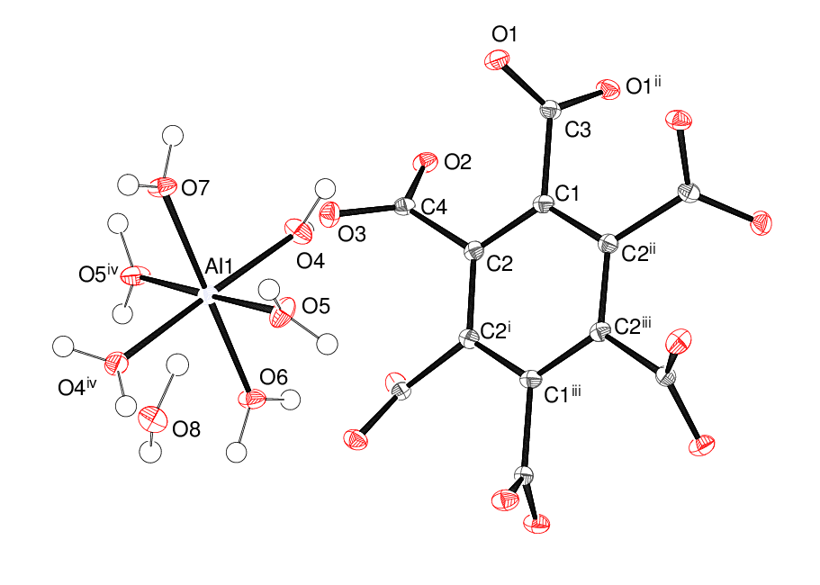
Figure 1: The building units of the synthetic mellite crystal structure showing 50% displacement ellipsoids. Symmetry codes: (i) –x, ½–y, z; (ii) y–¼, x+¼, ¼–z; (iii) ¼–y, ¼–x, ¼–z; (iv) ½–y, x, –z. Selected bond lengths: C3–O1 = 1.2571 (11) Å, C4–O2 = 1.2611 (14) Å, C4–O3 = 1.2561 (14) Å, Al1–O4 = 1.8772 (8) Å, Al1–O5 = 1.8683 (8) Å. Al1–O6 = 1.8841 (13) Å, Al1–O7 = 1.9081 (13) Å.

The structure of synthetic mellite contains (C₁₂O₁₂)^{6–} hexa-anions with the unusual point symmetry of D₂. The dihedral angles between the benzene ring plane and the planes of the C1/O1/O1^{ii} (ii = y–¼, x+¼, ¼–z) and C4/O2/O3 carboxylate groups are 70.45 (5)° and 53.66 (6)°, respectively. These twists doubtless occur to minimise steric interactions between the pendant carboxylate groups. The mean Al–O separation in the essentially regular octahedral [Al(H₂O)₆]³⁺ cation is 1.881 Å and the bond-valence sum (BVS)³⁰ for the aluminium ion (site symmetry 2) is 2.97 (expected = 3.00). In the extended structure, the components are linked by O–HO hydrogen bonds involving both the coordinated (O4–O7) and uncoordinated (O8) water molecules, which results in a three-dimensional network. The crystal structure of natural mellite is identical.

Mellite is an unusual mineral that contains a benzene ring, and is on the interface between organic and inorganic chemistry. It makes interesting teaching material for undergraduates since concepts about aromaticity and the Hückel rule, traditionally applied to organic compounds, are now occurring in an ionic mineral lattice. There are 12 carboxy derivatives of benzene possible, containing from one to six carboxylic acid groups. They all have good stability and some occur in soils,³¹ but they do not occur naturally in minerals, which suggests there is a special stability for mellitic acid 1 and mellite. The other carbon containing ionic minerals are typically carbonates and oxalates.³²

Scheme 2 illustrates how the structure of mellitic acid 1 may arise by oxidative degradation of the carbon atoms surrounding the central aromatic ring. Clearly all sites of the benzene ring of mellitic acid are functionalised, with a carboxylic acid grouping, because of the extended sheet structure of graphite. Substitution with a carboxylic acid must also deactivate the benzene ring and stabilise it to oxidation, so mellitic acid is probably a very stable by-product. This method of formation may be geomimetic and mimic how mellitic acid 1 might have formed by the slow oxidative degradation of carbonaceous material in brown coal (Scheme 2). In the Atacama desert, or other terrain such as planet mars,²⁸ mellitic acid would be a last remaining beacon of previously consumed carbonaceous material.

Scheme 2 Synthesis of mellitic acid by the oxidative degradation of graphite, a possible geomimetic process

Summary
Synthetic mellite is formed by crystallisation of the benzenehexacarboxylate anion with Al₂(SO₄)₃.18H₂O. The X-ray single crystal structure is the same as that of the mineral mellite. These conditions for mellite synthesis suggest that the lower pH in brown coal is not optimum for mellite crystallisation. The formation of mellitic acid from coal and the crystallisation of mellite are proposed as geomimetic processes.

Supplementary

Pictures of organic minerals; IR spectra of synthetic mellite and natural mellite.

Experimental

All reagents were purchased from Aldrich Co. The sample of natural mellite, from Csordakút (Hungary) in the form of a soft, dark-coloured irregular lump (mass 8.2 g) was purchased on eBay.

Mellite [Al(H₂O)₆]₂·C₁₂O₁₂·4H₂O: a pellet of KOH was weighed quickly before it had absorbed water (95 mg, 1.7 mmol) and was dissolved in distilled water (25 ml). The correct quantity of mellitic acid was added (97 mg, 0.28 mmol) to deprotonate all six carboxylic acid. A solution of Al₂(SO₄)₃·18H₂O (189 mg, 0.28 mmol) or (378 mg, 0.57 mmol) was prepared in distilled water (25 ml). The mellitic acid and aluminium sulphate solutions were mixed and left to stand overnight. The mother liquor was decanted and the homogeneous colourless crystals were washed twice with distilled water. Colourless crystals of the title compound were harvested (140 mg, 74%) and characterised by X-ray single crystal structure determination. If the stoichiometric quantity of Al₂(SO₄)₃·18H₂O is used the mixture is opaque, but still crystallises. If an excess of Al₂(SO₄)₃·18H₂O is used a transient white gel forms which quickly re-dissolves, and the yield is not affected. IR (diamond anvil, cm^{–1}) 2600–3500, 1689w, 1531vs, 1433vs, 1338vs, 909w, 785s, 728s, 634s, 599vs, 503vs and 412w. The IR spectrum of natural mellite from Csordakút (Hungary) is identical.

Crystal structures: The intensity data for synthetic mellite were collected on a Rigaku CCD diffractometer (graphite monochromated Mo Kα radiation, λ = 0.71073 Å). The structure was solved by direct methods with SHELXS-97 and the atomic model refined against |F|² with SHELXL-97.³³ The water H atoms were located in difference maps and their positions were freely refined: the constraint U_{iso}(H) = 1.2U_{eq}(O) was applied. [Al(H₂O)₆]₂·C₁₂O₁₂·4H₂O (C₁₂H₃₂Al₂O₂₈), M_{r} = 678.34, colourless prism, 0.18 × 0.18 × 0.11 mm, tetragonal, space group I4₁/acd (No. 142), Z = 8, a = 15.5627 (11) Å, c = 23.1222 (16) Å, V = 5600.1 (7) Å³ at 100 K. Number of measured and unique reflections = 19951 and 1617, respectively (–20 ≤ h ≤ 19, –20 ≤ k ≤ 17, –30 ≤ l ≤ 26; 2θ_{max} = 55.0°; R_{int} = 0.033). Final R(F) = 0.029, wR(F²) = 0.083 for 123 parameters and 1499 reflections with I > 2σ(I) (corresponding R-values based on all 1617 reflections = 0.030 and 0.084, respectively), CCDC deposition number 1052513.

The data for natural mellite were collected and processed in the same way: [Al(H₂O)₆]₂·C₁₂O₁₂·4H₂O (C₁₂H₃₂Al₂O₂₈), M_{r} = 678.34, colourless irregular lump, 0.32 × 0.21 × 0.09 mm, tetragonal, space group I4₁/acd (No. 142), Z = 8, a = 15.5630 (12) Å, c = 23.1048 (16) Å, V = 5596.1 (7) Å³ at 100 K. Number of measured and unique reflections = 17969 and 1610, respectively (–20 ≤ h ≤ 20, –14 ≤ k ≤ 20, –29 ≤ l ≤ 29; 2θ_{max} = 55.0°; R_{int} = 0.043). Final R(F) = 0.028, wR(F²) = 0.077 for 123 parameters and 1481 reflections with I > 2σ(I) (corresponding R-values based on all 1610 reflections = 0.030 and 0.078, respectively), CCDC deposition number 1052601.

References
1. W. H. Blackburn and W. H. Dennen, Encyclopedia of Mineral Names, Mineralogical Association of Canada, Canada, 1997.
2. J. C. G. Walker, Origins of Life, 1985, 16, 117.
3. M. M. Rahman, R. B. Abdullah and W. E. Wan Khadijah, J. Ani. Phys. and Ani. Nutrit., 2013, 97, 605.
4. C. Milton, E. J. Dwornik, P. A. Estep-Barnes, R. B. Finkelman, A. Pabst and S. Palmer, American Mineralogist, 1978, 63, 930.
5. G. L. Prornovsrv, Lvovskoe Geol. Obshch., Mineralog. Sbornik, 1955, 9, 120.
6. H. A. Mace and R. C. Peterson, The Canadian Mineralogist, 1955, 33, 7.
7. B. V. R. Murty, Zeitschrift fur Kristallographie, 1960, 113, 445.
8. E. Matzat, Acta Cryst., Sect. B, 1972, 28, 415.
9. R. E. Gerkin, A. P. Lundstedt and W. J. Reppart, Acta Cryst. , Sect. C, 1984, 40, 1892.
10. E. Foresti and L. Riva di Sanseverino, Atti della Accademia Nazionale dei Lincei, 1969, 47, 41
11. C. Giacovazzo, S. Menchetti and F. Scordari, Acta Cryst., 1973, B29, 26.
12. C. Robl and W. F. Kuhs, J. Solid State Chem., 1991, 92, 101.
13. J. Jehlicka and H. G. M. Edwards and P. Vitek, Plan. Space Sci., 2009, 57, 606.
14. J. Jehlicka and H. G. M. Edwards, Int. J. Astrobiol., 2008, 7, 83.
15. J. Jehlicka and H. G. M. Edwards, Org. Geochem., 2008, 39, 371.
16. J. Jehlicka, H. G. M. Edwards and S. E. Jorge Villar, Spec. Acta. Part A. Mol. Biomol. Spect., 2006, 65, 229.
17. S. M. Humphrey, R. A. Mole, R. I. Thompson and P. T. Wood, Inorg. Chem., 2010, 49, 3441.
18. X. Y. Tang, S. T. Yue, P. Li, N. Wang and Y. L. Liu, J. Rare Earths, 2008, 26, 800.
19. L. P. Wu, M. Munakata, M. Yamamoto, T. KurodaSowa and M. Maekawa, J. Coord. Chem., 1996, 37, 361.
20. A. Cousson, S. Dabos, H. Abazli, F. Nectoux, M. Pages and G. Choppin, J. Less-Common Metals., 1984, 99, 233.
21. V. A. Uchtman and R. J. Jandacek, Inorg. Chem., 1980, 19, 350.
22. C. Volkringer, T. Loiseau, N. Guillou, G. Ferey, D. Popov, M. Burghammer and C. Riekel, Solid State Sci., 2013, 26, 38.
23. J. Bernard, US2176348 A 17 Oct 1939
24. C. S. Hahn, N. S. Cho and H. S. Yang, Carbon, 1981, 19, 225.
25. L. Pauling, J. Am. Chem. Soc., 1926, 48, 1132.
26. J. P. Bibaut, J. Overhoff, E. W. Jonker and K. Gratama, Recuil des Trav. Chim. Des Pays-Bas, 1941, 60, 742.
27. C. Friedel and J. M. Crafts, Ann. Chim., 1884, 1, 470.
28. Y. Blanco, L. A. Rivas, M. Ruiz-Bermejo and V. Parro, ICARUS, 2013, 224, 326.
29. O. Ermer and J. Neudorfl, Helv. Chim. Acta, 2000, 83, 300.
30. N.E. Brese and M. O'Keeffe, Acta Cryst. 1991, B47, 192.
31. L. Haumaier, J. Plant Nut. Soil Sci., 2010, 173, 727.
32. W. H. Blackburn and W. H. Dennen, The Encyclopedia of Mineral Names, Mineralogical Association of Canada, 1997.
33. G. M. Sheldrick. Acta Cryst. 2008, A64, 112.

Acknowledgements

We thank the EPSRC National Crystallography Service for the X-ray data collections.

