The isolation of N-tert-butyl-p-toluidine hydrochloride and the synthesis of mauveine.

M. John Plater* and William T. A. Harrison

Department of Chemistry, University of Aberdeen, Meston Walk, Aberdeen, AB24 3UE, UK. e-mail: m.j.plater@abdn.ac.uk

Graphical Abstract
The isolation of N-tert-butyl-p-toluidine hydrochloride and the synthesis of mauveine
M. John Plater* and William T. A. Harrison

Abstract
Heating p-toluidine hydrochloride in tert-butanol gave a crystalline precipitate of N-tert-butyl-p-toluidine hydrochloride. This compound is now readily available by a simple procedure and was used to make mauveine which is identical to authentic MoSI (Museum of Science and Industry) mauveine by TLC analysis.

Keywords: colouring matter, trimethylcarbinol, tertiary butanol, N-tert-butyl-p-toluidine, authentic mauveine.

Introduction
Previously we reported the synthesis of a mixture of mauveine A and B by the oxidation of a mixture of N-tert-butyl-p-toluidine, o-toluidine and aniline (1.0:1.5:1.8) with K₂Cr₂O₇ in dilute sulfuric acid¹ and related studies²⁻⁵ (Scheme 1). The reaction favours the formation of mauveine A and B over other mauveine chromophores and the ratio of aniline to o-toluidine controls the ratio of mauveine A to mauveine B.¹ The material is similar to authentic

Scheme 1 : A two step synthesis of mauveine rich in mauveine A and B.

mauveine by TLC analysis, which is observed as two spots when run on a TLC plate. However, our ratio of mauveine A to B was low compared to that of authentic mauveine. Increasing the ratio of aniline to o-toluidine increased the ratio of mauveine A to B, but also produced satellite peaks before and after mauveine B. The synthesis was not fully optimised because we had difficulty preparing the novel starting material, N-tert-butyl-p-toluidine, sufficiently pure by the literature procedure⁶ or related methods.⁷⁻¹⁰ It needs to be free of any remaining p-toluidine. Now we report a better method of isolation and further studies with it on mauveine synthesis.

Discussion
Initially we prepared N-tert-butyl-p-toluidine in a manner similar to the literature procedure which involved heating p-toluidine hydrochloride with ^{t}BuOH at 150 ⁰C in a digestion bomb for 24 h.⁶ The work-up involved the addition of water, neutralisation with base, extraction into Et₂O, treatment with Ac₂O to acylate remaining p-toluidine, steam distillation then distillation in vacuo. We also observed that a small amount of p-toluidine remains in the synthesis which we removed by column chromatography with some difficulty. For the synthesis of mauveine, which resembles authentic mauveine (rich in homologues A and B but deficient in other homologues such as B₂ and C) reported by us, this remaining p-toluidine must be removed from the starting material as it is consumed to give a shadow pattern of the wrong mauveine chromophores. Fortunately we discovered that by scaling up the synthesis of N-tert-butyl-p-toluidine the product N-tert-butyl-p-toluidine hydrochloride crystallises from the reaction (Scheme 2). A small quantity of water was added and the product filtered off to give an off-white grey precipitate which was acceptably pure and free from remaining p-

Scheme 2: Synthesis of N-tert-butyl-p-toluidine hydrochloride 5.

toluidine when analysed by TLC and NMR spectroscopy (supplementary section). The hydrochloride salt has some water solubility but is less water soluble than p-toluidine hydrochloride which allows the separation without having to treat with acetic anhydride. The work-up procedure is simple. Although the yield is only 60 % (8. 4 g of product from 10 g of starting material) the mass balance is good and the starting materials are cheap and readily available. More product can be recovered by evaporation of the filtrate and recrystallisation. Pure transparent crystals can be grown by crystallisation from hot water and the X-ray single crystal structure was determined (Figure 1).
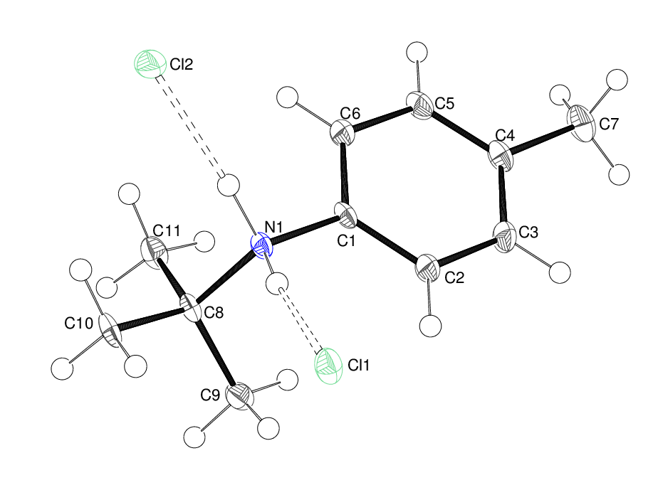

Figure 1: Drawing of the structure of compound 5 determined by X-ray single crystal structure determination. Colourless blocks of 5 were obtained by recrystallisation from water. C₁₁H₁₈N⁺Cl–, M_{r} = 199.71, crystal dimensions 0.22 × 0.13 × 0.06 mm, tetragonal, space group $P\overline{4}2_{1}c$ (No. 114), Z = 8, a = 9.9692 (14), c = 23.205 (3) Å, V = 2306.2 (5) Å³ at 100 K. Number of measured and unique reflections = 9602 and 2545, respectively (–11 ≤ h ≤ 12, –9 ≤ k ≤ 12, –30 ≤ l ≤ 30; θ_{max} = 27.5°; R_{int} = 0.115). Final R(F) = 0.046, wR(F²) = 0.131 for 129 parameters and 2505 reflections with I > 2σ(I) (corresponding R-values based on all 2545 reflections = 0.047 and 0.132, respectively). CCDC reference number 1017151.

This reaction is interesting to compare to heating aniline hydrochloride with methanol.¹¹⁻¹⁴ At lower temperatures of 230-250 ºC for a few hours N-alkylation occurs to give N-methylaniline hydrochloride but then at a higher temperature of 335 ºC for 24 h the product rearranges to p-toluidine with a mp of 45 ºC (N-methylaniline and o-toluidine are liquids). No N-alkylated product was recovered so at higher temperatures N-alkylation is presumably reversible or the N-alkyl product undergoes an intramolecular rearrangement. This reaction, known as the Hofmann-Martius rearrangement, was first observed in 1871.¹⁵ This type of reaction has also been used to make 2,6-diisopropyl-p-toluidine by reacting p-toluidine with propene or propanol and a Lewis acid.¹⁶

The ready availability of N-tert-butyl-p-toluidine hydrochloride has allowed us to perform more experiments to study the synthesis of mauveine. By carrying out many experiments, each using 373 mg of N-tert-butyl-p-toluidine hydrochloride, we found that the oxidation of N-tert-butyl-p-toluidine hydrochloride : o-toluidine : aniline (1.0:1.5:3.0) with K₂Cr₂O₇ in dilute sulfuric acid at 40-45 ºC for 12 h gave a good ratio of mauveine A to mauveine B which approximated to authentic mauveine (Scheme 3).

Scheme 3: A two step synthesis of mauveine A and B from N-tert-butyl-p-toluidine hydrochloride.

The compound mixtures are compared on a TLC plate (Figure 2) and look very similar. Perkin did not use chromatography to purify mauveine, but extraction and

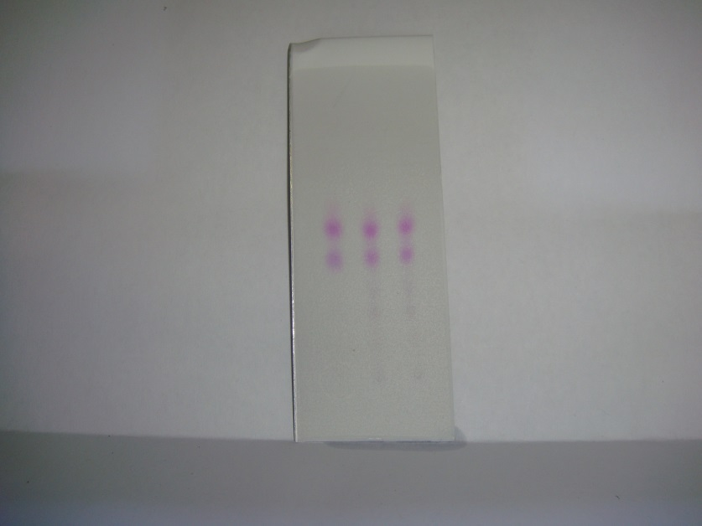

Figure 2: TLC plate run with secBuOH:EtOAc:H₂O:HOAc (60:30:9.5:0.5). The left column is authentic mauveine from MoSI. The middle and right spots are identical runs of mauveine reported here made using N-tert-butyl-p-toluidine hydrochloride in place of p-toluidine

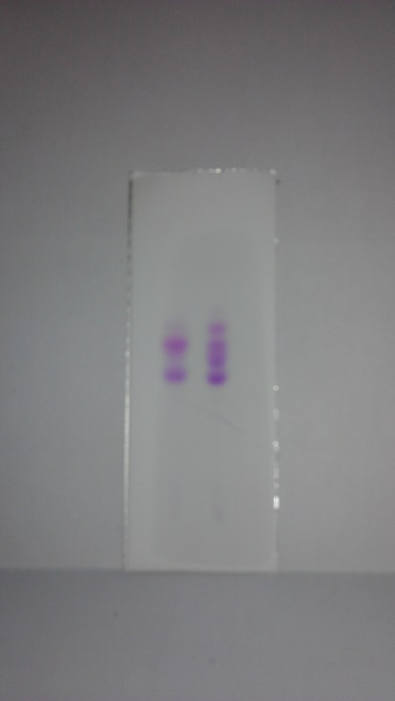

Figure 3 : TLC plate run with secBuOH:EtOAc:H₂O:HOAc (60:30:9.5:0.5). The left column is authentic mauveine from MoSI (two spots). On the right (four spots) is mauveine made by Perkin’s stated method (see text).

precipitation methods, so product profiles need not be identical, but these TLC plates do look the same. 19th century aniline may also have contained small amounts of other aromatic amines. Interestingly, by drying the plate and re-eluting, a mauveine chromophore fingerprint spot ahead of mauveine B is apparent in authentic mauveine and the mauveine reported here. Figure 3 shows a comparison of authentic mauveine with mauveine made by Perkin’s stated method (the oxidation of a mixture of p-toluidine/o-toluidine/aniline [1.0:1.5:1.5] with K₂Cr₂O₇). It always shows a characteristic set of four spots and we were not able to selectively precipitate or wash out two of them.¹

The lower temperature help’s to increase the selectivity for just mauveine A and B. There are some possible reasons why this may be. At a lower temperature N-tert-butyl-p-toluidine hydrochloride may not be deprotected or fragment leading to p-toluidine, which could lead to mauveines B₂ and C,¹ and the excess of aniline and o-toluidine may not spontaneously form further chromophores. We also performed the oxidation of a mixture of p-toluidine, o-toluidine and aniline (1.0:1.5:3.0) at the same temperature of 40-45 ºC. TLC analysis after purification of the product mixture showed mainly mauveine A and B₂, then a small amount of mauveine B and C. This was a qualitative analysis only by comparison of R_{f} values with published standards.¹⁷

Conclusion
The synthesis and isolation of pure N-tert-butyl-p-toluidine hydrochloride, free of p-toluidine hydrochloride, is efficient and can be scaled up. It has been used to synthesise mauveine which is similar in composition to authentic MoSI mauveine when analysed by TLC.

Experimental
IR spectra were recorded on a Perkin-Elmer Spectrum Two diamond anvil IR spectrometer. UV spectra were recorded using a Perkin-Elmer Lambda 25 UV-VIS spectrometer with EtOH as the solvent. ¹H and ¹³C NMR spectra were recorded at 400 MHz and 100.5 MHz respectively using a Varian 400 spectrometer. Chemical shift values, δ, are given in ppm relative to the residual solvent, and coupling constants, J are given in Hz. Low resolution and high resolution mass spectra were obtained at the University of Wales, Swansea using electron impact ionisation and chemical ionisation. Melting points were determined on a Kofler hot-stage microscope.

The X-ray intensity data for 5 were collected on a Rigaku CCD diffractometer (graphite monochromated MoKα radiation, λ = 0.71073 Å, T = 100 K): the unit-cell dimensions were obtained by least-squares refinement against the positions of 4740 reflections (3.3° < θ 27.5°). The structure was solved by direct methods with SHELXS-97¹⁸ and the atomic model was refined against |F|² by full matrix least-squares with SHELXL-97.¹⁸ All the C-bound H atoms were geometrically placed (C–H = 0.95–0.98 Å) and refined as riding atoms; the N-bound H atoms were located in a difference map and their positions were freely refined. The methyl groups were allowed to rotate, but not to tip, to best fit the electron density.

N-tert-Butyl-p-toluidine hydrochloride p-Toluidine hydrochloride (10 g, 70 mmol) was placed in a 45 ml PTFE Parr digestion bomb and treated with pre-melted ^{t}BuOH. The liquid was about 0.5 cm above the level of the salt after stirring to remove air bubbles. The mixture was sealed and heated at 150 ⁰C for 24 h. After cooling the bomb was filled with crystals. H₂O (10 ml) was added the the reaction mixture was filtered. A small amount of H₂O (5 ml) was slurried with the crystalline mass then filtered to give off-white crystals of the title compound (8.4 g, 60 %) from H₂O, mp ºC > 220 ⁰C (sub) ; ν_{max} (KBr disc) 2709s, 2603s, 2471s, 2063w, 1578w, 1514w, 1441w, 1378w, 1172vs, 1021w, 860w, 813w, 738s, 560s and 483vs; δ_{H}(400 MHz; CDCl₃) 1.40 (9H, s), 2.41 (3H, s), 7.35 (2H, d, J = 8.8) and 7.39 (2H, d, J = 8.8); δ_{C}(100.1 MHz; CDCl₃) 19.7, 24.8, 61.0, 125.0, 128.5, 130.0 and 140.4; m/z (orbitrap ASAP) 164.1430 (M⁺, 100%) C₁₁H₁₈N requires 164.1434.

Mauveine A and Mauveine B : N-tert-Butyl-p-toluidine hydrochloride (373 mg, 1.87 mmol, 1.0 eq), o-toluidine (300 mg, 2.8 mmol, 1.5 eq) and aniline (520 mg, 5.6 mmol, 3.0 eq) were dissolved in distilled water (100 ml) acidified with cH₂SO₄ (9 drops, 0.45 ml ) then treated with K₂Cr₂O₇ (1.3 g, 4.40 mmol) and stirred at 40-45 ⁰C for 12 h. The purple reaction mixture was filtered through a fine pore sinter and washed with cold water (200 ml). The precipitate was extracted with MeOH (40 ml x 8) in the sinter each time agitating the precipitate in MeOH before filtration through the sinter under vacuum. The combined extracts were heated to dryness in a beaker with a fume hood on. The crude product was purified by chromatography on silica gel. MeOH firstly eluted impurities then cNH₃/MeOH (20:80) eluted a mixture of purple chromophores (58 mg, 6%) that were not separated. After evaporating to dryness in a beaker the product was then treated with MeOH (10 ml) then cHCl (10 ml) and evaporated to dryness on a hotplate with a fume hood on. The product was purified by chromatography on silica gel. MeOH firstly eluted a small amount of impurity then cNH₃/MeOH (20:80) eluted predominantly a mixture of mauveine A and mauveine B (44 mg, 5%) (85 % from the above tert-butylated mixture). These were analysed qualitatively by TLC eluting with secBuOH:EtOAc:H₂O:HOAc (60:30:9.5:0.5). The material showed only two spots identical to authentic mauveine (A and B), see figure 2. The sample analysis was verified by purification of a small sample (25 mg) by chromatography on silica gel and collecting fractions. Elution with secBuOH:EtOAc:H₂O:HOAc (60:30:9.5:0.5) gave firstly mauveine B then mauveine A with the same spectroscopic properties to literature material.^{1,19}

Mauveine by oxidation of p-toluidine/o-toluidine/aniline at 40-45 ºC : A mixture of p-toluidine (200 mg, 1.87 mmol, 1.0 eq), o-toluidine (300 mg, 2.8 mmol, 1.5 eq) and aniline (520 mg, 5.6 mmol, 3.0 eq) was dissolved in distilled water (100 ml) acidified with cH₂SO₄ (9 drops, 0.45 ml) and treated with K₂Cr₂O₇ (1.3 g, 4.40 mmol) and stirred at 40-45 ⁰C for 12 h. The reaction mixture was filtered through a fine pore sinter and washed with cold water (200 ml). The precipitate was extracted with MeOH (40 ml x 8) in the sinter each time agitating the precipitate in MeOH before filtration through the sinter under vacuum. The combined extracts were heated to dryness in a beaker with a fume hood on. The crude product was purified by chromatography on silica gel. MeOH firstly eluted impurities then cNH₃/MeOH (20:80) eluted a mixture of purple chromophores in low yield (3 mg, 0.4%). These were analysed qualitatively by TLC eluting with secBuOH:EtOAc:H₂O:HOAc (60:30:9.5:0.5). By comparison of R_{f} values with standards and the known relative R_{f} values for mauveine B₂ and C, the products are mauveine A (major), B₂ (major), B (minor) and C (minor).¹⁷

References
1. M. J. Plater, J. Chem. Res., 2014, 38, 163.
2. M. J. Plater, J. Chem. Res., 2011, 35, 304.
3. M.J. Plater and W. T. A. Harrison, J. Chem. Res., 2013, 37, 427.
4. M. J. Plater and W. T. A. Harrison, J. Chem. Res., 2014, 38, 351.
5. M. J. Plater and T. Jackson, J. Chem. Res., 2014, 38, 437.
6. P. G. Gassman, G. A. Campbell and R. C. Frederick, J. Am. Chem. Soc., 1972, 94, 3884.
7. P. G. Gassman and G. A. Campbell, J. Am. Chem. Soc., 1972, 94, 3891.
8. J. R. Gage and J. M. Wagner, J. Org. Chem., 1995, 60, 2613.
9. A. Bell and M. B. Knowles, 1951, US2692287.
10. P. W. Carleton and J. D. Woodward, 1932, US1994852.
11. A. W. Hofmann, Proc. R. Soc., London, 1872, 21, 54.
12

. A. W. Hofmann, Chem. Ber., 1872, 5, 720.
13. A. W. Hofmann, Chem. Ber., 1874, 7, 526.
14. W. Staedel, Patentschrift Klasse 12, No. 21241 1882.
15. A. W. Hofmann and C. A. Martius, Chem. Ber., 1871, 21, 742.
16. R. Stroh, J. Ebersberger, H. Haberland and W. Hahn, Angewandte Chemie, 1957, 69, 124.
17. J. Seixas de Melo, S. Takato, M. Sousa, M.J. Melo and A.J. Parola, Chem.
Commun., 2007, 2624.
18. G. M. Sheldrick, Acta Crystallogr., Sect., A: Fundam. Crystallogr., 2008, A64, 112.
19. O. Meth-Cohn and M. Smith, J. Chem. Soc., Perkin Trans., I 1994, 5.

Acknowledgements
We are grateful to the EPSRC national mass spectrometry service centre for mass spectra and to the trustees of the mauveine collection in MoSI for a sample of authentic mauveine.

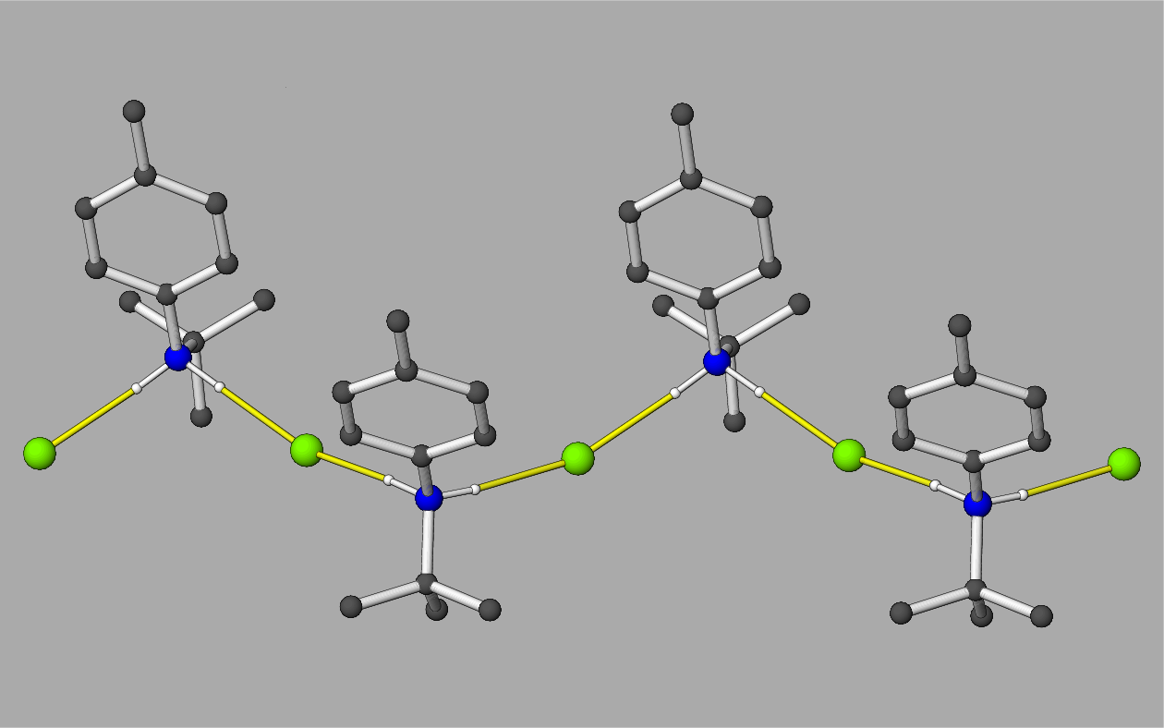

Figure 2: Fragment of a [100] hydrogen-bonded chain in the crystal of 1, with the N–HCl hydrogen bonds shown as yellow lines. All the C-bound H atoms are omitted for clarity. Crystal symmetry dictates that both [100] and [010] chains occur in the crystal.

