## Regeneration of Corneal Cells and Nerves in an Implanted Collagen Corneal Substitute

C.R. McLaughlin1,2, B.Sc., P. Fagerholm3, M.D., PhD., L.Muzakare1, M.Sc. N. Lagali1, Ph.D., J.V. Forrester4, M.D., L. Kuffova4, M.D., M.A. Rafat1, M.Sc. Y. Liu5, Ph.D., N. Shinozaki6, Ph.D., S.G. Vascotto1,Ph.D., R. Munger1, Ph.D., and M. Griffith1,2 Ph.D.,

1University of Ottawa Eye Institute, 501 Smyth Road, Ottawa, ON, Canada K1H 8L6

2Dept. of Cellular and Molecular Medicine, Univ. of Ottawa, 451 Smyth Road, Ottawa, ON, Canada K1H 8M5

3Linköping University Hospital, Dept. of Ophthalmology, Se-58185 Linköping, Sweden.

4Department of Ophthalmology, University of Aberdeen, Aberdeen, AB25 2ZD, Scotland, UK

5National Research Council Canada, 1200 Montreal Road, Ottawa, ON,Canada, K1A 0R6

6Tokyo Dental College-Ichikawa General Hospital Cornea Centre, Ichikawa, Chiba, Japan

**Grant Information:**

NSERC Canada Grant STPGP 246418-01 and Canadian Stem Cell Network grant to MG, NSERC studentship to CRM, NSERC Visiting Fellowship to YL and CIHR Canada post-doctoral fellowship to NL.

**Corresponding Author:**

May Griffith, PhD

University of Ottawa Eye Institute

The Ottawa Hospital – General Campus

501 Smyth Road

Ottawa, ON K1H 8L6, Canada

Phone: (613) 737-8899, ext. 74011

Fax: (613) 739-6070

E-mail: mgriffith@ohri.ca

### Co-author Contributions to Manuscript

Fagerholm, Per

Dr. Fagerholm, an ophthalmologist at Linköping University Hospital in Sweden, was responsible for the implantation of the artificial corneas into the pigs.

Muzakare, Lea

Lea Muzakare was a research technician in the Griffith Laboratory who aided in the tissue processing of the pig implants.

Lagali, Neil

Dr. Lagali, was a post doctoral fellow in the Munger Lab who was mainly responsible for the *in vivo* confocal microscopy images.

Forrester, John and Kuffova, Lucia

Drs. Forrester and Kuffova are ophthalmologists at the University of Aberdeen in Scotland. They trained me to perform corneal transplants in mice and how to harvest samples for analyses.

Rafat, Mehrdad

Dr. Rafat, was at the time a PhD student in the laboratory who performed the mechanical testing of the corneal substitutes.

Liu, Yuwen

Dr. Liu, was at the time, a post doctoral fellow in the laboratory who developed the formulation for the artificial cornea.

Shinozaki, Naoshi

Dr. Shinozaki, Director of the Ichikawa General Hospital Cornea Center in Japan, provided some of the electron microscopy images of the implanted corneas

Vascotto, Sandy

Dr. Vascotto, at the time, was a post doctoral fellow, who helped contribute to the development of the biotin staining method for labelling the implants.

Munger, Rejean

Dr. Munger, an optical physicist at the University of Ottawa Eye Institute, aided in analysis of the in vivo confocal microscopy images of the artificial cornea.

Griffith, May

Dr. Griffith was my supervisor, and helped guide me in designing the study, arranged for my surgical training and helped me with the manuscript preparation.

**Abstract**

**Purpose**: Our objective was to evaluate promotion of tissue regeneration by extracellular matrix (ECM) mimics, using corneal implantation as a model system.

**Methods:** Carbodiimide crosslinked porcine type I collagen was moulded into appropriate corneal dimensions to serve as substitutes for natural corneal ECM. These were implanted into corneas of mini-pigs after removal of the host tissue, and tracked over 12 months, by clinical examination, slit-lamp biomicroscopy, *in vivo* confocal microscopy, topography and aesthesiometry. Histopathology and tensile strength testing were performed at the end of 12 months. Other samples were biotin-labeled and implanted into mice to evaluate matrix remodeling.

**Results**: The implants promoted regeneration of corneal cells, nerves and the tear film, while retaining optical clarity. Mechanical testing data was consistent with stable, seamless host-graft integration in regenerated corneas, that were as robust as the untreated contralateral corneas. Biotin conjugation is an effective method for tracking the implant within the host tissue.

**Conclusions:** We show that a simple ECM mimetic can promote regeneration of corneal cells and nerves. Gradual turnover of matrix material as part of the natural remodeling process, allowed for stable integration with host tissue and restoration of mechanical properties of the organ. The simplicity in fabrication and demonstrated functionality shows potential for ECM substitutes in future clinical applications.

Key words: Cornea, ECM (extracellular matrix), collagen, nerve regeneration, mechanical properties, hydrogel

### Introduction

The extracellular matrix (ECM) has been considered to be a biologically active scaffold that provides the appropriate microenvironment for stem or precursor cells to differentiate during embryonic development of an organ. During wound healing, ECM macromolecules help provide cues for repair and regeneration, serving as “regeneration templates”. 1

The human cornea is the optically clear, tough covering in front of the eye that is responsible for majority of light transmission and refraction to the retina for vision. It is avascular and has three main cellular layers. It can be viewed as a hydrated ECM containing stromal cells that is sandwiched by an outer stratified, non-keratinizing epithelium and inner single-layered endothelium. 2 The ECM is composed mainly of collagen, being over 70% dry weight of the cornea. 2 Due to its superficial location, the cornea is prone to disease or trauma that may result in the loss of transparency, and, where irreversible, permanent vision loss occurs. Corneal opacification from disease or trauma is estimated to affect over 10 million people worldwide 3 and is generally treated by transplantation with grafts from donor human corneas. A variety of materials, both synthetic, such as poly(2-hydroxyethyl methacrylate) 4, as well as naturally derived materials, have been utilized for the production of artificial hydrogels for developing tissue engineered scaffolds. 5, 6 The need to develop viable alternatives to human donor tissue results from the current and projected shortage of acceptable corneas for transplantation worldwide driven by age demographics, increases in incidence of transmissible diseases (like HIV, hepatitis and CJD) and the increasing use of laser vision corrective surgery (which renders corneas unsuitable for grafting).

The relative structural simplicity and the medical need, makes the cornea an ideal model for the development of a simple, single component ECM mimic. Collagen has previously been utilized by other groups for uses in the cornea, such as intracorneal lamellar implants 7, and as contact lens for wound healing and drug delivery. 8 We recently reported the development of a corneal substitute that comprised a matrix of crosslinked type I collagen that promoted corneal cell and nerve repair over 6 months. 9 The hydrated matrix (hydrogel) was stabilized by cross-linking through chemical reactions mediated by water soluble carbodiimides (WSCs). The WSCs themselves do not become incorporated as part of the final cross-links in these collagen hydrogels, so there is no possibility of toxic substance release into tissues from subsequent cross-link break down after hydrogel implantation. 10

The aim of the present study was to examine the effectiveness of collagen hydrogels as ECM substitutes in promoting stable, tissue regeneration over 12 months in pigs, and to determine the mechanisms involved. We show that the gradual remodeling of the implanted matrix allowed for seamless host-graft integration, in restoration of both optical and mechanical properties, as well as restoration of innervation patterns.

### Materials and Methods

**Fabrication of Corneal Implants**

Corneal implants were fabricated as previously described. 9 Briefly, 0.5 to 1 ml aliquots of 10 % wt/wt solutions of acid freeze dried, porcine type I atelocollagen (Nippon Ham, Tskuba, Japan; Koken, Japan) were adjusted to pH 5 by titration with 1.0 M aqueous NaOH, followed by thorough mixing. A 10% (wt/vol%) aqueous solution of 1-ethyl-3-(3-dimethylaminopropyl) carbodiimide (EDC) and its co-reactant N-hydroxysuccinimide (NHS) (both from Sigma Aldrich, Oakville, Canada) at a 2:1 molar ratio of EDC to NHS, was rapidly and completely mixed into the collagen solution to crosslink the collagen. The final homogenous solution was dispensed into contact lens moulds and cured at 100% humidity. After curing (21°C for 24 h and then at 37°C for 24 h), cross-linked, cornea-shaped hydrogels (12 mm diameter, 500 μm thickness) were removed from each mould and washed with 0.1 M phosphate buffered saline (PBS) (Sigma Aldrich, Oakville, Canada) at 4°C. Each implant was individually stored in PBS containing 1% chloroform to maintain sterility. For pig implantation, a 6 mm disc was trephined from the center of each cornea shaped matrix. For mouse implants, flat sheets (100 μm thickness) were made using the above procedure and 2.0 mm discs were trephined out of the hydrogel sheets for implantation.

**Biotin Labelling**

Corneal implants intended for mouse implantation were incubated in a 25 µg/mL solution of biotinamidohexanoic acid 3-sulfo-N-hydroxysuccinimide ester, sodium salt in PBS, for 1.5 hours at 37°C. The ratio of the biotin reagent to free primary amine groups (on lysine repeats) in collagen was 1 to 3 equivalents. Any unreacted biotin was chemically neutralized by incubating implants for 30 min in Dulbecco’s Modified Eagle Medium (DMEM, Sigma Aldrich) plus 10% fetal bovine serum (FBS), after which samples were thoroughly washed and stored in PBS at 4°C.

**Implantation Method**

Implants into animals were performed with ethics approval from the University of Ottawa (Protocol EI-5), and in accordance to the Animal Licence Act (UK) and in accordance with ARVO guidelines for the treatment of animals. Corneal matrices (500 µm thick and 6 mm diameter) were implanted into one cornea each of eight Göttingen mini-pigs by deep lamellar keratoplasty (DLKP), with overlying sutures (Zirm retention bridge suturing). 11 This involved trephining to a depth of 500 µm, and removing this tissue, which left 190 µm of the host stroma. Prior to surgery and at all follow up examinations, animals were anaesthetized with i.m xylazine (5 mg/kg; Rompun®, Bayer Leverkusen, Germany) and ketamine (30 mg/kg; Ketalar®, Parke-Davis, Barcelona, Spain). The non-operated, contralateral eyes served as controls. The penetrating keratoplasty technique for Balb/C mice was modified by the authors from previously published procedures. 12 Briefly, a biotin labeled collagen hydrogel was implanted into each cornea of a mouse, after removal of the host cornea, and sutured in place with a continuous 11-0 suture (Ethicon™, Edinburgh, UK) that was retained for the duration of the experiment.Animals were given antibiotics and analgesics over the first week postoperatively, with no steroids administered. Sutures were removed three weeks postoperatively for the pigs, and remained in place for the mice.

**Clinical Evaluation**

In pigs, follow-up examinations were performed on a daily basis for the first week following surgery, and then weekly. Slit-lamp examinations were performed to verify corneas were optically clear, followed by Schirmers’ test to assess tear film, and sodium fluorescein staining to determine epithelial integrity and barrier function. Intraocular pressure measurements were measured with a Tono-Pen XL Tonometer (Medtronic Solan, Minneapolis, MN) also taken to show that proper aqueous humour flow was occurring, and not being blocked by the implants. Aesthesiometry was used to test for nerve touch sensitivity in the control and surgically operated eye using a Cochet-Bonnet aesthesiometer (Handaya Co., Tokyo, Japan), as previously described.13

Using a fluorescence profilometer (Par Vision Systems, New Hartford NY), corneal topographies were measured *in situ* on both control and operated eyes in the pigs preoperatively and at twelve months postoperatively. Average refractive powers were derived from the measured topographies of each cornea. The average power (Pave) was calculated by transforming the radius of curvature (R in meters) of the best-fit sphere from the topography into dioptric power with Pave = (n-1)/R using a refractive index (n) of 1.337.

*In vivo* confocal microscopy (IVCM) examination (ConfoScan3, Nidek, Japan) was utilized to assess nerve in-growth, and to determine total corneal thickness in live animals (depth difference between epithelial and endothelial images.14 IVCM was used to obtain full-thickness corneal scans of control and operated eyes from all 8 pigs at three examination periods: preoperatively, and then at 6, and 12 months postoperatively. For the mice, corneas were examined *in vivo* three times per week under the operating microscope for signs of rejection, including increased corneal opacity and thickness. 15

**Assessment of Nerve Regeneration and Remodelling**

Serial IVCM images of the central area of each cornea were acquired at 10µm depth intervals (image size: 440 × 330µm, w × h) through the entire thickness of the cornea and several scans were made through each cornea. All images containing at least one nerve fiber bundle (NFB) were identified and indexed according to depth from the corneal epithelial surface. Nerve tracing software, Image J and Neuron J (NIH) 16 were used to determine the total length of all NFBs (including branches) in each image. The NFB density for each image was calculated as the total NFB length divided by the image volume (image area × confocal depth of field) and expressed as µm/mm3. The NFB density has been used as a method by other groups 17 to evaluate normal and postoperative human corneal innervation *in vitro*. For statistical analysis, IVCM images were grouped by image depth from the epithelial surface into three corneal regions: sub-basal (20-50µm), representing the nerves of the subbasal nerve plexus found at the basal epithelium and sub epithelial regions, anterior stroma zone 1 (60-100µm) and anterior stroma zone 2 (110-150µm). Below a depth of 150 µm, there was a marked infrequency of nerves in the control cornea to allow for a proper comparison to be made. However, the scarcity of innervation in the mid and deep stroma is consistent with findings for normal human corneas.18 The total length of NFBs from all image depths within each region was calculated and divided by the sample volume of the region to determine the NFB density in a region, expressed in µm/mm3. This metric has been used by Calvillo et al. 18 to assess postoperative NFB length changes in three-dimensional corneal volumes. NFB densities in control and operated eyes were compared at each examination period in each corneal region using the Mann-Whitney rank sum test for non-normally distributed data. A P-value of less than 0.05 was considered statistically significant. Differences in NFB density with time were determined by Friedman’s repeated measures analysis of variance on ranks. Pairwise differences adjusted for multiple comparisons were determined using the Student-Newman-Keuls procedure. All statistics were calculated using SigmaStat v3.1 software for Windows (Systat Software Inc., Point Richmond, CA). This method of image analysis has recently been described in further detail by our group. 19.

**Histopathological Evaluation**

The pigs were sacrificed 12 months postoperatively. Corneas with implants, and control unoperated corneas were processed for routine histopathological examination after H&E staining. Mice were sacrificed at one, two, four and eight weeks postoperatively (n=3 at each time point). Eyes were fixed in 4% paraformaldehyde in 0.1M PBS and then processed for routine cryosectioning.

**Immunohistochemistry**

For visualization of biotin tag, 10 µm sagittal sections through whole mouse eyes were pre-treated with 0.1% H­202 in PBS for 30 minutes to block endogenous peroxidase activity. They were then washed in PBS and blocked for 1 hour in 3% BSA in PBS prior to application of a 1:1000 dilution (in blocking solution) of streptavidin-horseradish peroxidase (HRP, Amersham Biosciences) for 3 hours at room temperature. Following washing, sections were reacted with diaminobenzidine (DAB; Roche) for visualization of the resulting dark brown biotin-HRP-DAB complexes. Sections were examined using differential interference contrast microscopy.

To visualize the epithelium for the pig and mouse sections, slides were blocked in 4% FBS in 0.2% Triton X-100 in TBS pH 8.0, with 50 mM NH­4Cl to reduce background fluorescence. An antibody towards pan-cytokeratin (Z0622, DAKO, Mississauga, Canada) was applied at 1:400 in 0.2% Triton X-100 in TBS overnight at 4°C, washed with TBS, and visualized with a 1:600 dilution of CY2 conjugated anti-rabbit secondary and 1:10000 of DAPI to stain the nucleus and visualized using a Zeiss Axioscop 2. Macrophages were visualized using a 1:5000 dilution of F4/80 antibody (MCAP497, Serotec, Raleigh, NC, USA) . Other samples were stained with antibodies against collagen VII (Sigma C6805), smooth muscle actin (CMC533, Cell Marque, Hot Springs, AR), and procollagen (M38, Developmental Studies Hybridoma Bank, Iowa City, Iowa). They were first blocked in 5% FBS in PBS. Antibodies to Smooth Muscle Actin (1:100), Collagen VII (1:50) and Procollagen (1:20) were then applied overnight at 4°C in blocking solution plus 0.3% Triton X-100, washed with PBS, and visualized with a 1:400 dilution of CY2 conjugated anti-rabbit secondary.

For transmission electron microscopy (TEM), all samples were fixed in Karnovsky’s fixative and osmium tetroxide, en bloc stained with uranyl acetate and embedded in epoxy resin. Thin sections were cut and stained to visualize corneal nerves.

**Physical and Optical Characterization**

The hydrogels utilized for implantation were tested for optical properties, permeability, water content and biocompatibility. Results were published in Liu et al. 9

**Mechanical Testing**

After 12 months post-surgery, corneas with implants were harvested from three pigs and cut into dumbbell shapes with a 4 x 10 mm waist, which included the central implant area to ensure that the central gauge length of each tensile sample contained the maximum area of the implanted gel. Tensile measurements were performed on the samples using an Instron Materials Testing System (model 5565) with a load cell of 500N capacity and pneumatic, rubber faced grips (model 2712, jaw pressure 5 bar), at a crosshead speed of 10 mm/min and an initial grip separation of 13 mm. To avoid breakage and slippage of the sample in the pneumatic jaws, the 6 mm wide tabs on the end of each dumb bell sample (mainly scleral tissue) were compressed with forceps, tamped dry to remove exuded medium, then coated with Dermabond™ (Ethicon, Somerville, USA), a fast curing, cyanoacrylate-based skin adhesive, and reinforced with tape on both sides. This method of sample mounting completely prevented jaw breaks and sample slippage. Samples were not stress preconditioned prior to testing to failure. Controls consisted of unoperated contralateral corneas.

The maximum tensile strength, elongation at this tensile maximum and Young’s modulus for each sample were calculated from the raw stress-strain data, using the Instron’s Bluehill software, and the initial cross-sectional area. Elastic (tangent) moduli were calculated from the quite linear part of the stress/strain curves found for all samples over the 0.15 to 0.30 strain range. This linearity has been reported previously for human corneas. 20

Tensile properties of the collagen hydrogel alone were similarily measured, on flat film cast from the cross-linking gel (500 µm thickness).

### Results

**Biotin Labelled Collagen Implants in Mice**

Homogenous biotin labeling of collagen implants was confirmed by visualization of dark brown staining of serial sections through samples after chromophore development. The covalent conjugation of biotin to the gels had no effect on optical clarity, and biotinylated matrices were found to be non-cytotoxic by *in vitro* testing (results not shown here). Non-implanted gels retained their biotin tag after 60 days at 37°C in culture media (data not shown). At one week postoperative, the biotinylated implant was largely intact, showing a distinct continuous edge between the implant and the epithelium (Fig. 1A) and between the implant and adjacent host stromal bed (not shown). The implant was completely covered by cytokeratin-positive epithelium (Fig. 1B). Several scattered macrophages were observed within the implant area (Fig. 1C). At two weeks postoperative, the overlying epithelium was further stratified (Fig 1D, E). In addition to macrophages (Fig 1F), biotin-labeled stromal cells were found around the implant (Fig. 1D). At four weeks and eight weeks post-operative, the implant showed evidence of initiation of remodelling as the implant edge was no longer continuous (Fig. 1G, J) and macrophages were still present (Fig. 1L). There were no macrophages in any of the unoperated control corneas (Fig 1O).

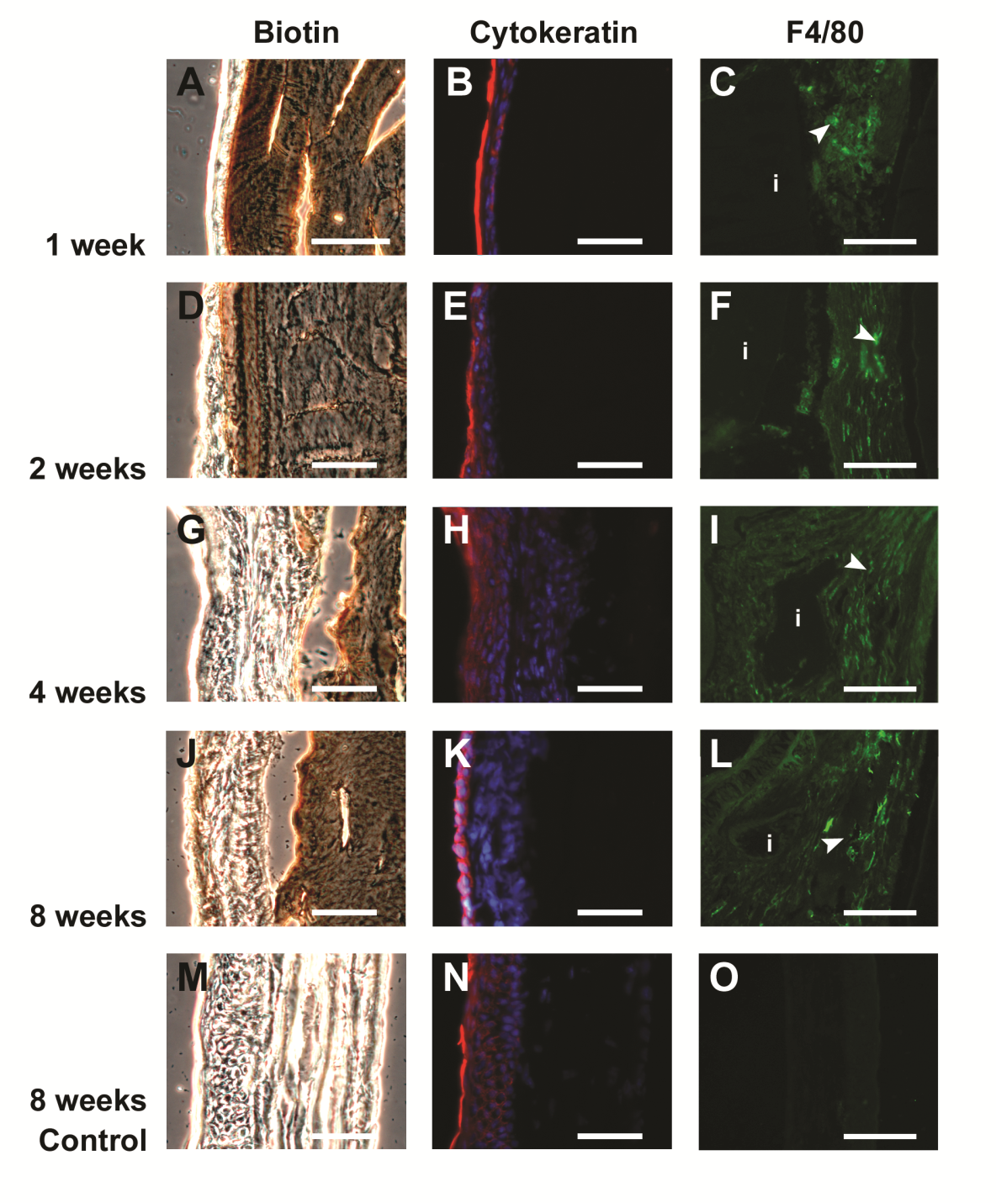

**Fig. 1.** Sections through biotinylated cornea substitutes implanted by penetrating keratoplasty into corneas of mice. (A-O) DIC images (A, D, G, J, M) and fluorescent staining for cytokeratin (red) and DAPI (blue) (B, E, H, K, N), and macrophages (C, F, I, L, O). (A-C) 1 week post implantation, showing biotin stained intact implant (A) covered by epithelium (B). Several macrophages are seen (arrowhead) (C). (D-F) 2 weeks post implantation, showing a further stratified epithelium (D,E), and the presence of macrophages (F), as well as biotin labelled stromal cells around the implant (D). (G-I) 4 weeks post implantation and (J-L) 8 weeks post implantation the edge of the implant is no longer continuous showing initiation of possible remodeling. (M-O) 2 month control cornea showing lack of DAB staining in the epithelium or stroma, and normal epithelial staining for cytokeratin (N), and lack of macrophages (O). Bars, 50 µm.

**Implantation in Pigs and Clinical Evaluation**

Implants in animals remained optically clear (Fig. 2B) which was confirmed clinically through slit lamp biomicroscopy. One animal had some very mild haze (+0.5 by slit lamp biomicroscopy) and a second animal had a discrete opacity at one of the suture points on the periphery. As previously published, slit lamp examination on non-labelled, implanted corneas of pigs showed re-epithelialization within the first postoperative week. 9 The absence of sodium fluorescein staining indicated that an intact epithelial barrier was restored and remained stable over 12 months. The Schirmer’s test indicated the presence of a tear film comparable to the contralateral unoperated eyes as measured at 12 months. From preoperative topographical measurements, the refractive powers (Pave) of the control and surgical eyes were not significantly different whereas postoperatively, the calculated Pave of both the control and implanted eyes had significantly decreased, but the postoperative Pave values of each control and its corresponding implanted eye were not significantly different. Touch sensitivity indicating nerve function was observed in operated corneas after 6 months postoperative 9, 21 and remained at 12 months.

Histopathological examination of sections through corneas with implants resembled those of unoperated controls, with a stratified epithelium and stroma with keratocytes arranged in lamellae (Fig. 2D) The epithelium was positively stained for pan-cytokeratin marker (Fig. 2F), similar to the epithelium of the unoperated contralateral controls (Fig. 2E). In addition, positive staining for type VII collagen, a marker for anchoring fibrils, was found in both unoperated control corneas (Fig. 2G) and corneas with implants (Fig. 2H). Insets (Fig. 2G, H) show corresponding TEM images of hemidesmosomes in the basal epithelial cells of control and operated corneas. Samples were negative for pro-collagen and anti-smooth muscle actin, as with the controls, suggesting that stromal cells are not activated and no active collagen production was seen at this time-point. However, both H&E and TEMs reveal stromal cells within implant areas that were arranged in lamellae, similar to unoperated corneas. As well, H&E images did not show any fibrosis in the cornea after 12 months of implantation.

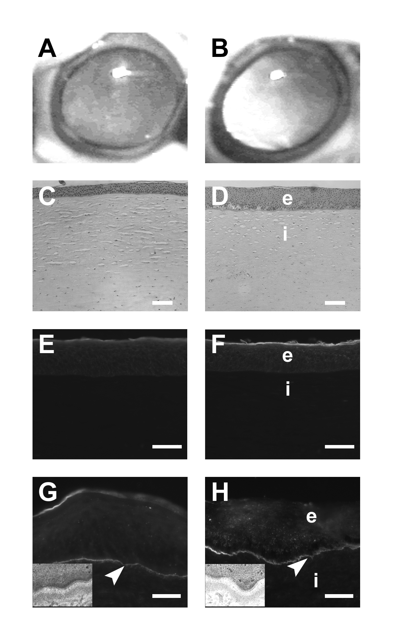

**Fig. 2.** **Corneal implantation by lamellar keratoplasty in pigs at 12 months.** (A): unoperated, contralateral cornea (B): optically clear operated cornea. (C-D): H&E staining of unoperated (C) and operated cornea (D), both showing a stratified epithelium over a stroma. (E-F) Cytokeratin staining showing the presence of a normal, differentiated, stratified, non-keratinizing epithelium on the unoperated (E) and operated cornea (F). (G-H) Collagen VII staining at the epithelial/stromal junction in the operated cornea (arrows) indicate the presence of anchoring fibrils in both operated (H) and control (G) corneas. Insets show TEM images of hemidesmosomes (arrowheads). Scale bars for C-F are 50 µm, scale bars for G-H are 40 µm. (e) denotes epithelium, (i) denotes implant.

In-growth of nerves into the implants was confirmed by IVCM (Fig. 3B,D) followed by immunohistochemical staining with an anti-neurofilament antibody (results not shown) and TEM. TEM images through the sub-epithelial region of the implanted site showed the presence of nerves containing both light and dense core vesicles typical of an axon (Fig. 3F,H). Similar nerve fibres were seen in unoperated control corneas (Fig. 3E,G).

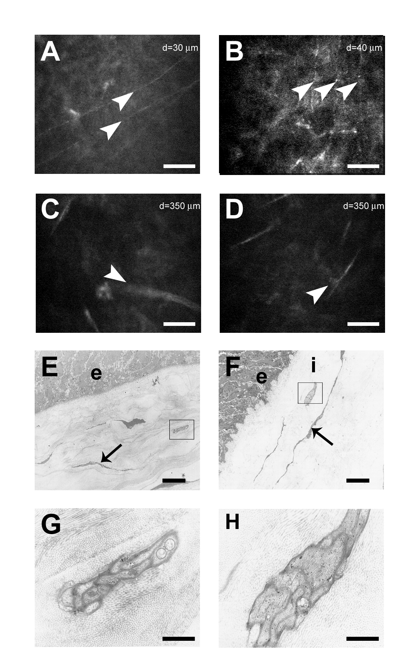

**Fig. 3.** **IVCM and TEM images at 12 months from pigs.** (A-D) *in vivo* confocal images. Regenerated nerves (arrowheads) can be seen sub-basally in both non-surgical (A) and operated cornea (B). In the deep stromal layer, deep nerves observed in the contralateral control (C) are also observed (arrowheads) in the operated cornea (D). (E-H) Postoperative regeneration of nerves in the tissue engineered cross sections of control and implanted corneas by TEM. (E) Unoperated cornea visualized using transmission electron microscopy showing normal epithelial stromal boundary and nerve fibre (boxed). The operated eye shows similar epithelial/stromal boundary (F), as well as re-innervation at 12 months (boxed). (G) Magnification of boxed inset from the control eye showing intact nerve. (H) Magnification of boxed inset from the operated eye showing a regenerated nerve, show the staining of light and dense vesicles. (A-D) Scale bars are 50 µm. (E-F) Scale bars are 5 µm. (G-H) Scale bars are 1 µm. (e) denotes epithelium, (i) denotes implant.

From IVCM images, nerve density in the sub-basal epithelial and stromal regions of the unoperated porcine corneas agrees well with values observed in normal human corneas. 17, 18 IVCM analysis of nerve density within the central implant region ( Table 1 and Fig. 4) indicated a significant decline in sub-basal nerve density at 6 months relative to both the untreated contralateral cornea (P<0.001) and preoperative (P=0.04) levels, as no sub-epithelial nerves were detected in any operated eye at 6 months following surgery (Table 1 and Fig. 4D). Sub-epithelial nerves, however, recovered to preoperative (P>0.05) and control (P=0.69) densities at 12 months (Table 1 and Fig. 4F). Similarly, anterior stromal zone 1 nerve density had declined significantly in implants relative to controls by 6 months (P=0.004, Table 1 and Fig. 4D), with recovery to preoperative (P>0.05) and control (P=0.9) levels at 12 months (Table 1 and Fig. 4F). Contrary to declines in sub-basal and anterior stromal zone 1 nerve density, in the anterior stromal zone 2, nerve density in implants had increased significantly by 6 months (Fig 4D) relative to controls (P=0.01). This significant increase relative to controls persisted to 12 months (P=0.04), while nerve presence in the anterior stroma zone 2 of control corneas remained sparse (Fig. 4F).

**Table 1.** Nerve Density (*n* = 8)*



Data represents the nerve density (x 105 m/mm3) for each time point

* Median (interquartile range: Q25, Q75). Means and standard deviations are given in square brackets where data was normally distributed.

† Medians with the same symbol were significantly different from each other (Student-Newman-Keuls test).

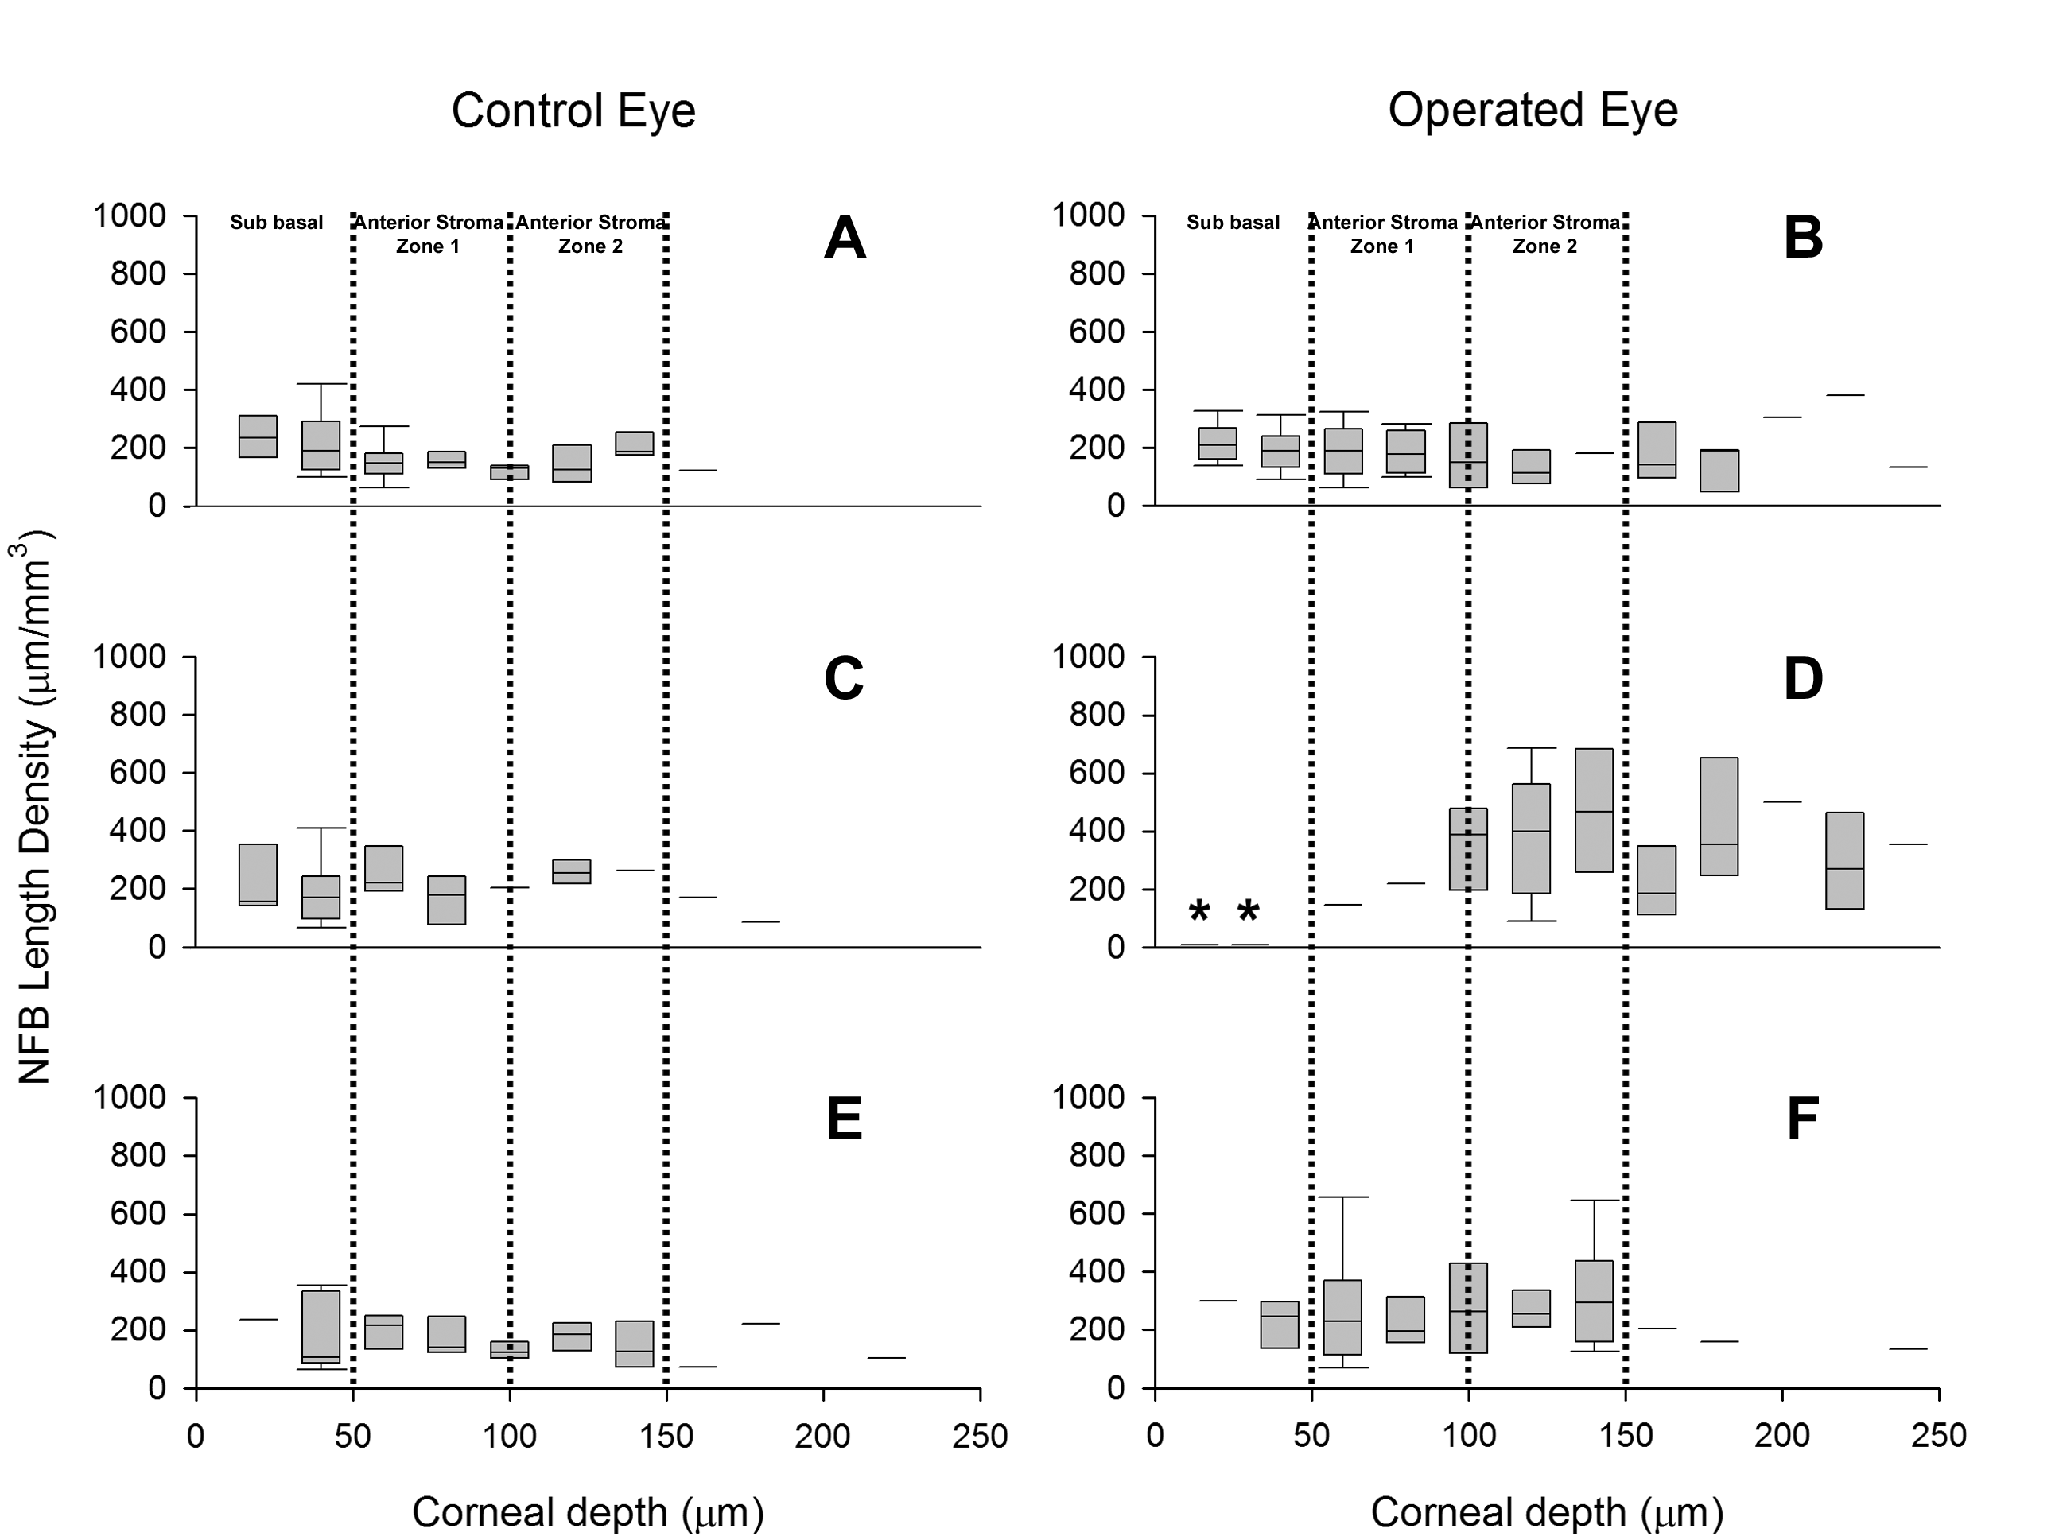

**Fig. 4.** **Nerve fibre bundle length density calculated by analysis of serial *in vitro* confocal micrographs.** (A-B) Preoperative densities showing similar NFB length density for control eye and operated eye. (C-D) 6 months post-surgery reveals the lack of innervation in the sub-epithelium following lamellar keratoplasty; asterisk (*) denotes significance of density from operated eye versus control. (E-F) 12 months post surgery shows NFB length density in the implanted returns to levels comparable to unoperated eye. Box plots are presented as medians, representing nerve density averaged over two adjacent microscopic images, showing the interquartile ranges (Q25, Q75), and whisker plots representing 10th and 90th percentiles.

*In vivo* measurements of corneal thickness with or without implants by IVCM (depth difference between the epithelial and endothelial images) showed no statistical significance (P<0.05) between the operated and unoperated corneas, indicating that the implants were not thinning or swelling within the 12 month test period, and were all 690±40µm.

**Mechanical Tensile Properties**

Tensile data showed that the corneas harvested from implanted eyes were similar to normal pig corneas in key mechanical properties (Table 2). However some animal to animal variation is to be expected and was found between the tensile properties of control cornea samples harvested from pigs at 12 month postoperation. Consequently, we believe that it is more statistically meaningful to compare the ratio of each specific tensile property of the cornea sample harvested from an implanted eye to that from the corresponding, contralateral control eye. These ratios are shown in Table 2. The maximum tensile stress ratio is very close to unity, which is the relative strength of each implant was very similar to its corresponding control. The average value of the elongation ratio was significantly greater than unity, whereas the elastic moduli ratio was below unity, both indicating that implants were less stiff and could be stretched more before failure as compared to the controls.

**Table 2.** Averaged tensile properties of pig corneas harvested from control and implanted eyes and of the cross-linked collagen hydrogel alone.

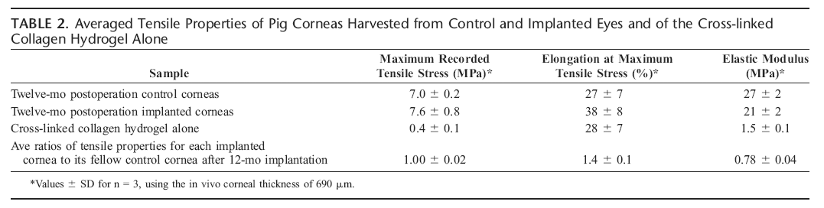

### Discussion

Desired outcomes of cornea transplantation include restoration of normal function, and the ultimate goal is to regenerate both natural architecture and cell function. To be a functional template for regeneration, an implanted ECM substitute or mimic should ideally allow in-growth of precursor cells to repopulate the matrix, and then biodegrade gradually to allow replacement by natural macromolecules elaborated by the newly established cells. In the cornea, this replacement must occur without unnatural changes in thickness or optical properties, and should also allow the cornea to recover its full tensile properties.

In this study, we directly labeled our collagen implants and showed that this method was effective for tracking the fate of the implants. The water soluble, biotin moiety chemically bound to a NHS ester, spontaneously reacted at a neutral pH with primary amine groups on lysine residues found in the fabricated corneal substitute. Covalently conjugating biotin to only 33% of the lysine amine groups (~24 equiv./1000 amino acid residues) 22 remaining after carbodiimide cross-linking of the collagen in the implant hydrogel was not expected to affect the enzymatic biodegradation rate of the collagen constituting the implant. This was confirmed *in vitro* (data not shown).

Our carbodiimide stabilized collagen implants showed biodegradation after 2 weeks in mice, as evidenced by the presence of macrophages and the loss of the continuous, smooth implant edge, but the degradation was not pronounced until 4 weeks postoperatively. It has been shown that the implantation of an allogeneic cornea will trigger an innate immune response by neutrophils, macrophages, natural killer cells, and dendritic cells, in which macrophages move into the implant area. 23 However, an adaptive response will also be initiated, that contributes to stable engraftment. 11 In our case, the macrophages observed were most likely contributing to implant breakdown but, there was no adverse impact on host-graft integration. The remodeling of the collagen implant was expected as enzymes such as matrix metalloproteinases, collagenases, and stromelysins are expressed in the cornea following wounding to remodel any scar tissue that may be formed 24, in addition to the innate immune and adaptive responses to surgery discussed above. Preliminary studies, have shown that initially a low grade, self-limiting inflammatory response occurs when these EDC/NHS crosslinked gels are implanted via full thickness penetrating into mice. 25 The main obstacle encountered in these full thickness grafts were the formation of a retro corneal membrane. However, because the mouse corneas were very small, the implants overlapped the adjacent, surrounding host tissue, making it very possible for host stromal cells to grow onto the overlying implants and thus give rise to a retroprosthetic membrane. Nevertheless, we show that with lamellar grafts, the implants were very well-tolerated and retained clarity over the 12 months. Unlike the more aggressive wound repair process that would occur in large wounds to the stroma, there was little fibrosis or scarring over time, although remodeling was clearly observed. The engineered ECM having its collagen microstructure chemically locked in a transparent form appeared to have functioned as a regeneration template, allowing for a more gradual remodeling process. The presence of a scaffold versus a gaping wound appears to have tempered the wound healing response.

In the pigs, at 12 months postoperative, both operated and control corneas remained optically clear as evidenced clinically through slit lamp biomicroscopy and topography showed retention of cornea shape and refractive power over time (not shown). Type VII collagen staining of anchoring fibrils in the basement membrane between the epithelium and stroma, along with TEM confirmation of hemidesmosomes confirm the stability of both the graft and the anchorage of the epithelial layer to the implant. Histological analysis through H&E staining did not show the presence of any fibrosis in the cornea after 12 months.

TEMs of operated corneas show stromal cells oriented in parallel striations, as well as cross-plied collagen fibril lamellae, even though the architecture of our implants initially comprises randomly oriented, cross-linked fibrils 26, not the highly organized, cross-plied lamellae of parallel fibrils found in mammalian corneas. 27 This regeneration of the ordered structure of a natural cornea in our implants at 12 months supports the biotin evidence and the contention that the gradual remodeling observed was the mechanism by which stable engraftment of the implant had occurred.

Reported elastic moduli for porcine and human corneas ranged from 0.3-60 MPa, depending on test conditions. 28 Kampmeier et al. reported a tangent modulus of 3.5 MPa for porcine corneas, but at a much lower strain (0.1 strain) than we have used. 29 Simonsen et al. 30 have followed restoration of strength in human corneas for up to 12 years following cataract surgery, requiring corneal incisions. Over the 4-5 years after the incisions were made, tensile properties of human corneal tissue that encompassed the incision were found to plateau at the strength of the nonoperated, control corneas (~5.5 MPa). In our study, restoration of tensile strengths was observed in operated pig corneas (Table 1). Our maximum tensile stress range is greater than the value reported by Zeng et al. 31 of 3.7±0.2 MPa for swollen pig corneas which is also close to reported values for swollen human corneas [~5.5 and 3.8±0.4 Mpa] 30, 31.

While direct experimental measurement of the maximum tensile strength of the implanted corneas immediately after implantation was not practical, the initial tensile strength can be calculated, based on the thickness of each layer in the implanted cornea (500 µm of implanted gel and 190 µm of pig tissue remaining after DLKP) and on the assumption of linear additivity of properties. From the average properties of cornea controls and gel properties (Table 1), the estimated value of the maximum tensile strength of the cornea immediately upon implantation is then

[(7.7±0.2)x190/690 + (0.4±0.1)x500/690] = 2.2±0.1 MPa

if no remodeling and/or regeneration had occurred. This calculated, initial tensile strength is much lower than the average value (7.6 ±0.8 MPa) found for the 12 month implanted corneas and is consistent with extensive remodeling over this time frame.

While we were not able to directly measure in any detail the implant breakdown process because an absolute measure of molecular scission would require an elaborate recovery and fractionation of the collagen and its breakdown products, which is beyond the scope of this study, we were nevertheless able to provide evidence for remodeling. The loss of implanted biotin-labelled collagen matrices in the mice coupled with the infiltration of macrophages and stromal cells, the presence of unlabelled matrix and restoration of overall mechanical properties to the operated corneas confirm turnover of the implanted collagen matrix.

We have therefore confirmed our prior *in vitro* study conclusions 9, 22 that simple ECM substitutes such as collagen crosslinked through EDC/NHS chemistry allowed for stable implantation and for integration of the implant into the adjacent host tissue by providing a conducive template for cell in-growth or overgrowth. These corneal substitutes allowed cell recruitment and nerve regrowth over the 12 month postoperative period for regeneration of proper architecture and function of the cornea. The integration with host tissue was seamless and stable. From biomechanical studies, remodeling of the pig cornea occurred to restore the mechanical properties to the implanted cornea, with an elastic modulus and tensile strength fairly similar to those of the native cornea. Use of biotin tagged corneal implants in mice strongly suggests remodeling of the matrix as a mechanism by which stable host-graft integration occurred in the present study. However, it is pertinent to note that the mice received full-thickness grafts by penetrating keratoplasty (penetrating the anterior chamber of the eye), while the pigs received lamellar implants in which the posterior stroma and endothelial layers were intact (and anterior chamber was undisturbed). In a previous longer term mouse study (Liu et al. 25 ), a low grade inflammatory innate immune response was induced, with retrograft membrane formation that may be related to the xenogeneic pairing, or migration of stromal cells from the underlying lip of the host cornea onto which the thin mouse implants were secured for suturing. However, all corneal implants in pigs remained free of inflammation even without steroid treatment. While further studies are investigating this effect, it is clear that lamellar grafts in pigs are fully integrated and show considerable potential for use in humans particularly if the endothelial cells are still functional since this implant did not seem to impair host endothelial function in any way. It is likely that integration of similar collagen-based lamellar implants into human eyes would also occur through similar mechanisms. Indeed, initial implants of small lenticules into blind human eyes in a limited clinical study with crosslinked collagen 5 have shown that the implants did not cause any inflammation nor irritation to the subjects. ECM substitutes such as this simple crosslinked collagen model therefore has the potential for future use in cornea replacements as implants, or temporary patches for promoting regeneration.

**Acknowledgements**

Supported by NSERC Canada STPGP 246418 to MG. Thanks to CooperVision for the pigs. The authors thank David Priest, Dr. David Carlsson, Dr. Mitchell Watsky, Dr. Lisha Gan and Dr. Lei Liu for technical expertise and advice. We also thank Dr. Yasuhiro Kato and Minoru Fukuda for TEM images, and Dr. Marilyn Keaney and her team at the University of Ottawa Animal Care and Veterinary Services for their contribution to our research efforts.

**References:**

1. Duan D, Klenkler BJ, Sheardown H. Progress in the development of a corneal replacement: keratoprostheses and tissue-engineered corneas. *Expert Rev Med Devices* 2006;3:59-72.

2. Nishida T. Cornea. In: Krachmer JH, Manis MJ, Holland EJ (eds), *Cornea.* Philadelphia: Elsevier Mosby; 2005:3-26.

3. Whitcher JP, Srinivasan M, Upadhyay MP. Corneal blindness: a global perspective. *Bull World Health Organ* 2001;79:214-221.

4. Chirila TV. An overview of the development of artificial corneas with porous skirts and the use of PHEMA for such an application. *Biomaterials* 2001;22:3311-3317.

5. Griffith M, Fagerholm P, Liu W, et al. Corneal regenerative medicine: Corneal substitutes for transplantation In: Reinhard T, Larkin F (eds), *Essentials in Ophthalmology: Cornea and external eye diseases.* Heidelberg: Springer Verlag; 2008.

6. Minami Y, Sugihara H, Oono S. Reconstruction of cornea in three-dimensional collagen gel matrix culture. *Invest Ophthalmol Vis Sci* 1993;34:2316-2324.

7. Dunn MW, Nishihara T, Stenzel KH, et al. Collagen-derived membrane: corneal implantation. *Science* 1967;157:1329-1330.

8. Willoughby CE, Batterbury M, Kaye SB. Collagen corneal shields. *Surv Ophthalmol* 2002;47:174-182.

9. Liu Y, Gan L, Carlsson DJ, et al. A simple, cross-linked collagen tissue substitute for corneal implantation. *Invest Ophthalmol Vis Sci* 2006;47:1869-1875.

10. Gratzer PF, Lee JM. Control of pH alters the type of cross-linking produced by 1-ethyl-3-(3-dimethylaminopropyl)-carbodiimide (EDC) treatment of acellular matrix vascular grafts. *J Biomed Mater Res* 2001;58:172-179.

11. Forrester JV, Kuffova L. Corneal Transplantation. Imperial College Press, London; 2004:18-21.

12. She SC, Steahly LP, Moticka EJ. A method for performing full-thickness, orthotopic, penetrating keratoplasty in the mouse. *Ophthalmic Surg* 1990;21:781-785.

13. Millodot M. A review of research on the sensitivity of the cornea. *Ophthalmic Physiol Opt* 1984;4:305-318.

14. Tervo T, Moilanen J. *In vitro* confocal microscopy for evaluation of wound healing following corneal refractive surgery. *Prog Retin Eye Res* 2003;22:339-358.

15. Plskova J, Kuffova L, Holan V, et al. Evaluation of corneal graft rejection in a mouse model. *Br J Ophthalmol* 2002;86:108-113.

16. Meijering E, Jacob M, Sarria JC, et al. Design and validation of a tool for neurite tracing and analysis in fluorescence microscopy images. *Cytometry A* 2004;58:167-176.

17. Oliveira-Soto L, Efron N. Assessing the cornea by *in vitro* confocal microscopy. *Clin Experiment Ophthalmol* 2003;31:83-84; author reply 84-86.

18. Calvillo MP, McLaren JW, Hodge DO, et al. Corneal reinnervation after LASIK: prospective 3-year longitudinal study. *Invest Ophthalmol Vis Sci* 2004;45:3991-3996.

19. Lagali NS, Griffith M, Shinozaki N, et al. Innervation of tissue-engineered corneal implants in a porcine model: a 1-year *in vitro* confocal microscopy study. *Invest Ophthalmol Vis Sci* 2007;48:3537-3544.

20. Andreassen TT, Simonsen AH, Oxlund H. Biomechanical properties of keratoconus and normal corneas. *Exp Eye Res* 1980;31:435-441.

21. Li F, Carlsson D, Lohmann C, et al. Cellular and nerve regeneration within a biosynthetic extracellular matrix for corneal transplantation. *Proc Natl Acad Sci U S A* 2003;100:15346-15351.

22. Liu Y, Griffith M, Watsky MA, et al. Properties of porcine and recombinant human collagen matrices for optically clear tissue engineering applications. *Biomacromolecules* 2006;7:1819-1828.

23. Kuffova L, Lumsden L, Vesela V, et al. Kinetics of leukocyte and myeloid cell traffic in the murine corneal allograft response. *Transplantation* 2001;72:1292-1298.

24. Holopainen JM, Moilanen JA, Sorsa T, et al. Activation of matrix metalloproteinase-8 by membrane type 1-MMP and their expression in human tears after photorefractive keratectomy. *Invest Ophthalmol Vis Sci* 2003;44:2550-2556.

25. Liu L, Kuffova L, Griffith M, et al. Immunological responses in mice to full-thickness corneal grafts engineered from porcine collagen. *Biomaterials* 2007;28:3807-3814.

26. Li F, Griffith M, Li Z, et al. Recruitment of multiple cell lines by collagen-synthetic copolymer matrices in corneal regeneration. *Biomaterials* 2005;26:3093-3104.

27. Meller D, Peters K, Meller K. Human cornea and sclera studied by atomic force microscopy. *Cell Tissue Res* 1997;288:111-118.

28. Hoeltzel DA, Altman P, Buzard K, et al. Strip extensiometry for comparison of the mechanical response of bovine, rabbit, and human corneas. *J Biomech Eng* 1992;114:202-215.

29. Kampmeier J, Radt B, Birngruber R, et al. Thermal and biomechanical parameters of porcine cornea. *Cornea* 2000;19:355-363.

30. Simonsen AH, Andreassen TT, Bendix K. The healing strength of corneal wounds in the human eye. *Exp Eye Res* 1982;35:287-292.

31. Zeng Y, Yang J, Huang K, et al. A comparison of biomechanical properties between human and porcine cornea. *J Biomech* 2001;34:533-537.